The layers of sacrifice and playing the victim
17.3.2019
written by Yuko Takeda
Here it begins again. We have just finished the first week of “Imagination of Violence- atelier 2,” the second artistic research workshop about violence. It is, in the nutshell, the collaboration between the third year Swedish-speaking acting students at Teak and post-doc researcher and theatre director Davide Giovanzana to investigate how theatre can respond to violence. My primary tasks as an acting pedagogue are the same as the last time: to lead the physical training for the students and to document the process in this blog. The second workshop lasts 8 weeks, culminating in the public presentations at the end of April.
The last workshop happened more than a year ago, in January and February 2018. It started out with the theme of “intolerability” of violence. The students conducted researches regarding different types of violence (e.g. visible and invisible violence), listened to lectures on violence from various academic disciplines such as sociology and psychology, watched provocative violent films, reenacted the gore, grotesque, extreme violence in pop culture, wrote their own monologues about invisible violence, and did a lot physical acting work to channel the animalistic energy needed to embody violence on stage. The workshop culminated in a demo performance to share the highlights of the long, intensive process with the public. You can read the blog posts about the first workshop at https://www.uniarts.fi/blogi/acting-expertise-sk%C3%A5despelarkonst-som-expertis.
While the first workshop focused more on the perpetrator and execution of violence, the second one has the theme of “sacrifice and playing the victim,” the one inflicted by violence. But, just like the first one, there is an overwhelming amount of complexity in dissecting what it is that we’re dealing with. In any case we have got to start from somewhere.
So, at the beginning of the workshop Davide told his overall plan to the students. There are three major lines of exploration: 1. theoretical research on sacrifice and victim, 2. the practical application of the research as in working on monologues, and 3. actors’ personal questions regarding acting. And as the fundamental attitude toward the artistic research workshop, Davide recommended that the students embrace so-called mistakes and failures as a valuable source for discovery and try to observe what’s happening without judgement or bias.
For the first week, Davide concentrated on mapping various aspects and situations of sacrifice, presenting his theoretical framework on the theme of sacrifice and victim, and physical acting work on a play text to tackle students’ personal questions regarding acting. Here are some highlights:

Mapping
As the starting points, Davide asked the students several questions, to which they could write down their responses. There were three mapping sessions for Week 1. The following are the topics of the mapping.
- Being a victim vs Playing a victim. What situation do you consider as being a victim and/or as playing a victim? What’s the difference between the two?
- Different types of sacrifice. Could you write down various situations of sacrifice such as sacrificing oneself for someone else, communal sacrifice or scapegoat, and playing the victim to manipulate? Could you list them from your personal experience?
- Strong vs weak. What is considered strong? What is considered weak on the personal and general levels? What are the society’s standards for the strong and the weak? What are strong women or men? What are weak women or men?
The students brainstormed, discussed among themselves, and jotted down their thoughts on big sheets of paper. After each mapping session, they discussed their responses with Davide.

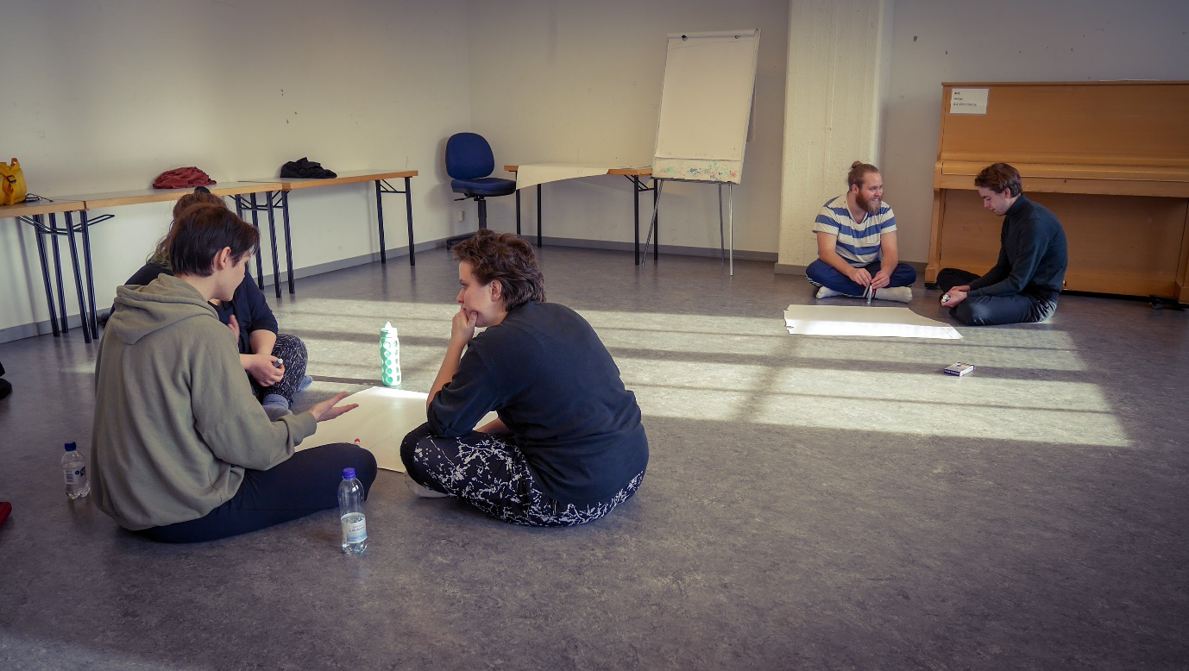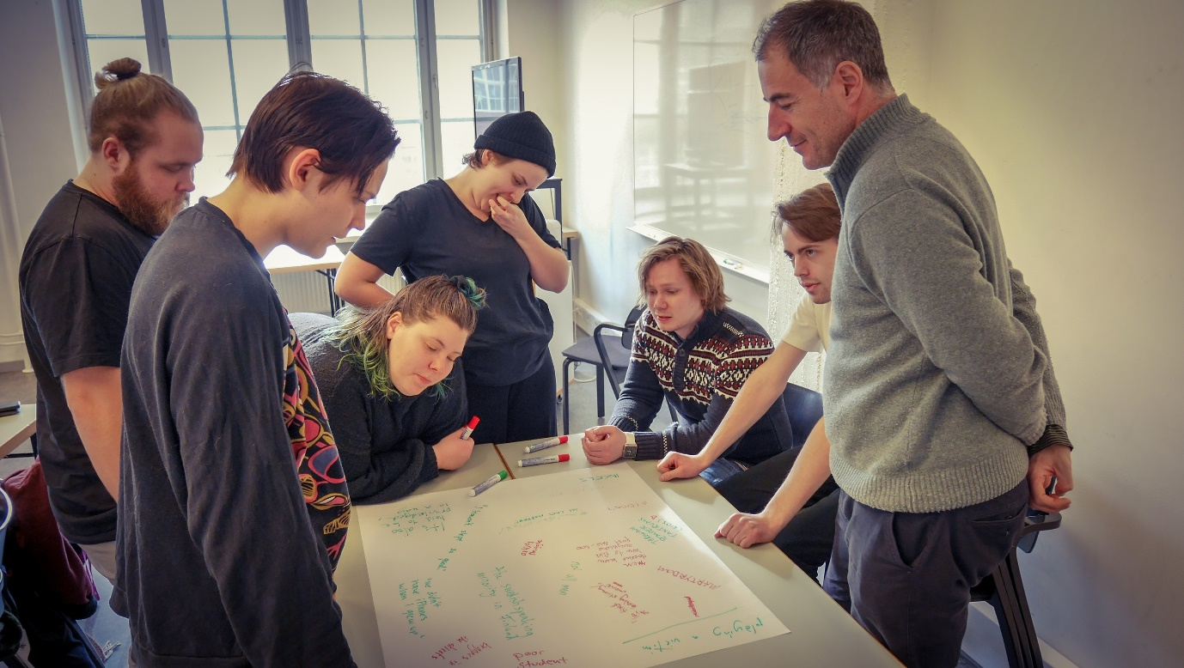

Physical acting work on the personal questions
Before the workshop began, each student had told his or her personal questions regarding acting, the personal issues to investigate as part of his or her own artistic research and process to develop acting skills. Davide then proposed that they would use short texts from a play Psychosis 4.48 by British playwright Sarah Kane to deal with the questions. The students had to memorize their texts before working with Davide one-on-one.
As a warm-up to the individual work, I led a few of physical training sessions for Week 1, using Viewpoints and Hino Method exercises. Both methods are good for improving bodily awareness with precision and focus. Davide also led a few, using exercises based in Lacoq technique to free up the physical impulses of the students. The pictures below are from Davide’s exercise called “Balloons,” where one has to constantly pop imaginary balloons with a specific part of your body as “the needle.”
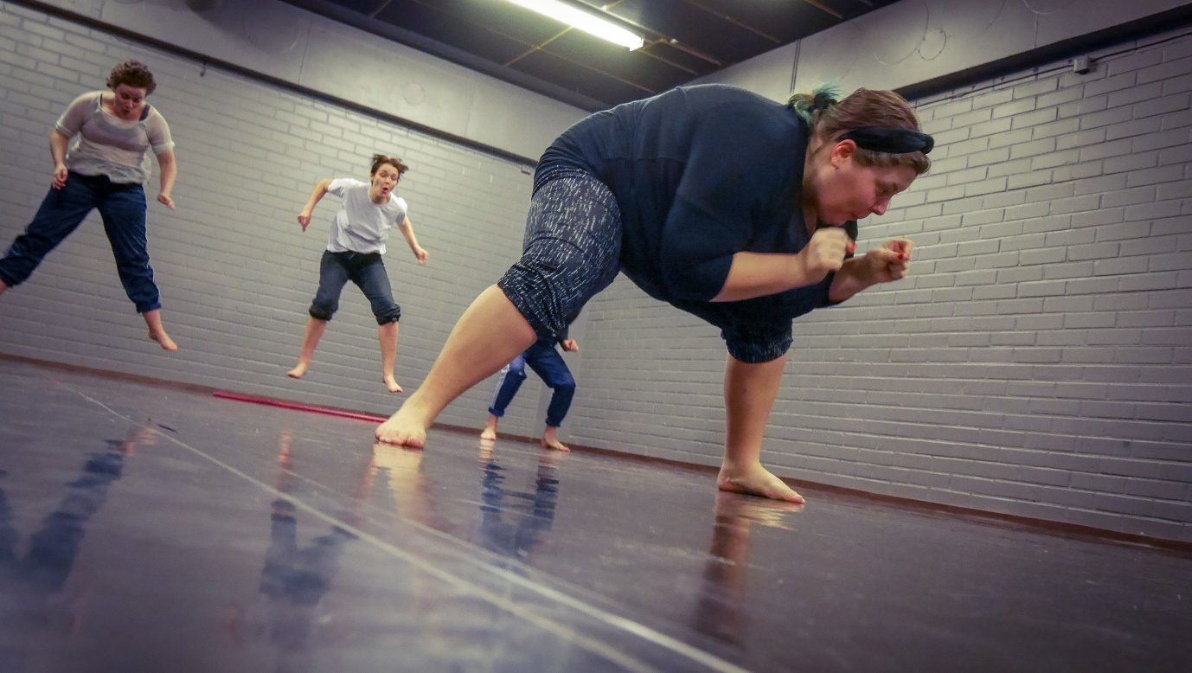
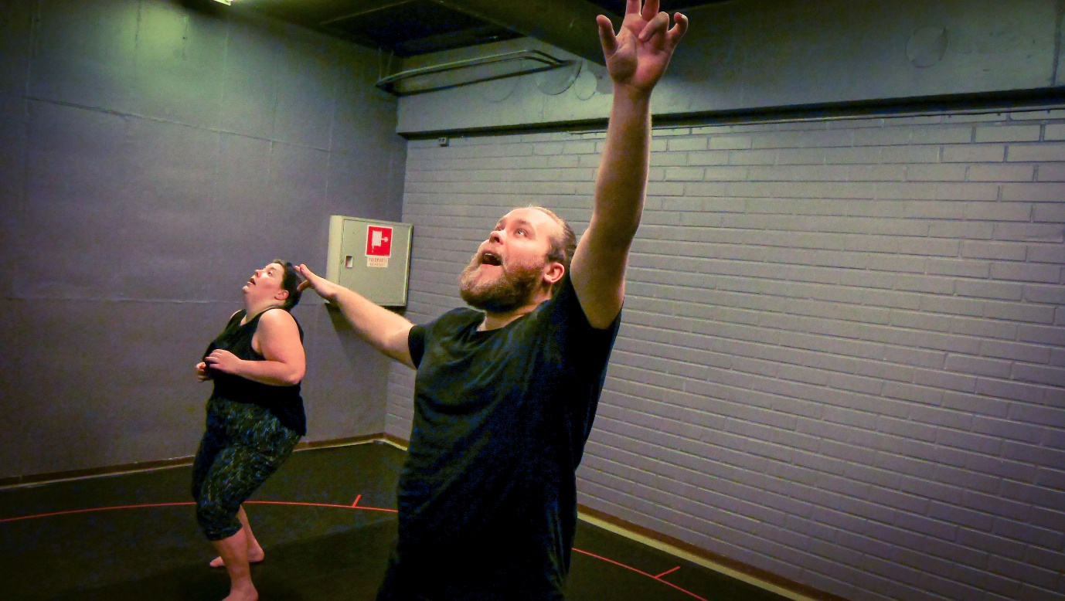

Once the bodies got a fair amount of work-out, the students were ready for the individual session with Davide. For Week 1 there were two students out of six who worked on their personal questions.
The first personal question had to do with control. How can an actor find freedom and let go of control? How can an actor overcome the voice of her inner “Is this good enough?”?
The second one was about being strong or vulnerable on the stage. Where can an actor draw strength from? What does it mean for an actor to be strong or vulnerable on the stage, how does it feel and look?
For each question, Davide set up a series of “experiments” for the student to try out. Other students were asked to observe the experiments like a scientist in a laboratory. Each student was assigned a specific category for observing such as the relationship between the actor’s body and the space, the communicability of text, the aliveness of the actor’s body, the quality of the actor’s voice, etc. This observation exercise is a reminiscence from the first workshop. Even though it is not a real scientific experiment, the non-judgmental attitude of a scientist toward the subject matter is a valuable skill to practice as an actor.
The experiments are about changing the physical conditions and circumstances of the actor in various stages. After each experiment, the students shared their observations. Little to no emphasis was put on the context of the text or the inner life of a character. Just by focusing on the physical aspects and variables in speaking the texts, the evaluation of the actor’s performance became less personal. In other words, the personal questions were dealt with in a relatively objective manner. But that did not mean that what the student experienced was unemotional. In fact, there were several moments of bravery, vulnerability and strength the students displayed during the experiments, which felt personal and emotional to me. It was yet another confirmation that the actor’s physicality is a tremendous resource and gateway to a rich inner life.
Here are some pictures from the experiments:
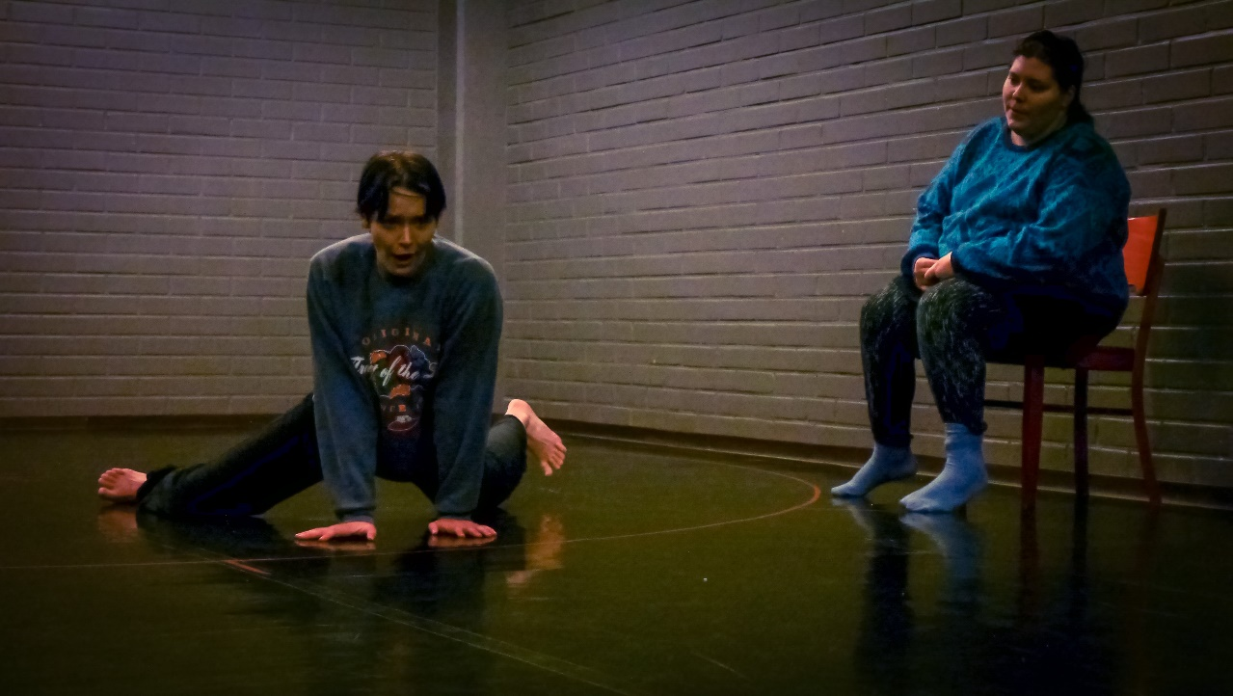
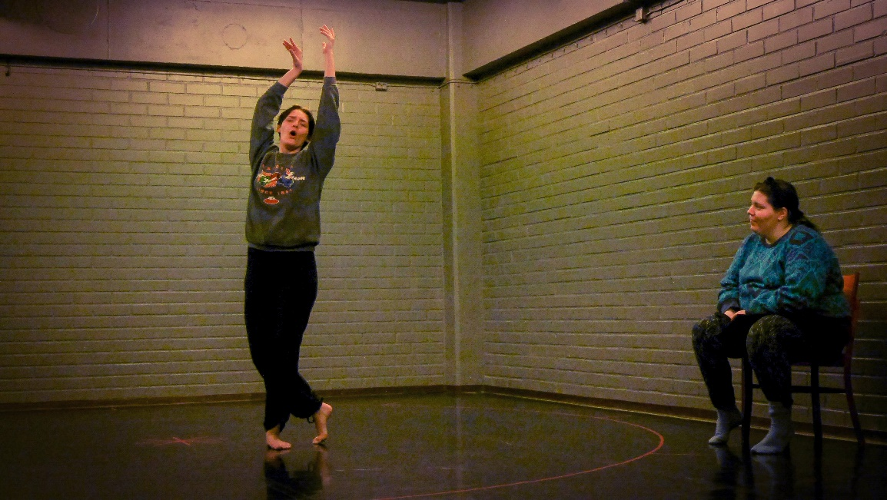
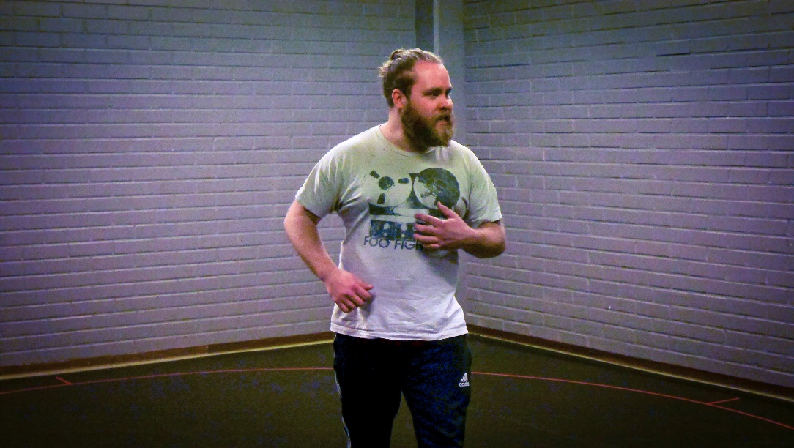
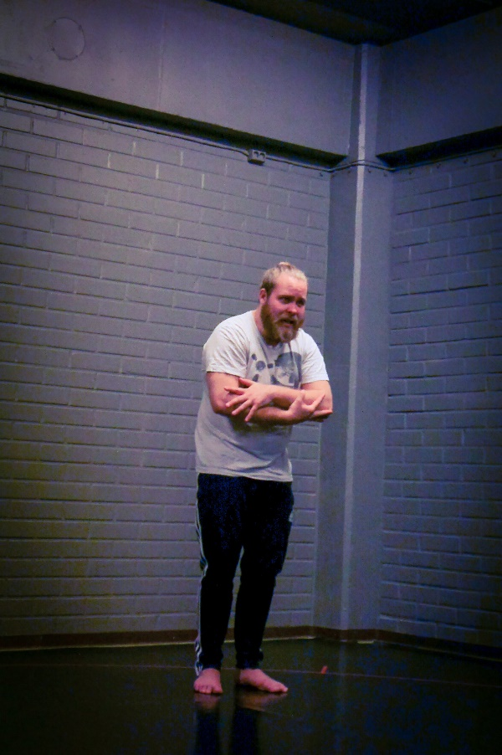

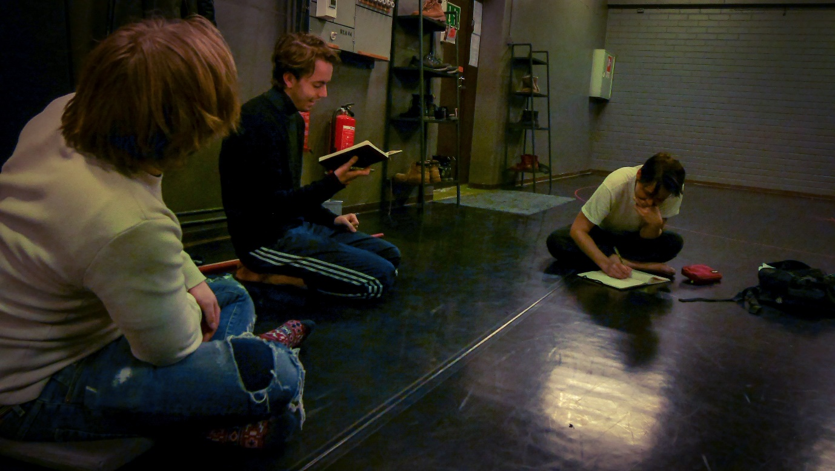

Theoretical framework on the theme of sacrifice and victim
Every day of the week, Davide set aside a time for theoretical research. He wanted to make sure that the students would gain a solid understanding of the theoretical framework he had built for the course. They would sit around the table, and Davide would read aloud the scholarly article he had written about sacrifice. It is a 50-page article synthesizing various theories and viewpoints to discuss the nature, variations, and functions of sacrifice in the human community and its relation to theatre. I’m not going to give any more details about the article since Davide is still working on it for publication.
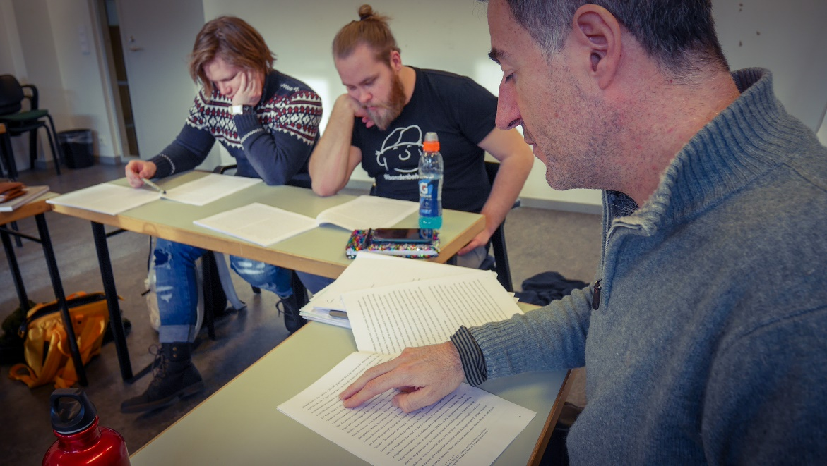
As they read on the article, the students asked many interesting, poignant questions to clarify Davide’s points of view and to express their views and interests.
The general consensus was that we should acknowledge that violence is a very complex subject with so many layers and nuances attached to it. Instead of resorting to moral or ethical judgment, we should observe it for what it is and try to see “what’s behind” violence, the bigger context that gives birth to violence.

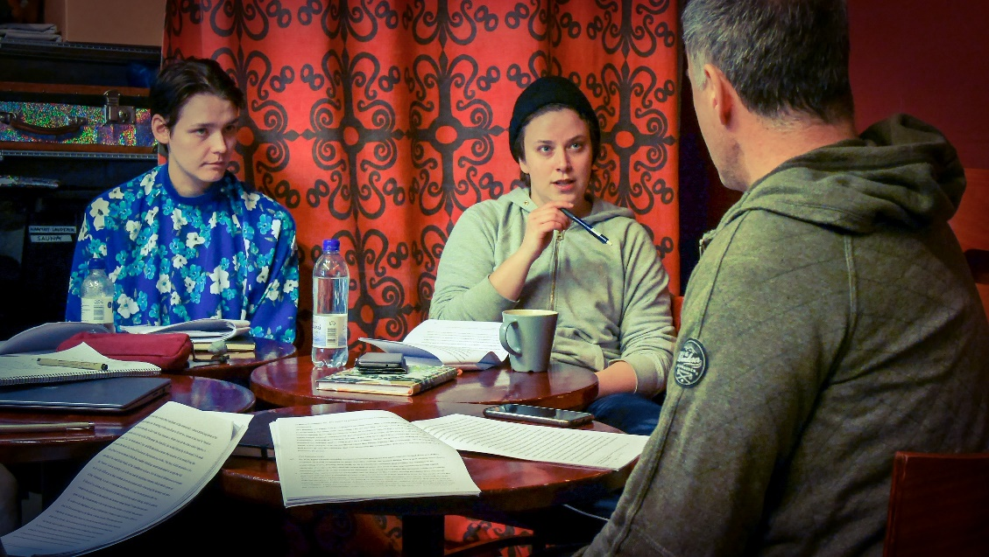

At the end of the week, with all the thinking and discussing violence, the students seemed overwhelmed with information.
“What is violence really?”
“Why are we trying to represent violence on stage? What’s the meaning?”
“Could we ever get out of violence?”
As much as it might feel confusing and daunting to have all those questions and no answer, uncertainty and mystery are a great start for a worthwhile journey, I think.
As a Bohemian-Austrian poet Rainer Maria Rilke said,
Be patient toward all that is unsolved in your heart and try to love the questions themselves, like locked rooms and like books that are now written in a very foreign tongue. Do not now seek the answers, which cannot be given you because you would not be able to live them. And the point is, to live everything. Live the questions now. Perhaps you will then gradually, without noticing it, live along some distant day into the answer. (from Letters to a Young Poet)

Onto the second week!

