Asking the right question
31.3.2019
by Yuko Takeda
The Week 3 of Imagination of Violence- atelier 2: Sacrifice and playing the victim is done. As always, the week was packed with a variety of things. Here are some highlights.
Academic research on sacrifice
Davide wanted to return to his article on sacrifice. This time was not about understanding his theoretical framework by reading it aloud. As one of the three assignments from the previous week, he had asked each to come up with two questions regarding his article. One should be for Davide to clarify or expand his ideas, and the other one is for the student to formulate his or her own interest about sacrifice for further research. Some of them were interested in the sacrifice of the actor on the stage, others, in the animality/excess of sacrifice, “perverse sacrifice” (explained by Davide as sacrificing his or her life as a form of exchange between for the elevation of the self), the nature of violence, the power structures in sacrifice, etc.
Davide listened to all their questions, occasionally asking them to clarify or specify their points. The scope of the possible research they’d have to do to pursue their interests seemed rather overwhelming. Davide gave a little allegory for encouragement. “An astronomer friend of mine has said to me, ‘You know that there are countless stars in the sky. How do you study them? All you need to do is to ask the right question,’ and then you’ll start to see patterns and frames to understand something.”
After they formulated their research questions, Davide asked them to think about how they would study or investigate the questions. In other words, he asked them to come up with the research methods or the research plan. There are many ways to research: making social experiments and performances, conducting interviews, looking into existing theories and comparing them, reflecting on one’s own experience, etc. etc. At this point in the course, whether their research methods are doable or not is insignificant. The most important is to practice thinking and questioning as a researcher.
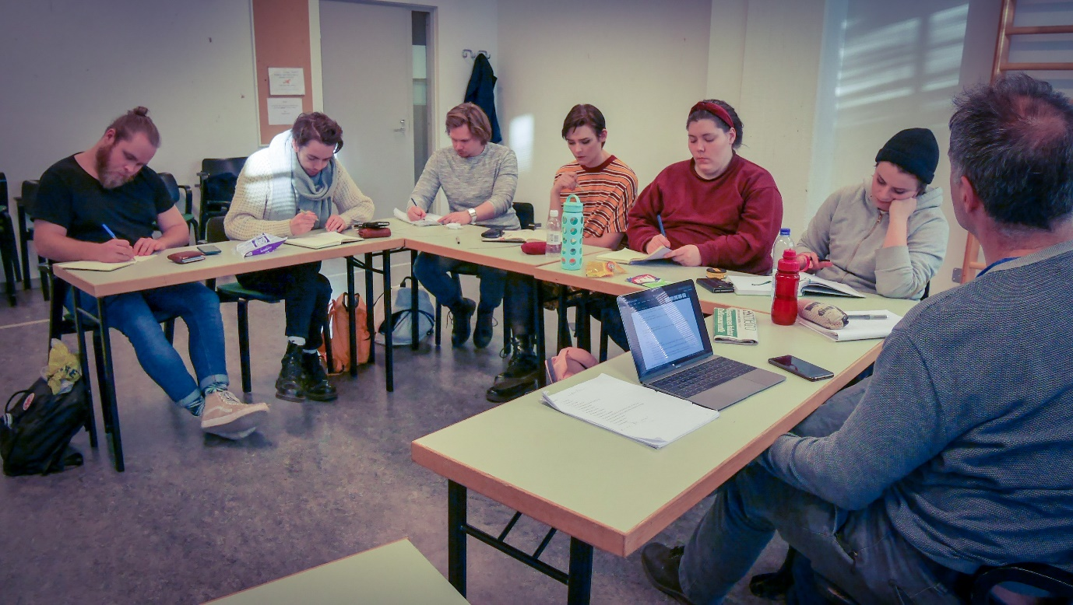

Personal questions about acting
Speaking of questions, Davide continued working with the students on their personal questions/challenges about acting. He kept the setup of “a scientific experiment” with a group of students (the scientists) observing one student (the subject). For Week 3, there were two students who explored their questions. One was about limits, and the other one was about shame and vulnerability. To explore limits, Davide asked the student to go through several exercises of various physical and mental intensities such as small action, extreme action, small actions with the thought of extreme action, normal action with the thought of small action, etc. What emerges in each?
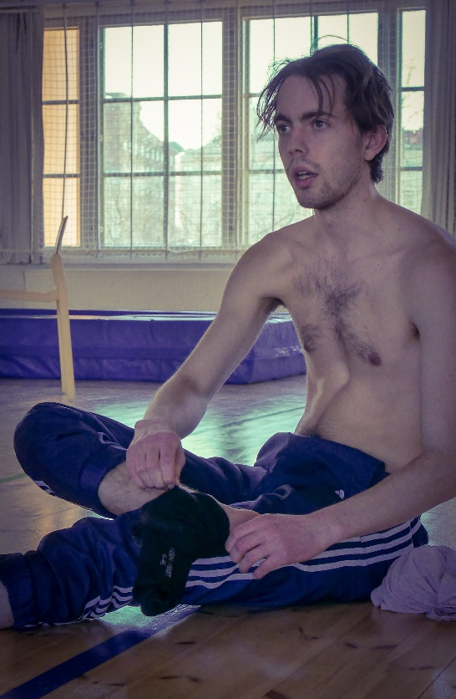
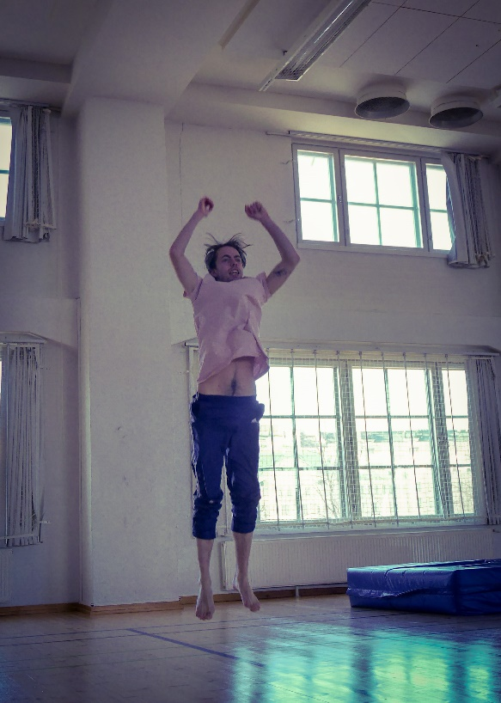

For the second student, Davide created a series of exercises where layers of physicality, space, situation and emotion were added one after the other to play around the notion of shame and being vulnerable on the stage. What changes from just standing in front of the audience to moving like an angry cat in a forest, chasing a mouse or vice versa?
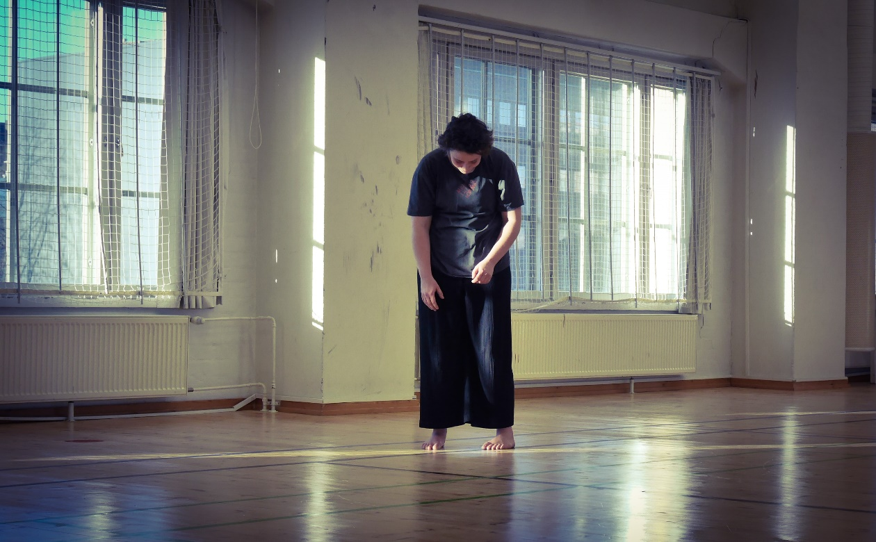
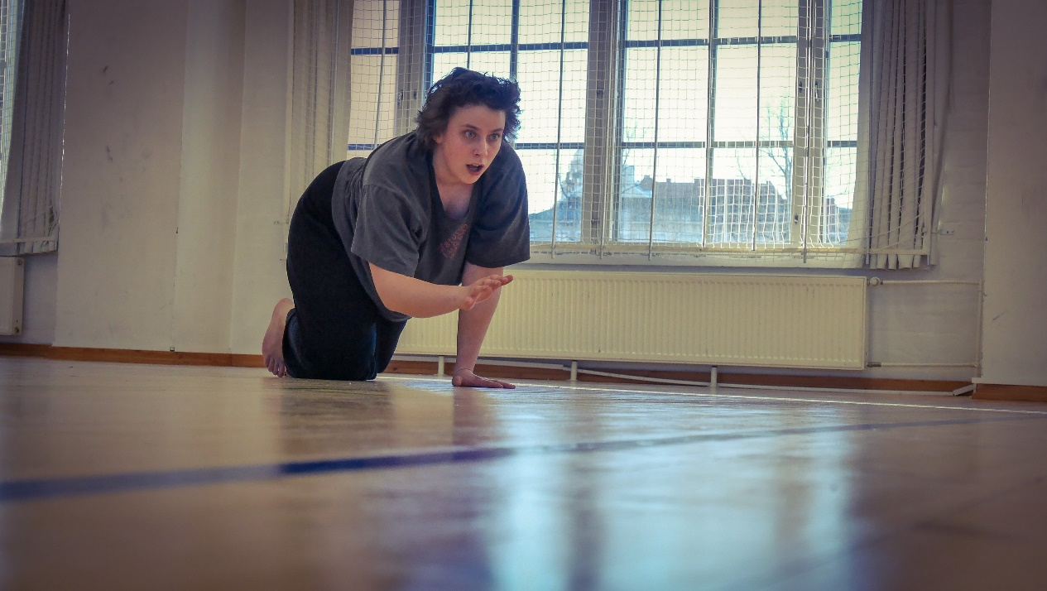

After the experiments, the observing students took several minutes to synthesize their observations and formulate their hypotheses.
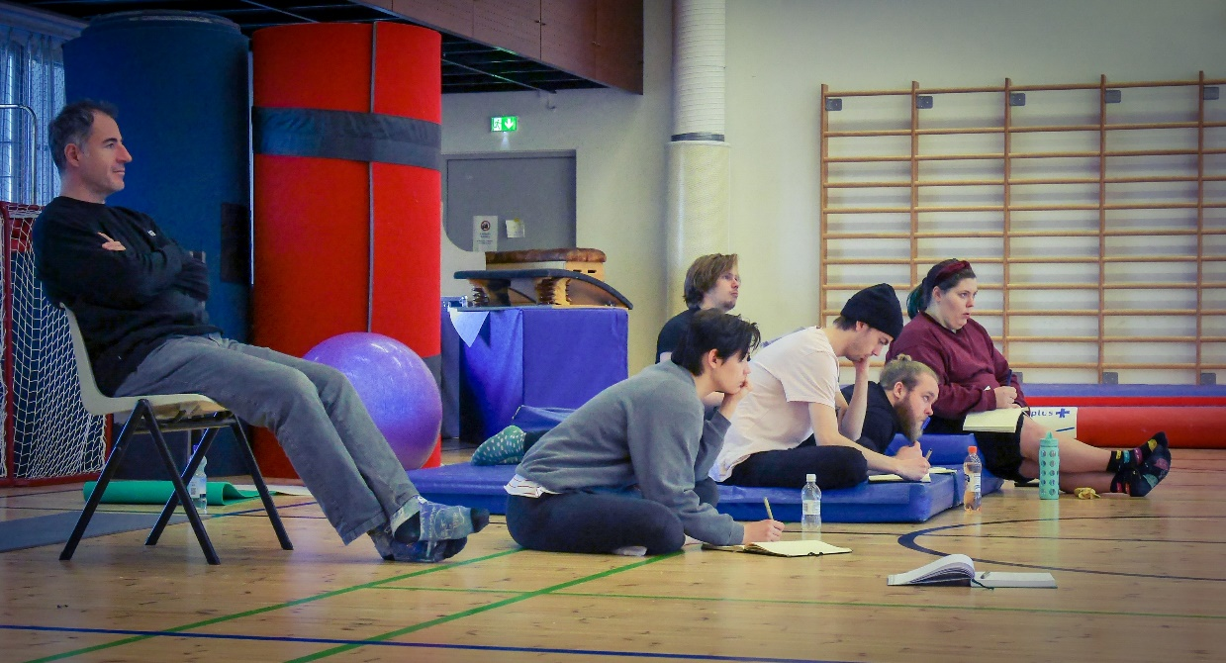
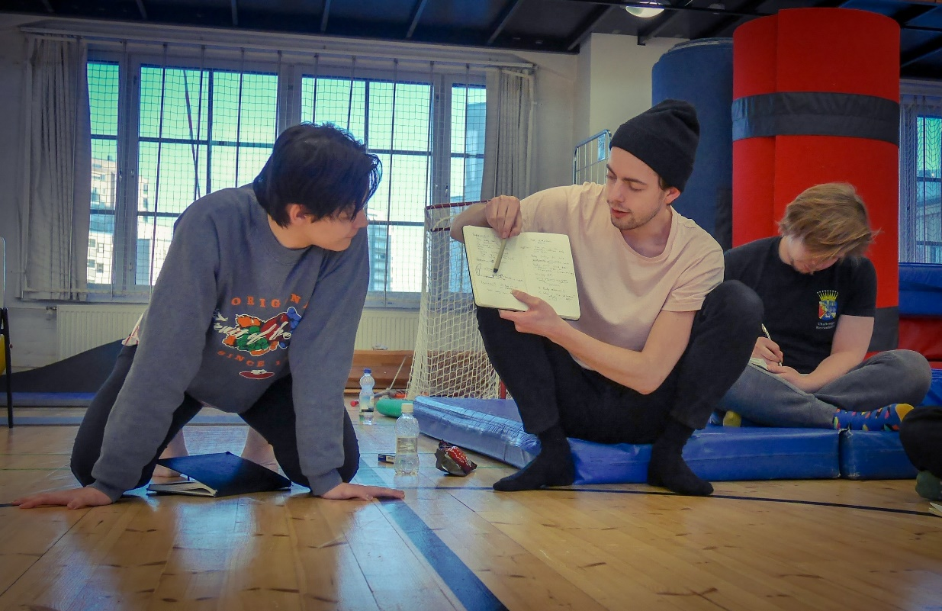
Then, one day Davide conducted a series of exercises to explore one of the students’ hypotheses about the controlled and uncontrolled movement. One student volunteered to do the exercises while others observed.
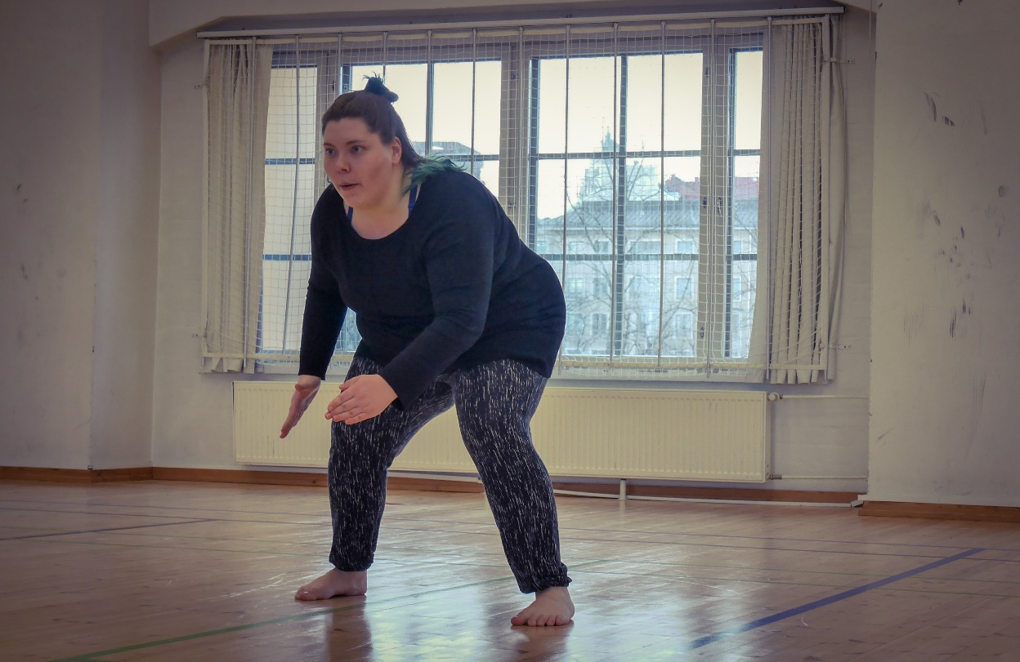
Afterwards, they discussed what they saw, trying to theorize it somehow. With very creative, inspiring names to describe their ideas, they seemed stimulated and enthusiastic. Davide cautioned them by telling them to not fall into the trap of a word game and to focus more on creating exercises to explore the questions.
Some of the hypotheses, nonetheless, seemed to contain potential for further experimentation. So, Davide asked them to formulate a new set of questions based on the hypotheses and experiments. They will continue developing them as the course progresses.
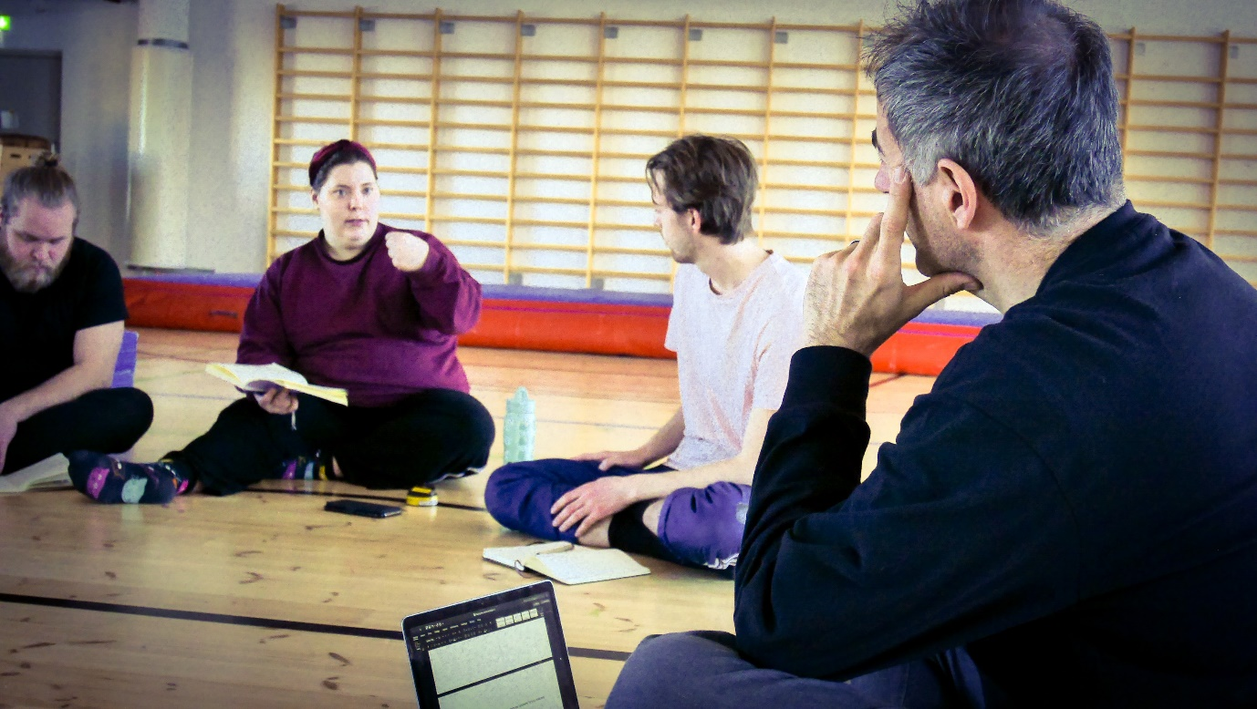

News stories about sacrifice
Another interesting event of the week was creating scenes based on or inspired by the news stories. As one of the three assignments from last week, the students had collected stories from the media about self-sacrifice, playing the victim and/or collective sacrifice (scapegoat) in our everyday life. They were divided into three pairs to look for them together. They also had to divide each story into three moments or scenes.
The stories they had brought in for sharing were ranging from pop culture icon Britney Spears’ 2007 breakdown to Finnish politician Teuvo Hakkarainen’s sexual assault scandal.
After hearing all the stories, Davide said that as a first try-out to explore what it means to perform sacrifice, they should start with the Britney Spears’ story. He asked them to work in the same pairs and assigned each pair a scene from the story. There were three:
1. When Britney enters a barbershop and askes a hairdresser to shave Britney’s head. The hairdresser refuses, so Britney shaves her own head.
2. The media mercilessly criticizes and mocks Britney
3. Britney’s letter to tell her side of the story
The point is not to “reenact” those moments, but to re-imagine them to uncover layers and nuances of sacrifice. Each pair got a little bit of guidance from Davide as to how to approach their scene.
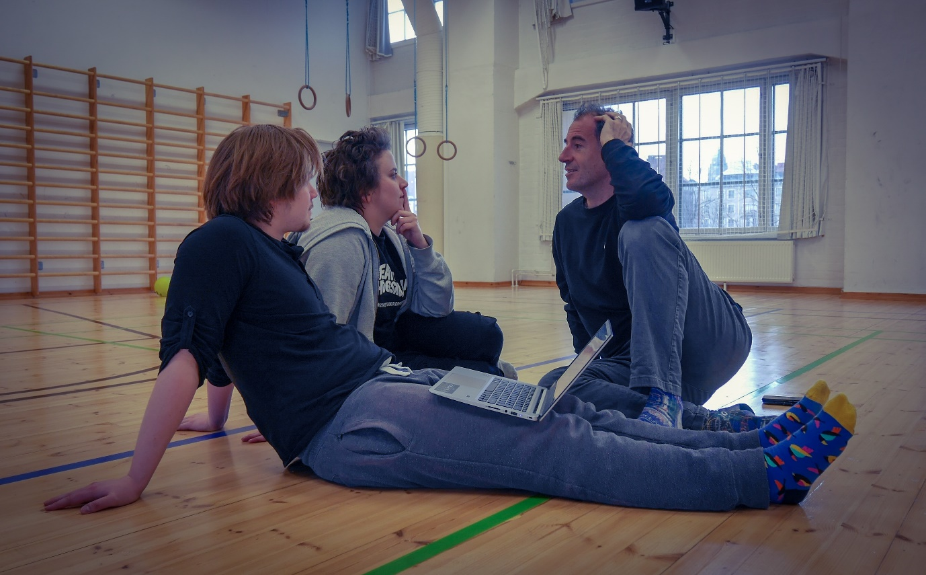
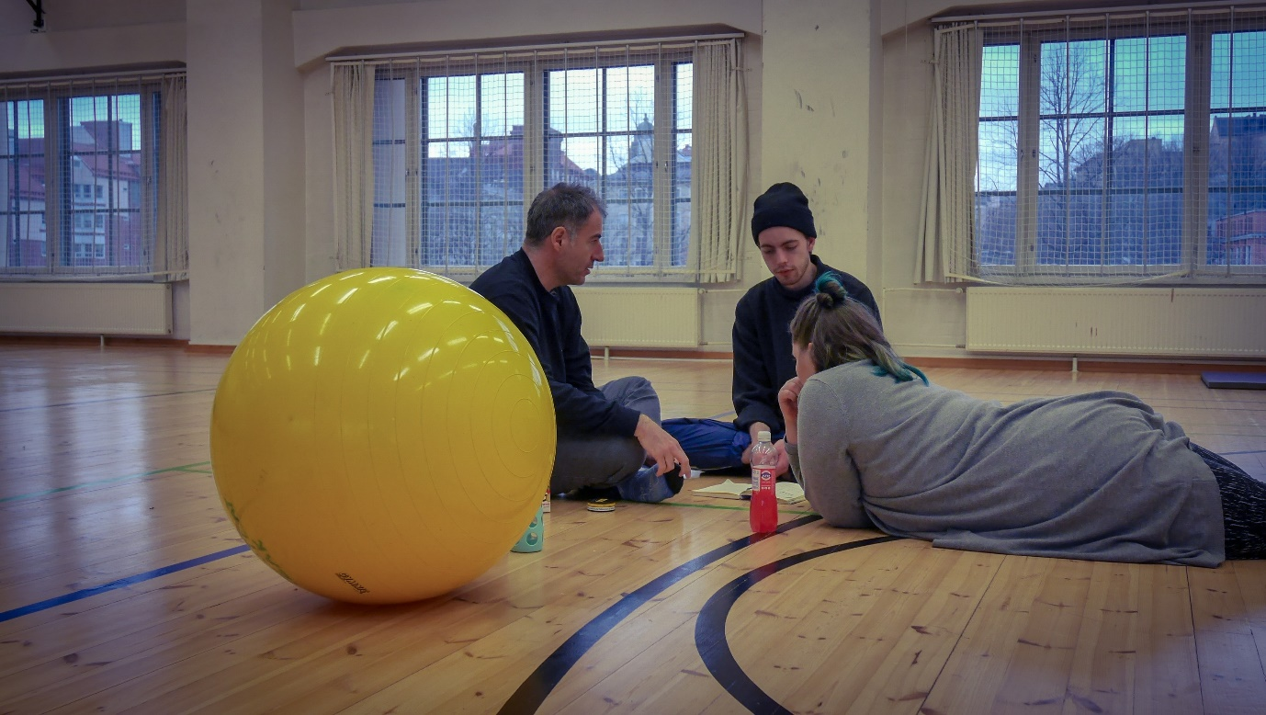
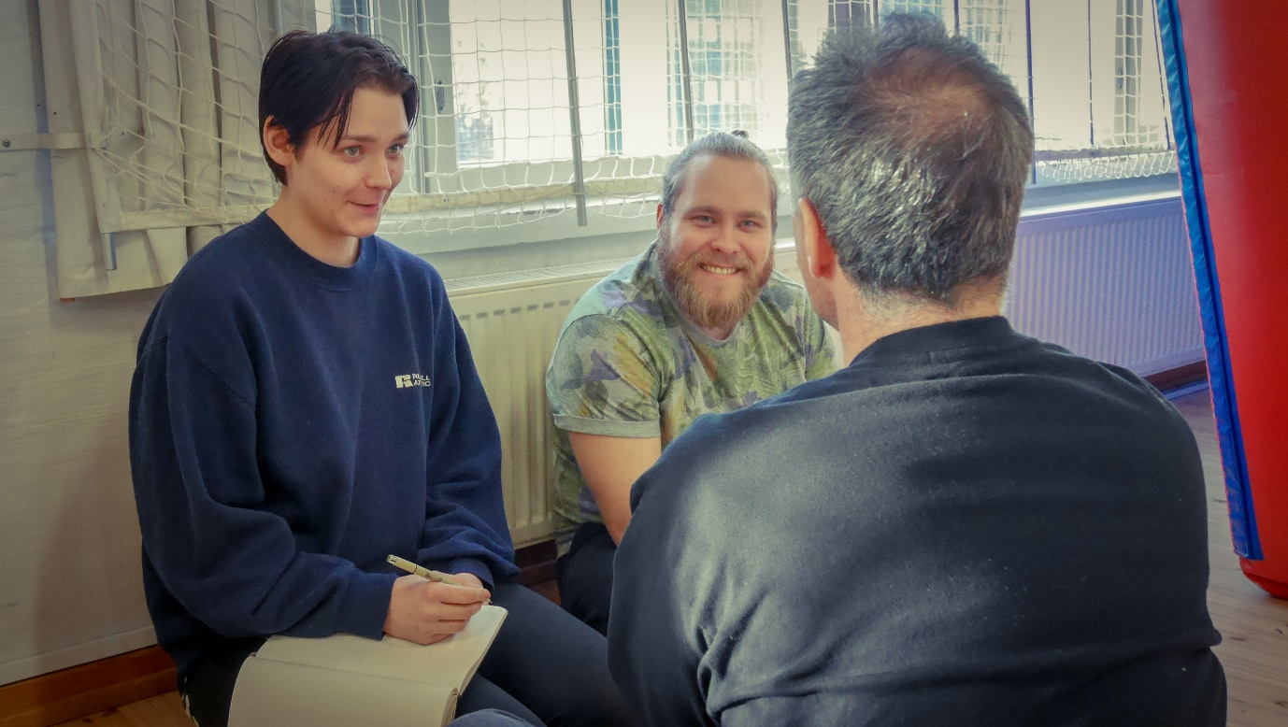
Then they took some time to rehearse their scenes and presented them. They did this exercise twice for this week. They performed the same scenes, but with different angles and emphases as to who’s the victim and what kind of sacrifice is done between the first time and the second time. It was interesting and revealing to see those different angles for each scene.

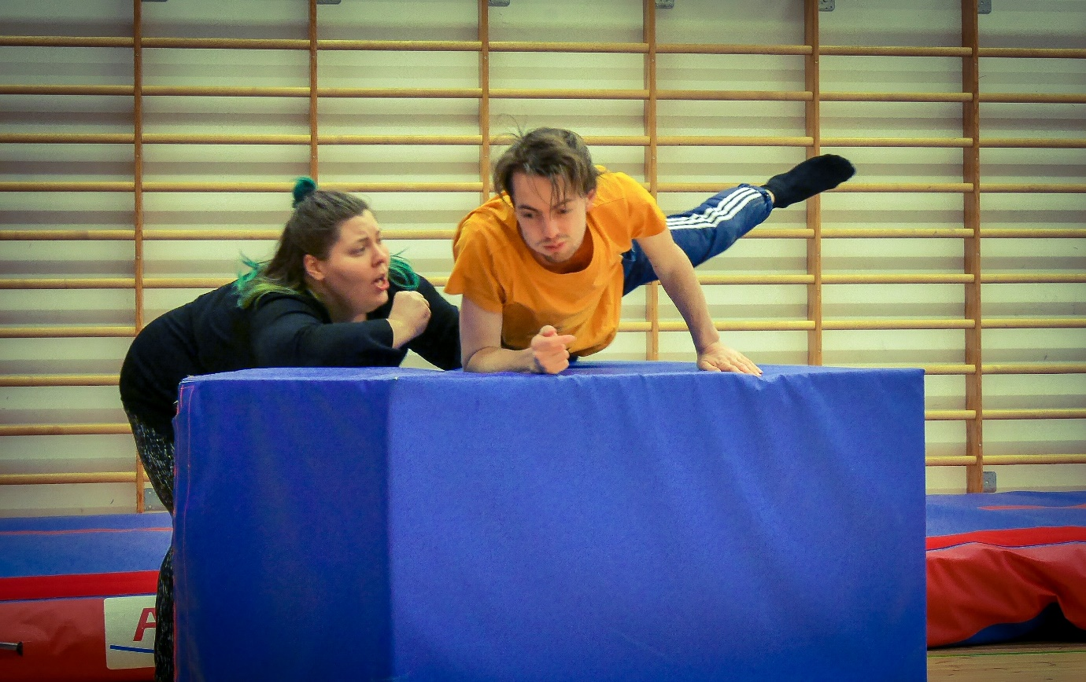
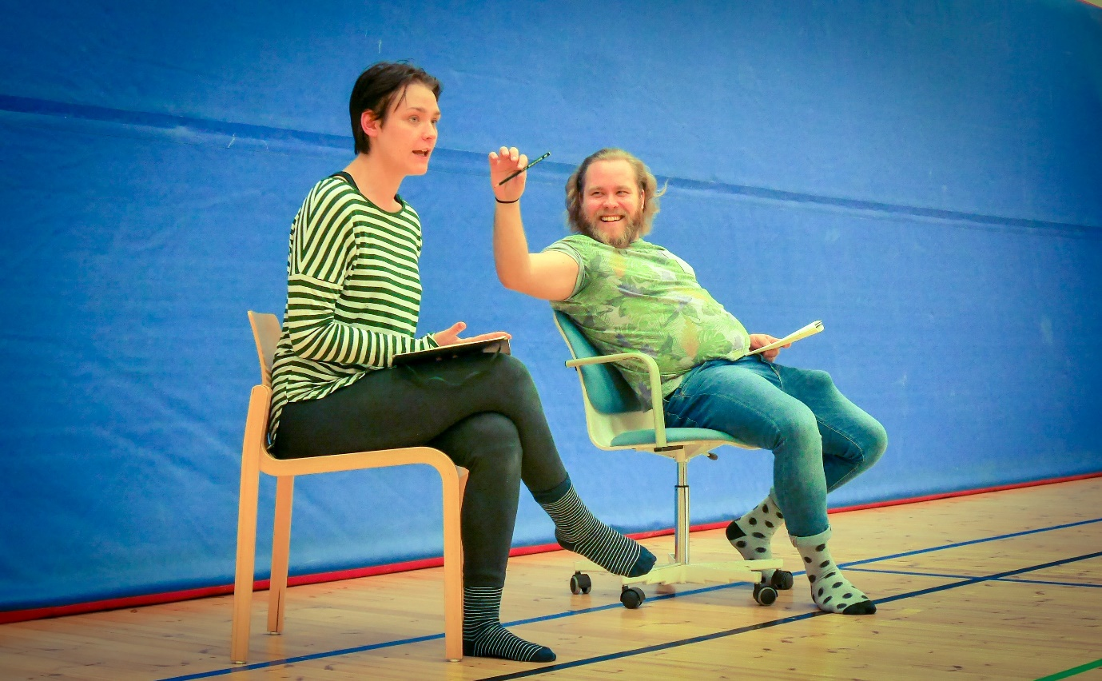
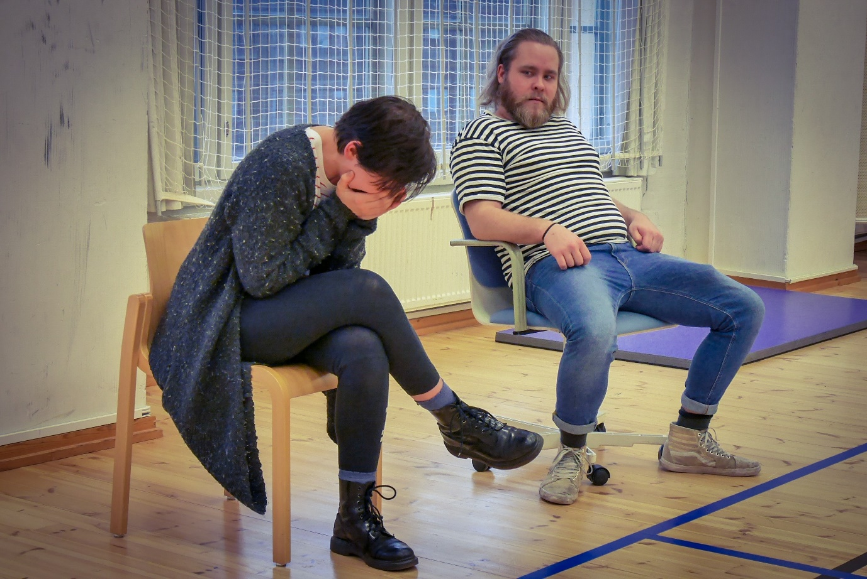
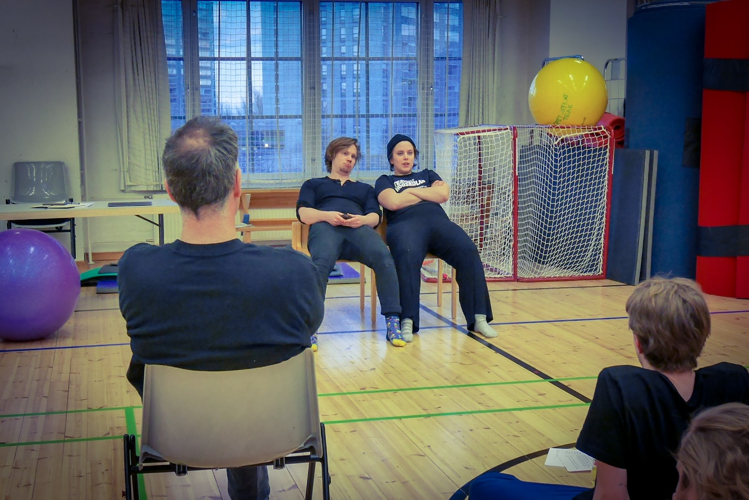

Writing personal monologues
The students started to work on their personal monologues this week. They already had written some initial texts. Davide asked them to try to somehow incorporate the circumstantial elements of the news stories and the Sarah Kane’s 4.48 Psychosis texts they’d used for the personal question exploration into their monologues. He gave them about an hour to re-write their texts one day.
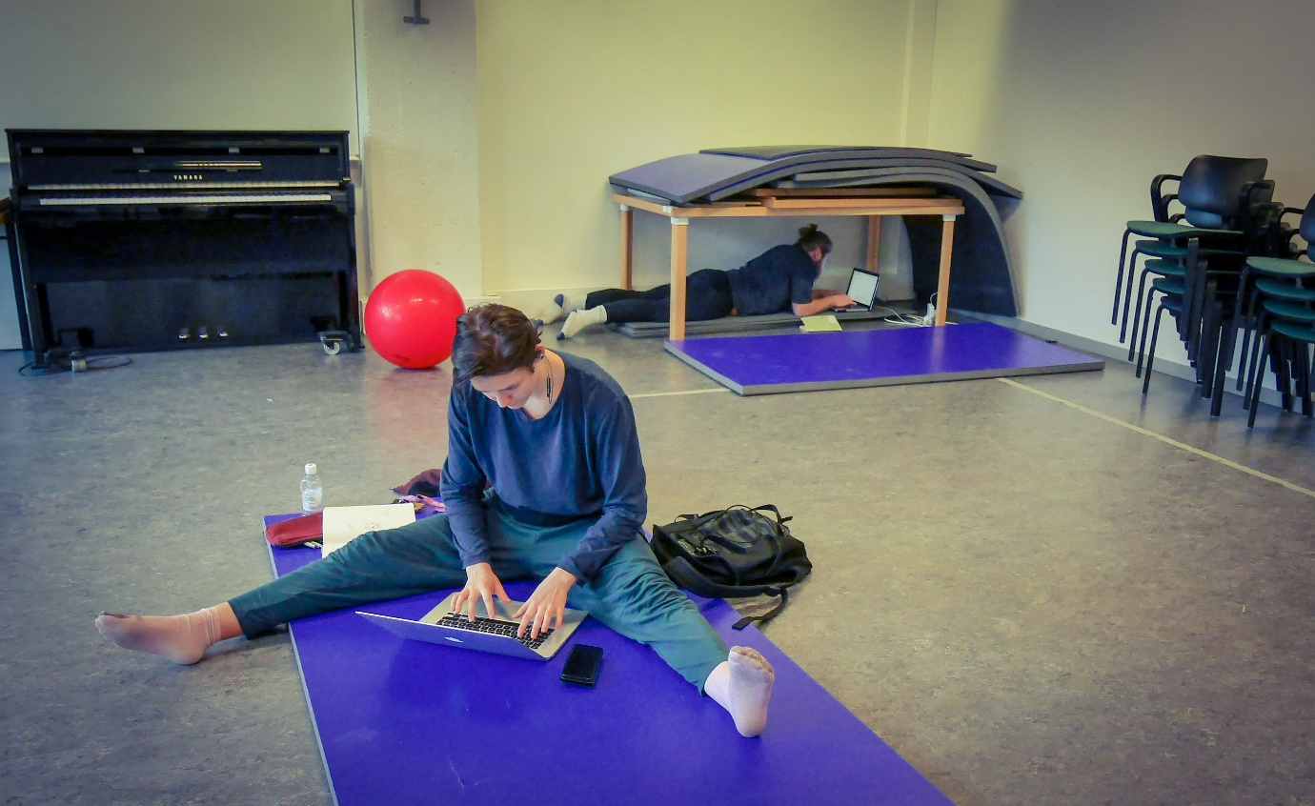
And they shared what they’d written with Davide. He gave them feedback for further re-writes.
This personal monologue work will be one of the main focuses in the latter half of the course.

Lecture on Violence
Janne Salminen, a doctoral candidate from Department of World Cultures (North American Studies) at University of Helsinki, paid a visit one day to give the students a lecture about violence and masculinity in the North American films. He gave fascinating examples of how masculinity and violence in film shaped and got shaped by the social and political climate of each era in the United States. For example, in the 70s, “Death Wish (1974)” implies that the society, especially the urban area was dangerous, and that violence was treated as a moral necessity to survive. On the other hand, in the 80s, when the conservative agenda was strongly present for Reagan Revolution, movies like “Rambo (1985),” starring Silvester Stallone and “Command (1985),” starring Arnold Schwarzenegger, flourished as if displaying a muscular physique and violence was justified and glorified for defending the country from national enemies. Janne went on to give more examples and concepts to explain the evolution of masculinity in the Hollywood films in the 90s and onward. The students were listening intently and asked Janne a lot of questions afterwards.

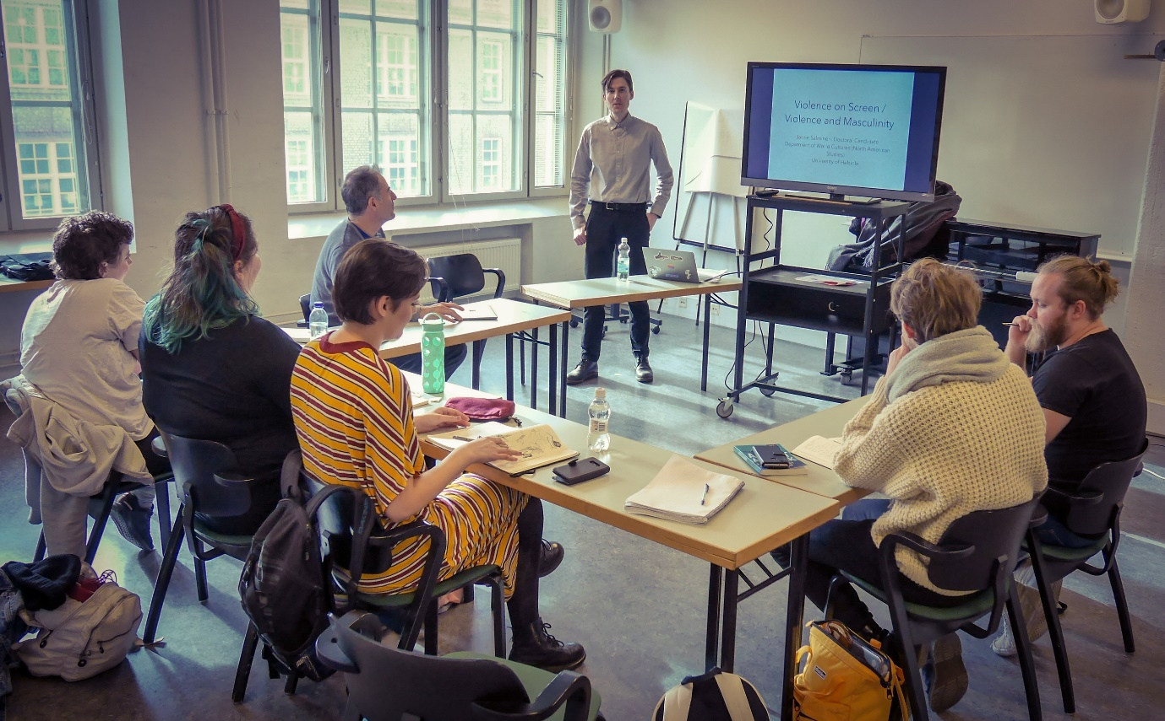
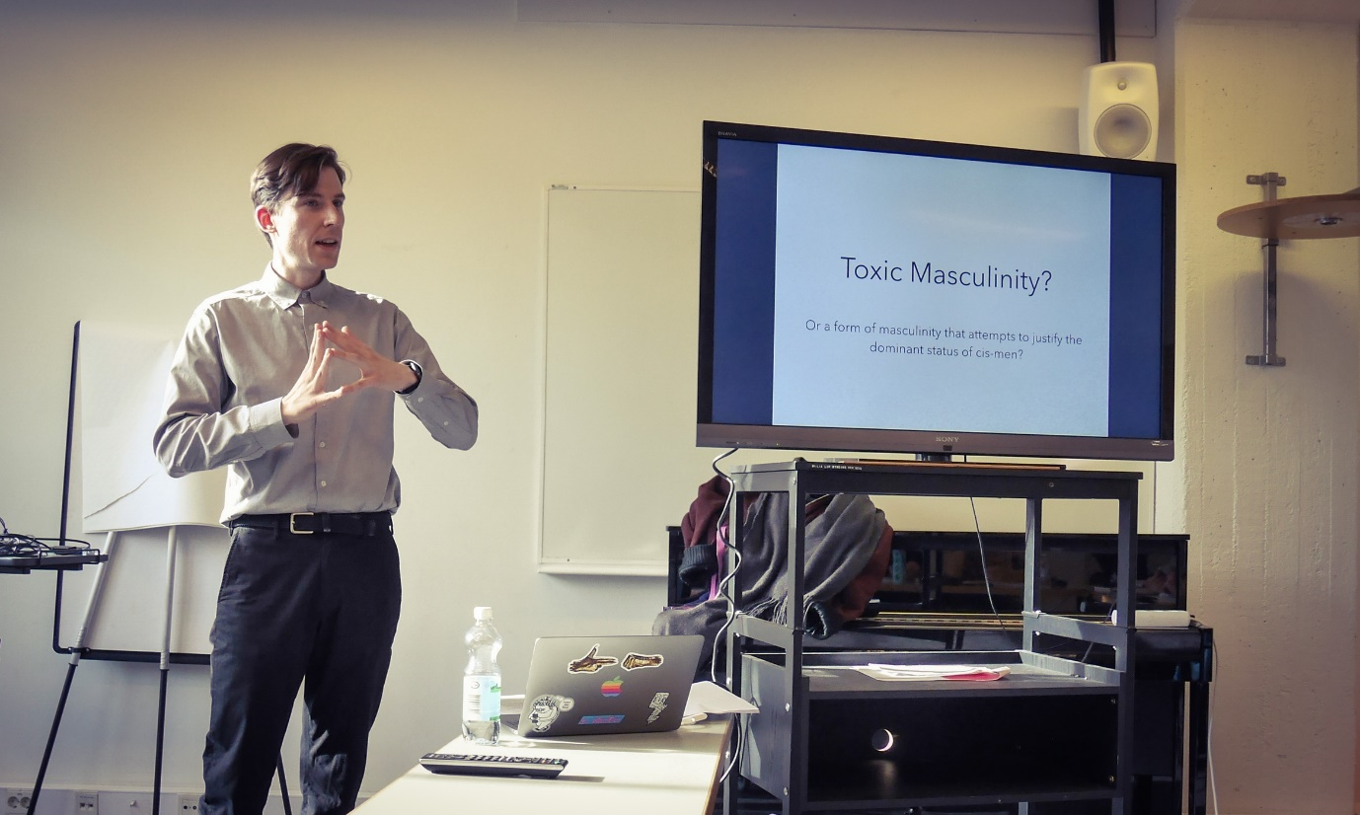

Physical training
I led a short physical training session almost every day this week before Davide’s curriculum. The focus was on how to be together and speak together. Consequently, I had the students do a lot of pair-work and collective movement and speaking exercises from Hino Method and Viewpoints. Whether it’s speaking or moving, in order to be present with others, one needs to listen with their entire being. The stillness generated from that kind of listening is so intense and so purifying.

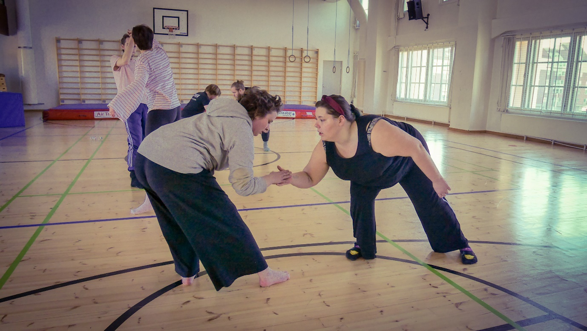
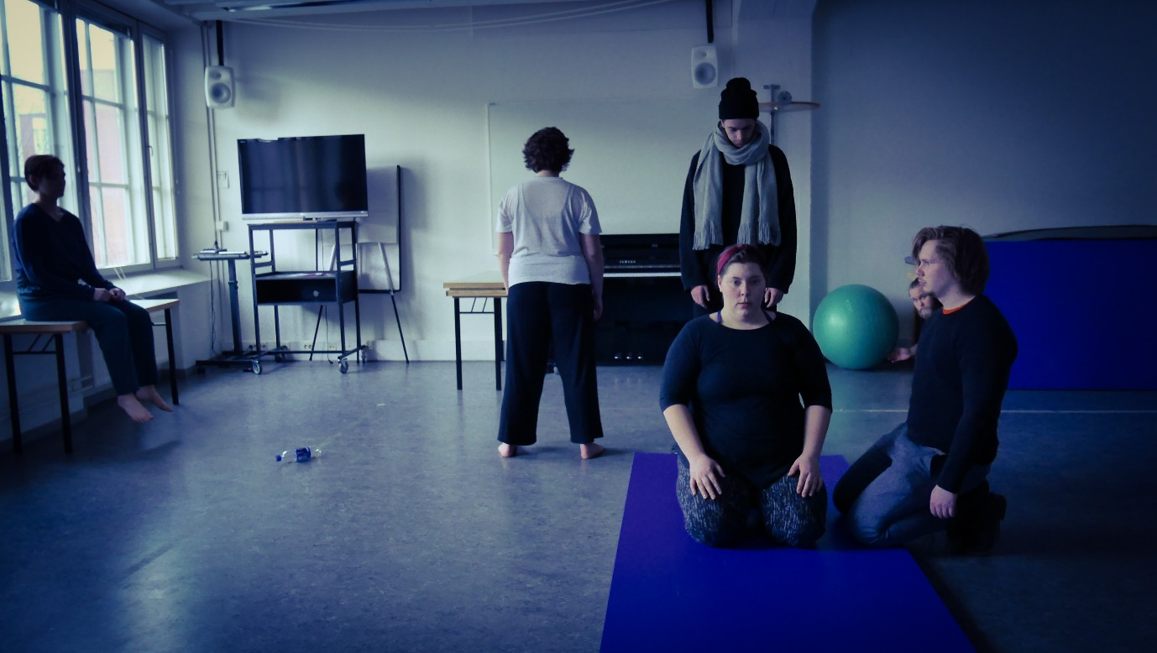

Good work!

