The only one, but not alone
22.4.2019
written by Yuko Takeda
The week 6 of the Imagination of Violence- atelier2: Sacrifice and Playing the Victim was shorter due to the Easter holidays. Nonetheless it was filled with intense acting work, writing and research for the students. It also sparked a few moments of deep reflection on the actor in theatre in my mind.
All in all, all the past weeks of searching, getting lost, questioning and exploring seemed to point at a sliver of light in the darkness, metaphorically speaking. At least the process has illuminated a part of the deeper, hidden issues and challenges for each of us as an artist.
Here are some highlights.

- Personal monologues
The main goal of the week was to finish up the text for the personal monologue and decide on a general direction and circumstances. Since each student was at a different phase of the monologue development, Davide worked with them on a case-by-case basis.
One student was struggling with structuring his personal text. So, Davide sat down at a desk with him to suggest some edits. Then they also discussed a possible context in which he could perform his text. By the end of the week, his text evolved into a cleverly crafted, discreetly unsettling meta-text about an aspiring actor in search for true artistry.
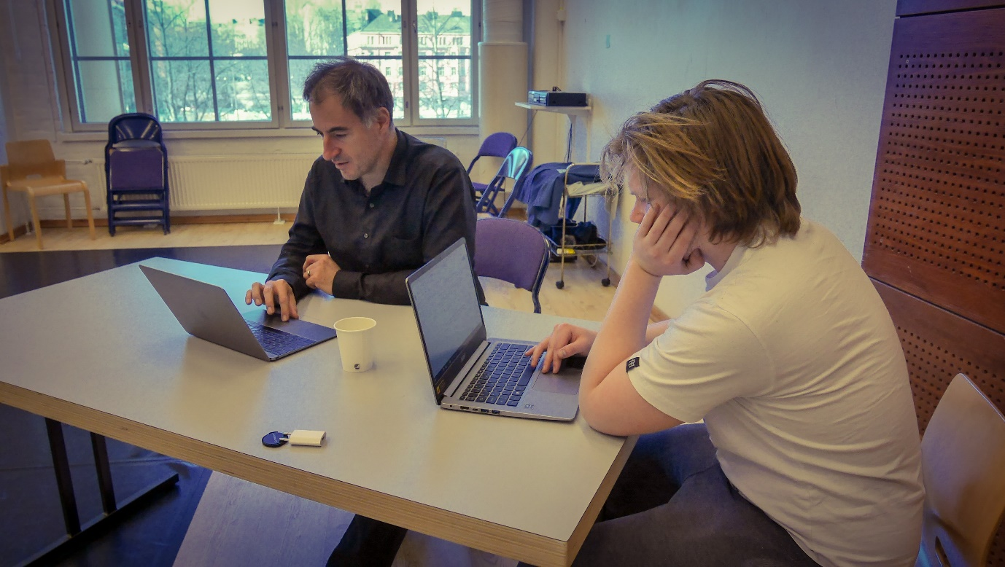
Another student was wanting to search possible frameworks or given circumstances for her monologue. She was keen on the exploration part of her acting work and what it could mean for her as artistic research, free from the constriction of having to find “the right way” to do her monologue for the presentation. After trying out several circumstances suggested by Davide, she proposed a new idea to try out for the next week.
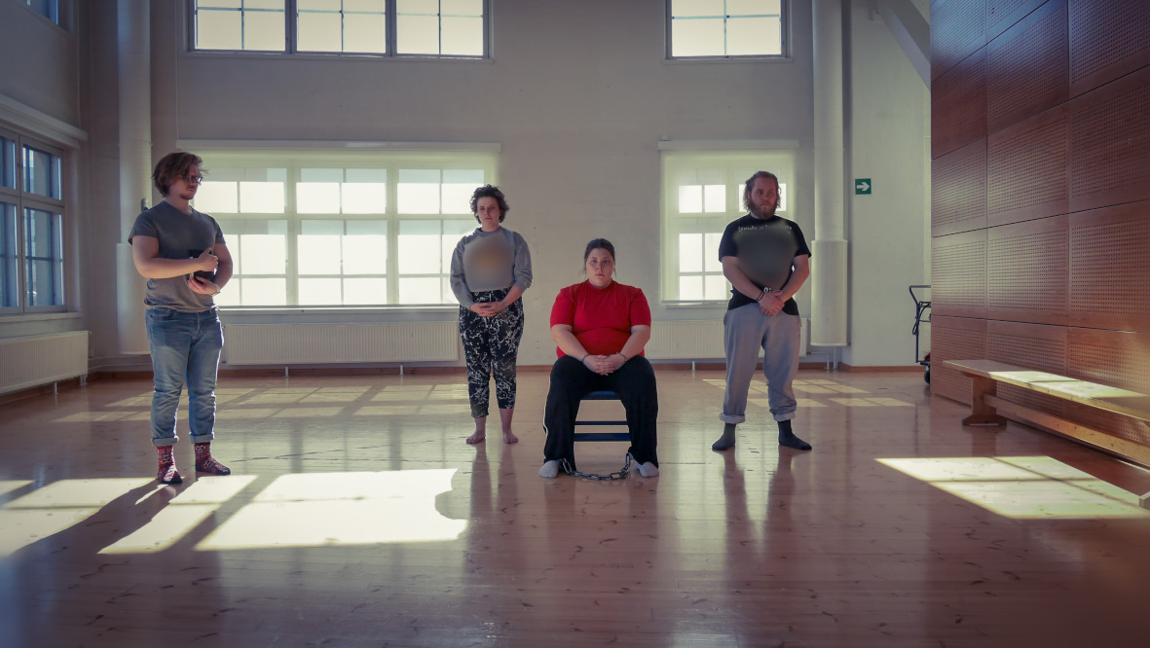
Other students were working on the specifics of their acting in their monologues such as transitions, emotional dynamics, physical actions, etc. Davide provided them with a possible action or thought they could incorporate to see how they felt doing them. Afterwards Davide would also give them feedback on how he interpreted it as the audience. The process repeated until both felt sold and good about what’s happening on the stage.
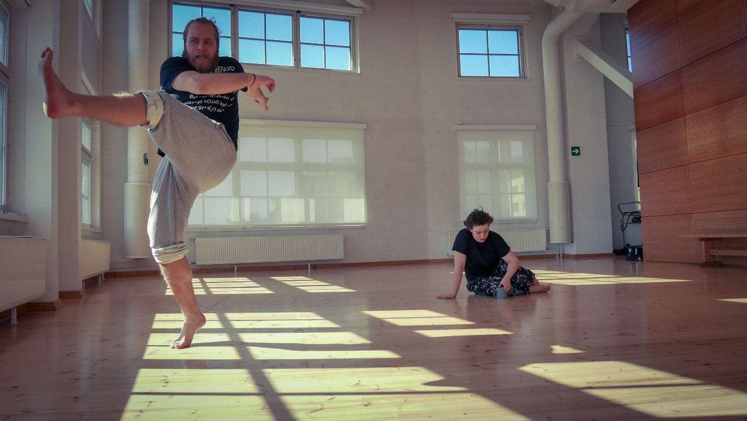
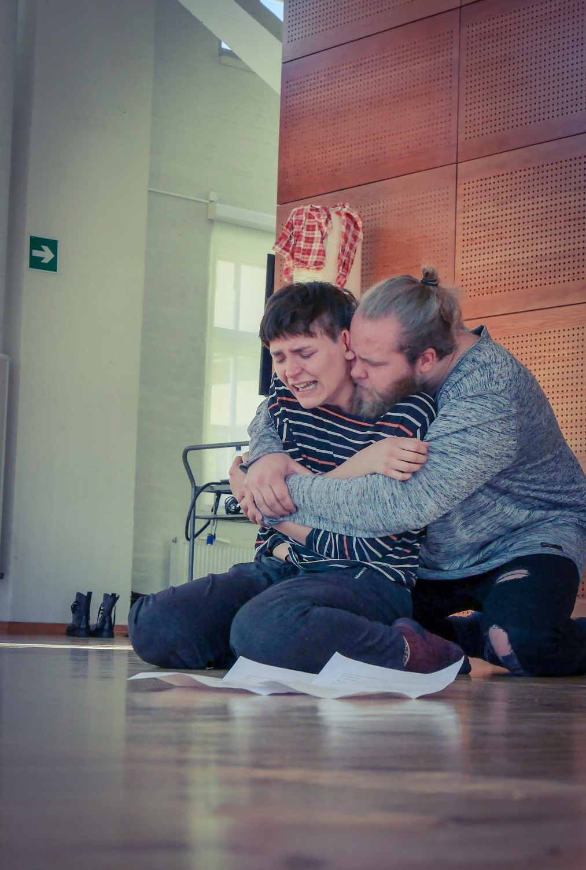
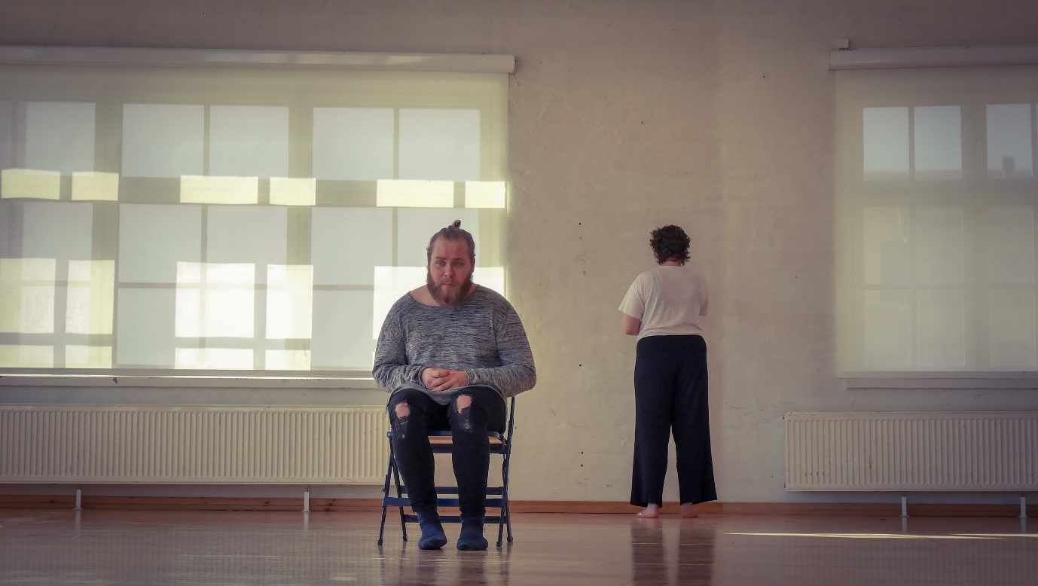

- Experiments on acting
To continue from the last week, Davide suggested a follow-up experimentation inspired by the students’ hypotheses. They had been drawn from their experiments to explore their individual questions regarding acting. This week’s theme was the audience’s projections, how the imagination of the audience is activated. Davide let a student choose one of the five different topics: pauses (different kinds of pauses in speaking the text), suggested and follow-up space (the space is suggested by sound, and the actor has to either comply with the soundscape or go against it), articulated small physical action, imaginary space (how the actor imagines the space), and inner friction/strong inner life. Those topics were directly coming from the students’ experimentations from the previous weeks.
Davide then asked each student to come up with a few variations of the topic of his or her choice and present them for the rest of the class. Those who were observing would make note as to what kind of association or impression they get as the audience.
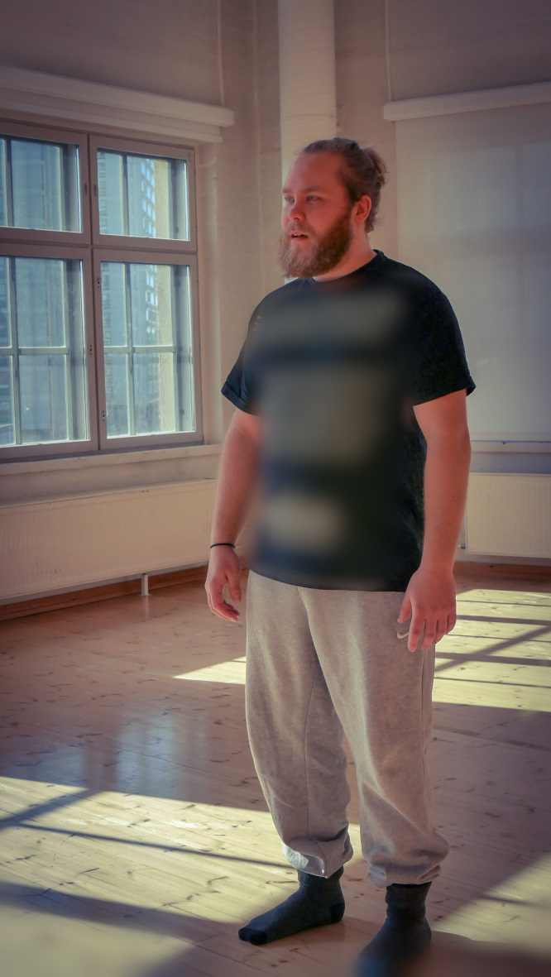
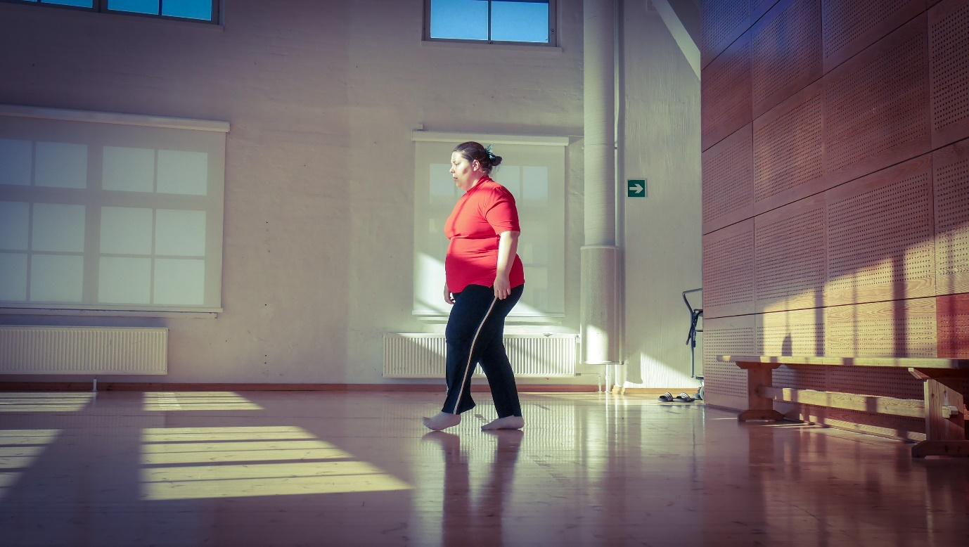

Afterwards they shared their impressions with others. It has been very interesting got witness how the students’ abstract questions about acting, such as vulnerability, shame, control and limit, have taken shape as specific spatial and physical experiments and observations.

- Academic research
The students continued their research regarding violence, sacrifice and playing the victim as pairs this week.
One pair conducted a BDSM-inspired performative experiment to explore the mechanism and effects of consensual violence on the stage.
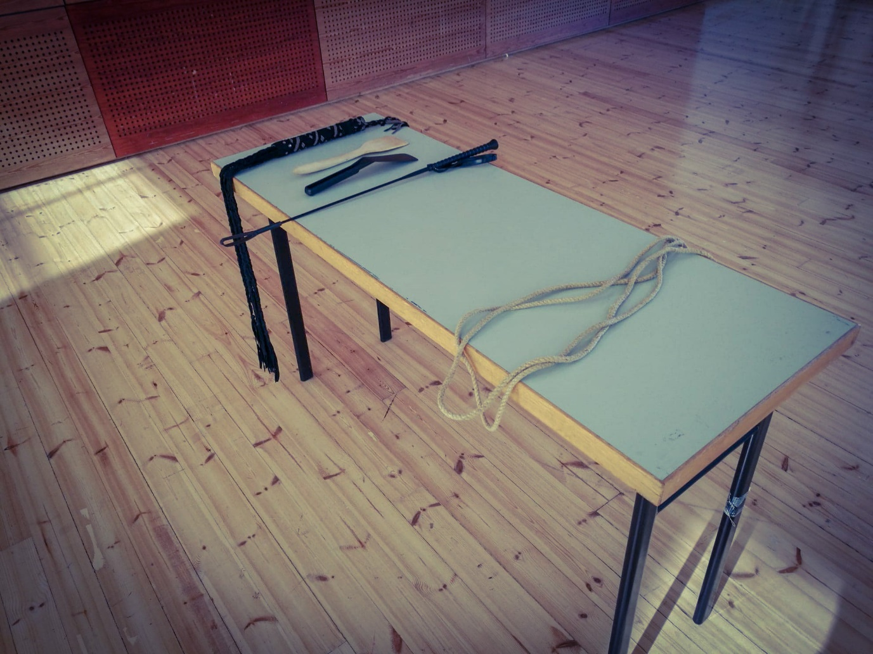
The second pair continued watching Hollywood movies with male-dominant and female-dominant casts such as The Hangover (2009), Bridesmaid (2011) and Ghostbusters (1984 & 2016). They were to collect more data and make observation about the gender differences in the expressions of violence, animality or excess.
The third pair was concentrated on listening to the recorded interviews they’d done about actor’s sacrifice and organizing the responses to see any patterns or tendencies.
Each research has gotten much more extensive and focused since the beginning.

- Psychologist’s visit
As a special feature of the week, a psychologist Pablo Escartin paid a visit one afternoon to answer some of the questions the students had regarding the psychology of violence and sacrifice. There were many questions, ranging from a philosophical one, “Is human violent by nature?” to a scientific one about the stress response and parasympathetic system. Time and time again Pablo responded to those questions by refacing the complexity of violence in various contexts. It is too simplistic and even dangerous to be satisfied with one explanation from one branch of knowledge. Nonetheless, Pablo shared fascinating ideas and thoughts with the students from a psychological standpoint.
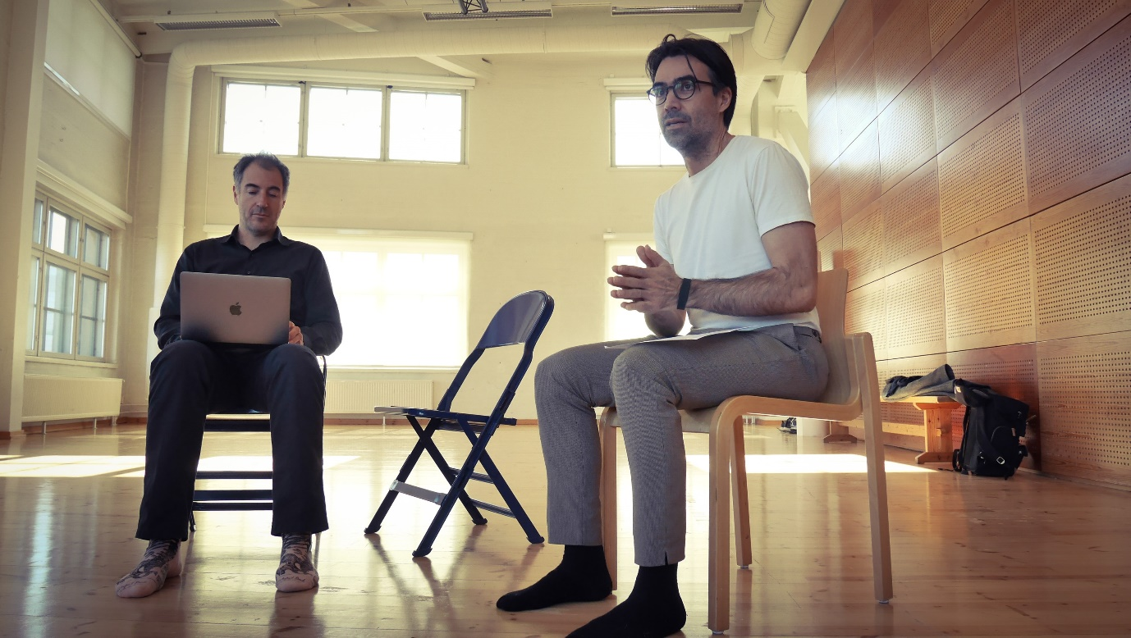
Some of the stuck with me.
- One’s relationship with a primary caretaker affects how violent one becomes later in life. The negligence of the caretaker could also cause one to be prone to shame.
- Aggressivity is not the same thing as cruelty (violence). Aggressivity in itself is not always harmful.
- Pain inflicted by a traumatic event is recorded in the limbic system and never really fades in intensity as if to experience it afresh again and again. It’s because there’s no “time” in the limbic system. Whatever happens there is “now.”
- Sacrifice changes the psychological reality to gain rights or acceptance to get something bigger or marginal than one’s normal capacity. It can be seen as the act of saving oneself from worthlessness.

- Costume search
Aside from the intensive course work, the students went to the costume shop to look for possible clothing for their monologues and scenes. Davie was also there, giving them suggestions and feedback on their choices.
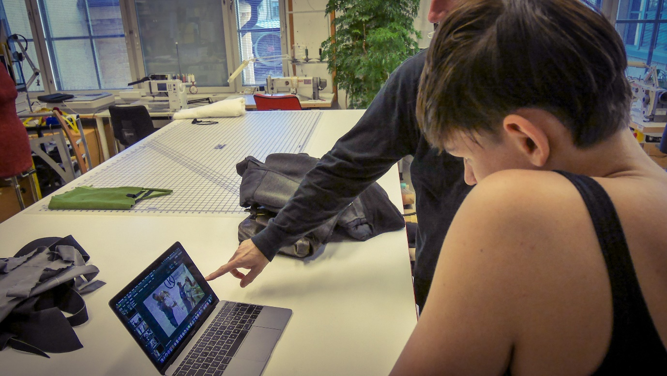
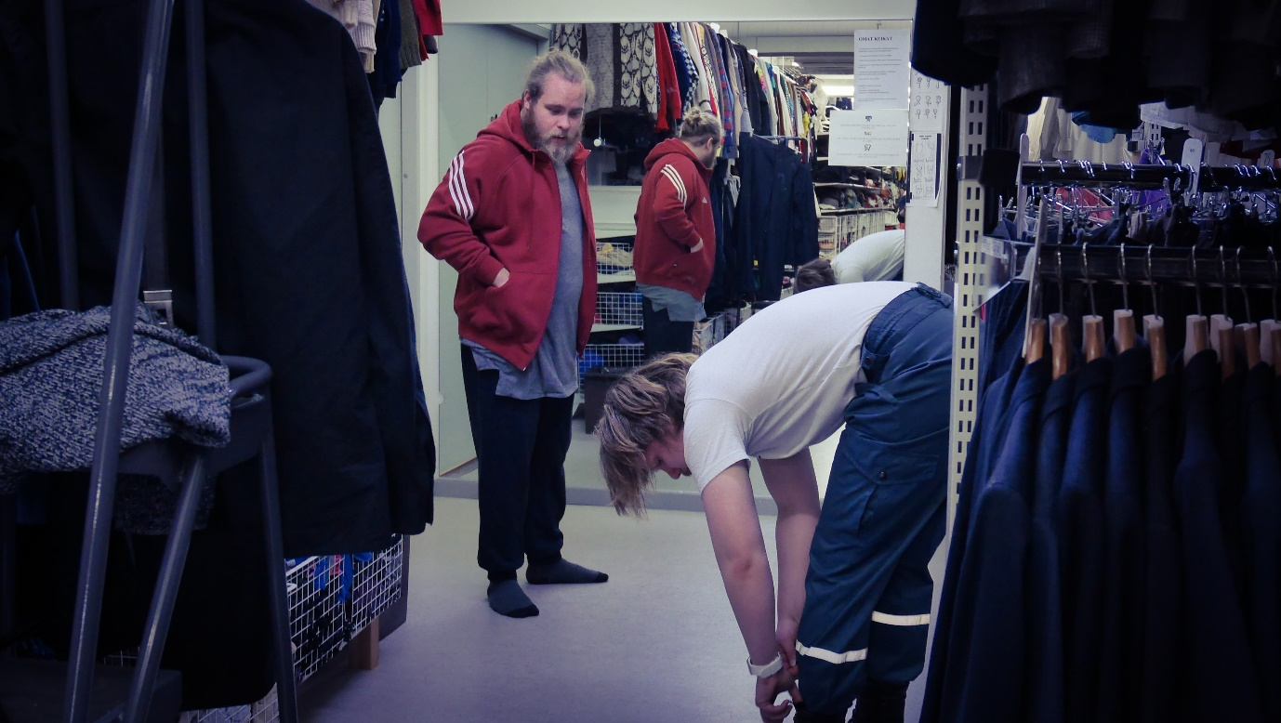
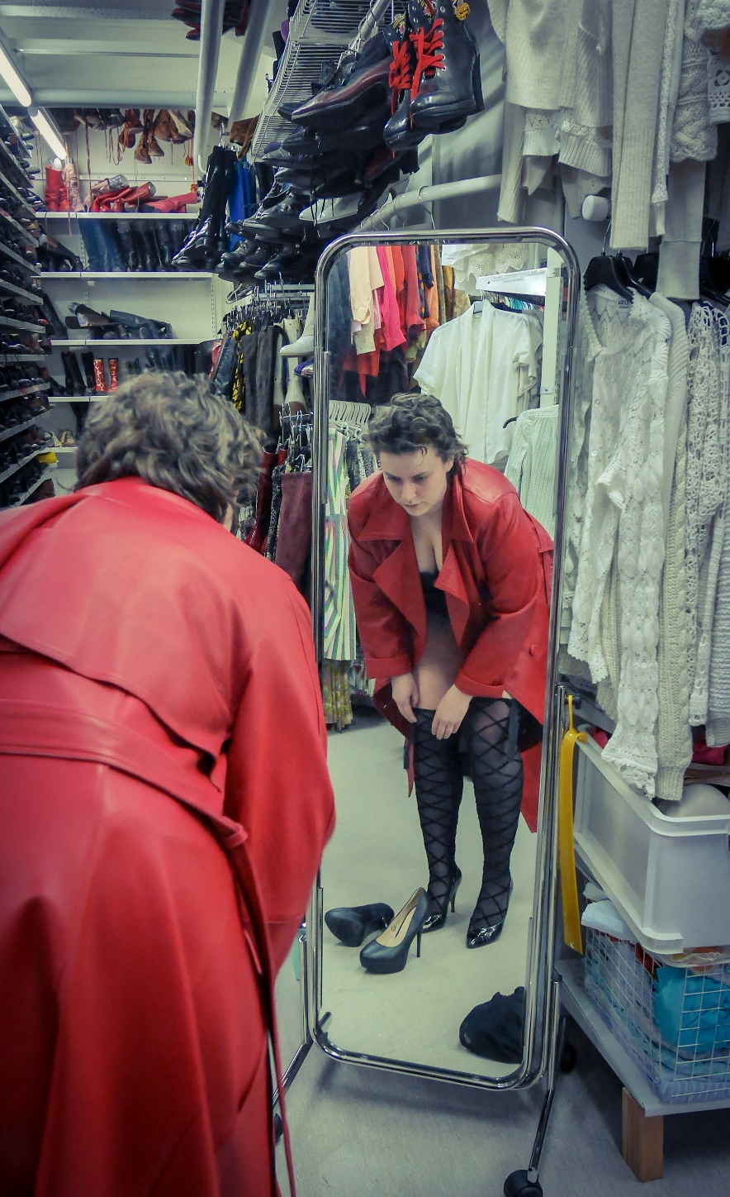
With costume on, their acting work started to gain yet another layer of specificity and definition.
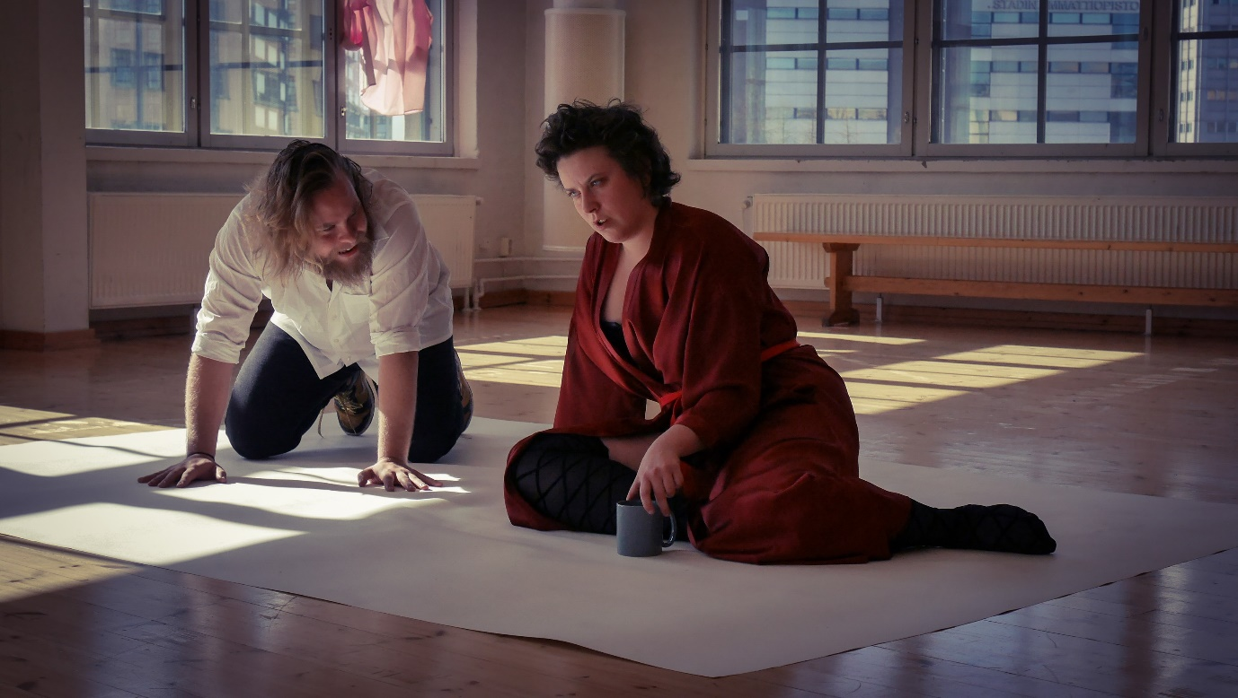
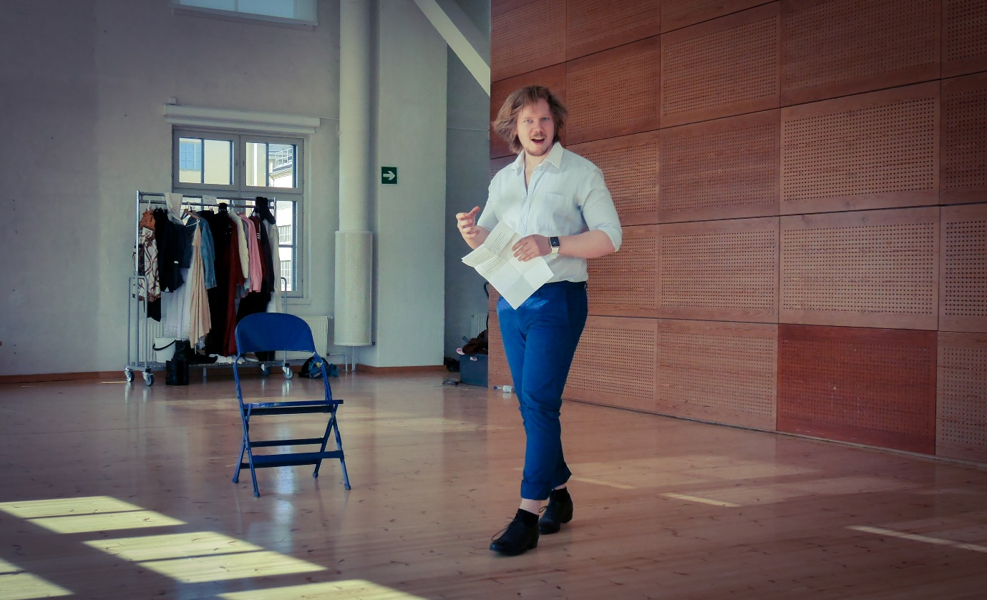
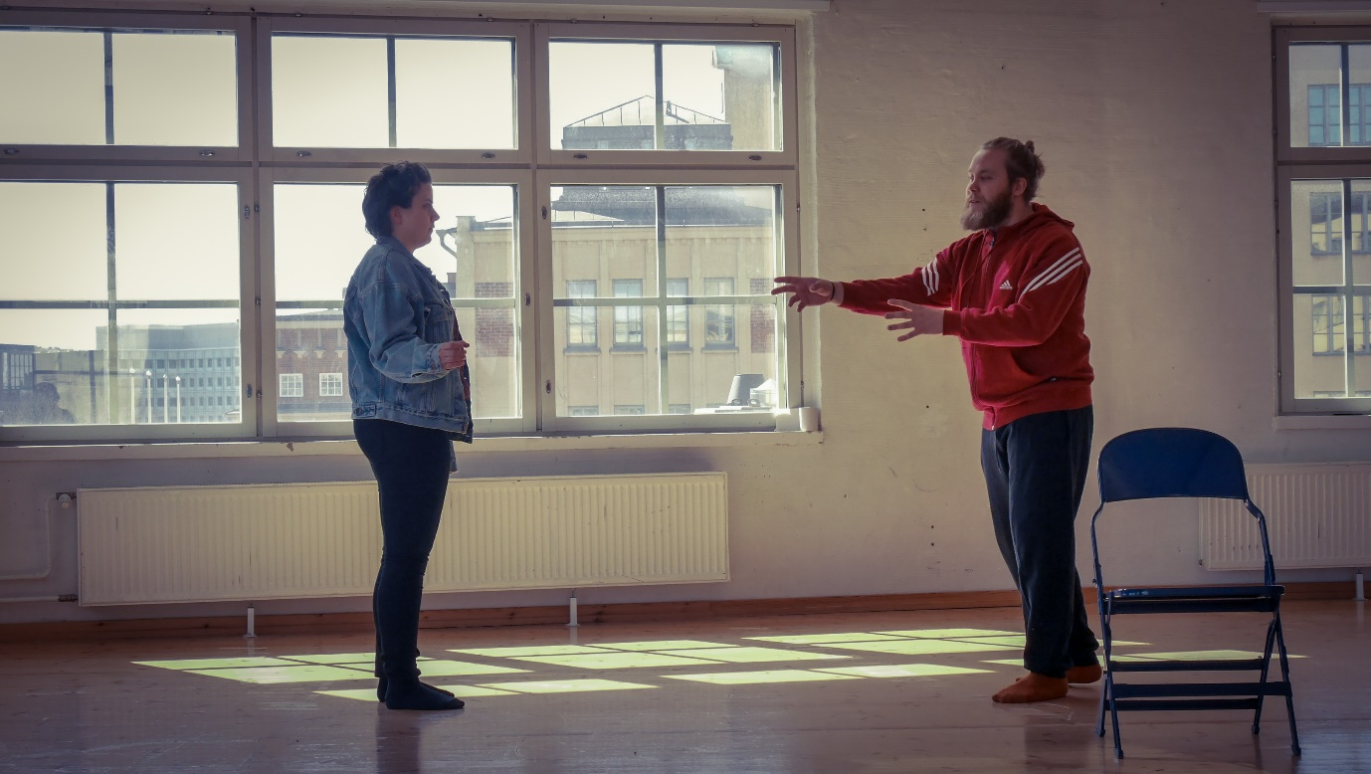
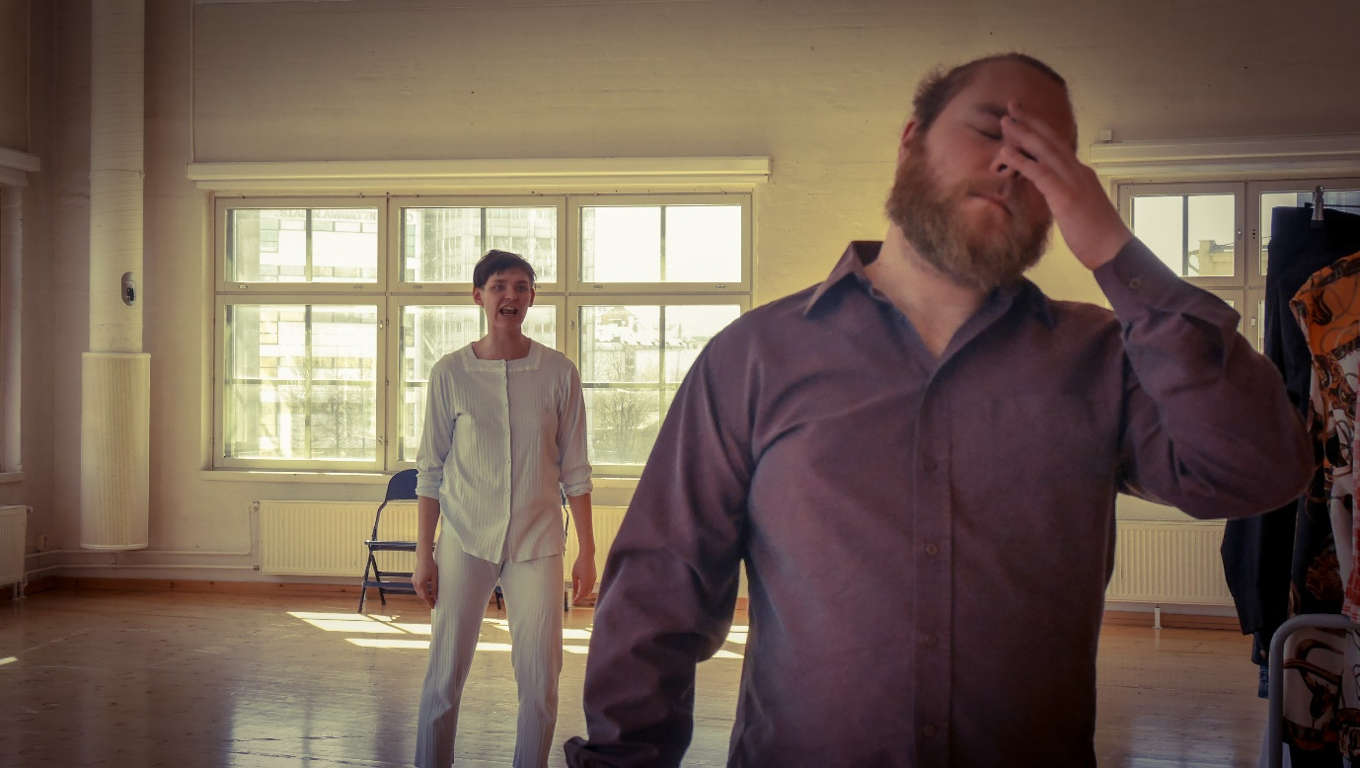

>>>>>
As for my part this week, I led a few physical training sessions as usual. My focus continued to be on sensitivity, listening, connection and relationship. But this week I pondered on the actor’s role in theatre a bit deeper and wider than I usually do in physical training.
One day during the training session, one student asked what acting is where there are so many acting styles and techniques out there. The question was coming from both genuine curiosity and frustration with the dominance of certain acting styles in the actor’s education. Since the students in this course have been trying to develop their own ways to practice acting as artistic research, the question sounded especially relevant.
In the corner of my mind, I thought about the definition of a renowned acting teacher Earle R. Gister (1934-2012), “Acting is living believably under imaginary circumstances.” But then I felt that giving the definition wouldn’t really address the core issue. Instead I told the students my personal take on what acting does when it’s done well. To me, acting reveals and/or generates a connection between the actor and the other. The other in this case refers to space, time, the audience, fellow performers on the stage, text, sound, any element you can think of. By being fully present in the connection, something extraordinary happens in between the actor and the audience as a shared experience. For me, when I experience so-called “good acting” as an audience member, I feel less lonely, not alone.. because of the connection. I didn’t want to bombard the students with all sorts of existing concepts about acting. So, I ended my talk by saying, “No matter what kind of acting you might end up doing or acting theory you might end up subscribing to, try to always come back to the basic human level.” I continued pondering over the question for a few days.
As I was observing how the students were working with Davide, their fellow course mates and the staff at the costume shop, the focus of my contemplation changed from acting to the actor’s role in theatre. The students were trying to find their own ways to be independent, autonomous actors in the fast-changing world. Nobody really knows what a new generation of such actors would look like or do. Artistic research is one way to start re-defining or re-inventing what it means to be an actor in this day and age.
But while there is an undefined, massive change underway on the personal, artistic and societal levels, something about the actor in theatre has always remained the same to me.
It is that the actor is never alone in the process of making theatre. He or she needs to work with the other by having a constant, continuous creative dialogue. The other in this context could be the director, the teacher, the fellow actors, the designers, the backstage crew, the audience, etc. Independence and autonomy can coexist with interdependency and collaboration. As the students navigate through never-ending inquiry and occasional confusion and frustration in the course, I hope that they know that they’re not alone. I also hope that their unique voices as artistic researcher/actor will find exciting resonance and harmony with the people around them, ready for the extraordinary.
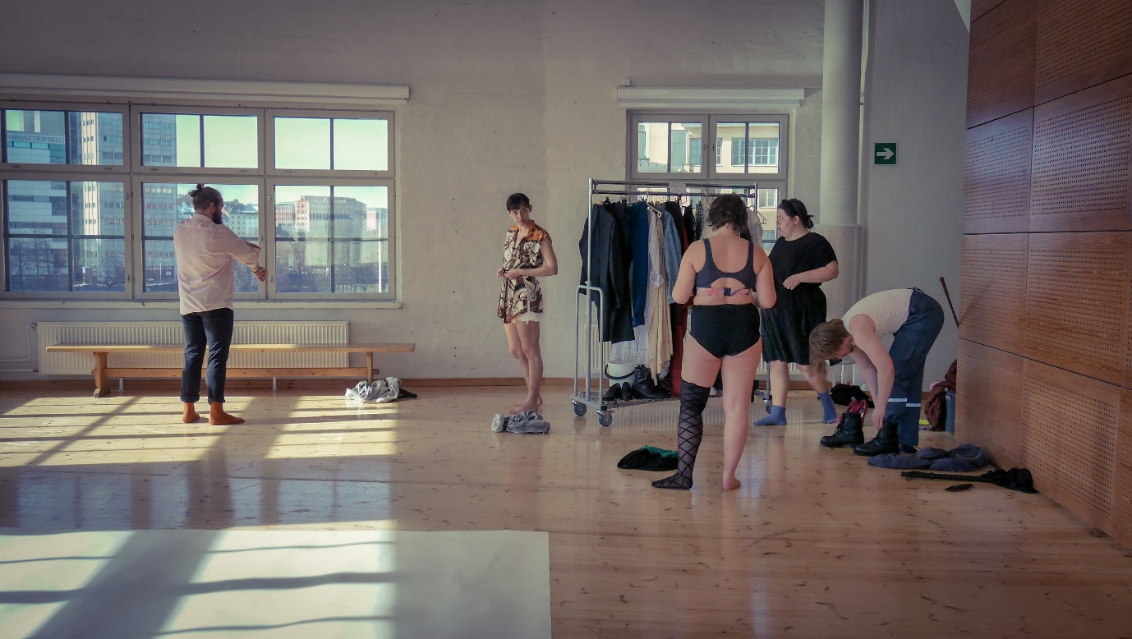

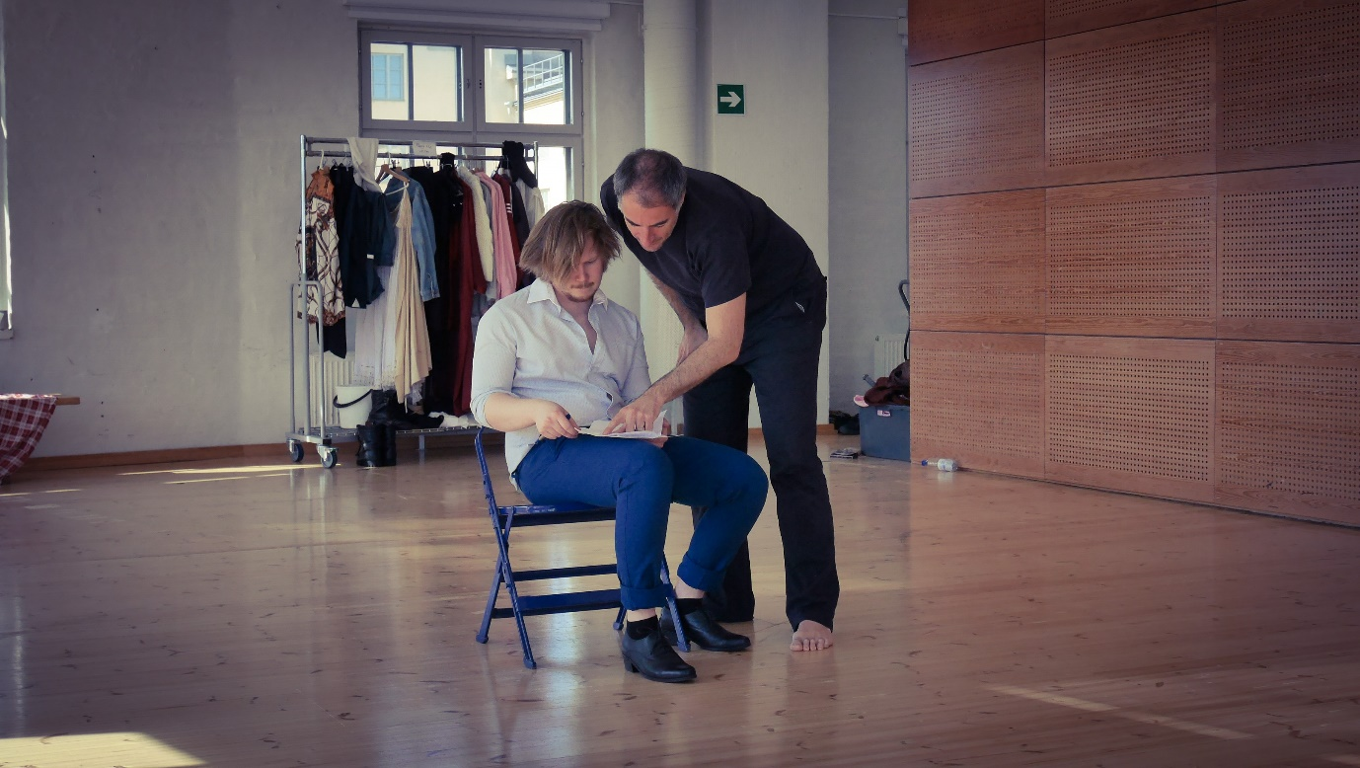

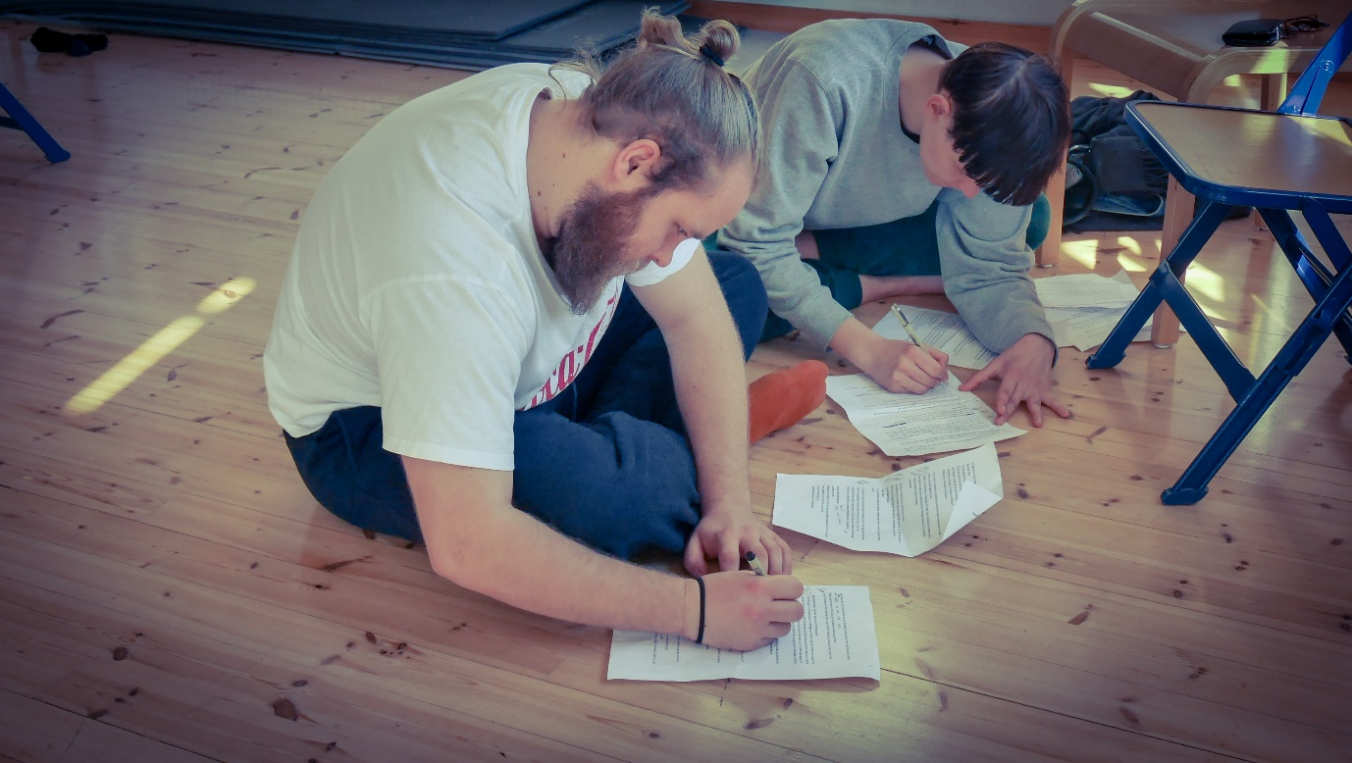
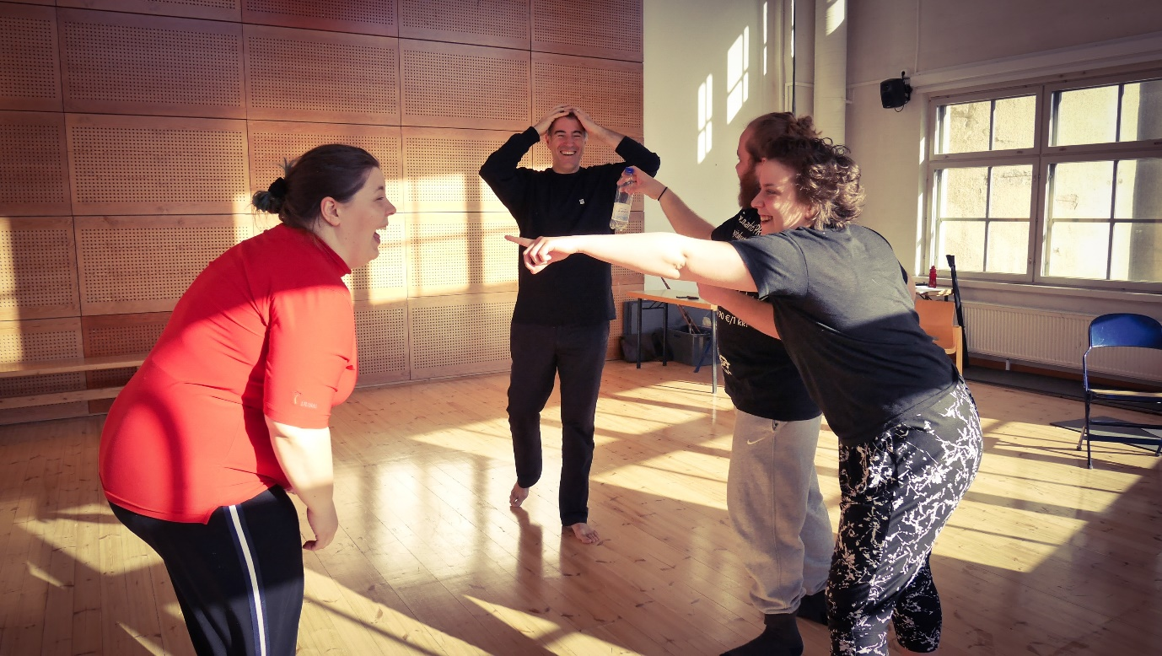

The students’ presentation is coming up soon. Limited seating (only 25 ppl for each presentation). Please book your seat now!
Presentation dates and times:
27.4 (Sat) 16:00
29.4 (Mon) 14:00 & 19:00
30.4 (Tue) 14:00
Place: TeaK room 535

