How to understand violence as an artist
20.1.2018 (Sat) written by Yuko Takeda
As of today, we finished the second week of the “Imagination of Violence- Atelier 1.”
The week’s underlying theme continued to be the “intolerability” of violence. On top of that, there were physical training, in-depth work on the monologues, the discussion of the images and situations of the hidden violence that should be intolerable, the lecture about sociological viewpoints on violence, and the viewing and discussion of a 2004 American drama film “Crash.” Each of those was very different from one another, and yet, like a polyphony, all together they composed a holistic learning experience for me as an artist and pedagogue. The following passages are the highlights from the week.
I led the physical training session as the first thing of the day every day. Suzuki Method was used mainly to address some of the fundamental skills of acting such as stillness, focus, and breath-calibration in speaking. I also encouraged the students to tap into the raw, powerful energy that is innate in the body to practice the method. In Suzuki, it’s called animal energy. I called it “f**k-you energy” to be in alignment with the overall theme of the course. The strict forms of the method are for the student to measure him or herself against and constantly challenge his or her own limits.
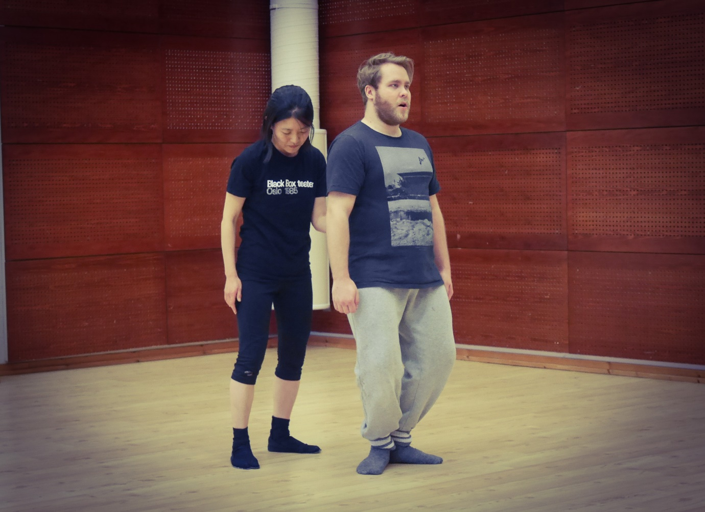
In addition to Suzuki, we practiced the Hino Method, too. The Hino Method not only develops the bodily sensitivity and efficiency but also challenges the very assumptions and preconceptions we have about the body. Its work demands full attention to the body and honesty to one’s own physiological experience. In the process of doing so, there can be confusion and frustration, but there’s also the wonder and joy of getting to know one’s own body and unlocking its potential. This week my focus with the method was the upper body, mostly shoulders, elbows, and fingers. 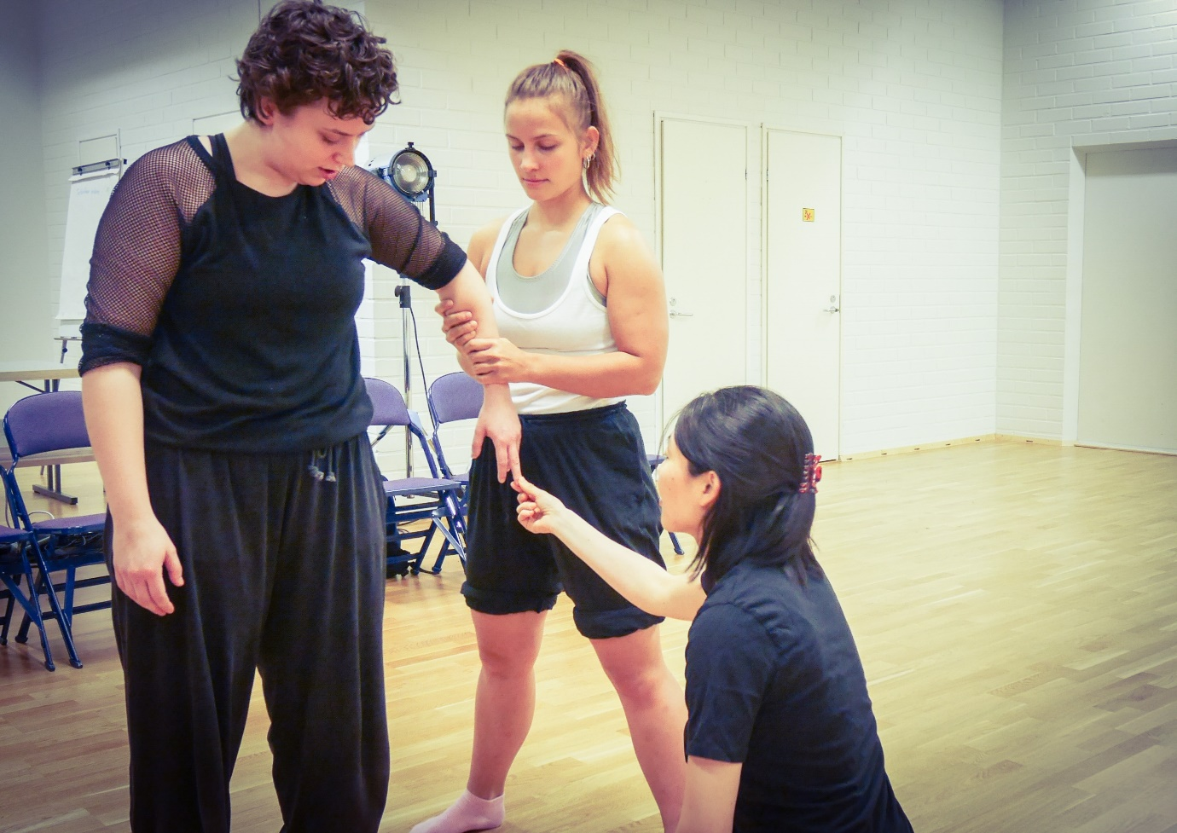
>>>>>>
As I mentioned in my first post “How to do artistic research as an actor?”, this course is also about each student’s developing him or herself as an artistic researcher. As a researcher, one needs to collect and analyze data and evaluate the results. How does that work in the case of an actor? The students have been trying various things in response to that question.
To give the students a framework of artistic research, Davide asked them to observe their fellow student’s monologue work like scientists. Each observing student was given a certain aspect of performance as the point of observation such as the actor’s relationship to the space, the connection between the body and the voice, the degree of violence, etc. He announced each round of the monologue work as a scientific experiment with certain variables. For example, “Experiment number one, Joel, with a physical obstacle,” “Experiment number two, Joel, with an imaginary obstacle,” etc. After letting a student perform his or her monologue several times in a row, Davide then had all the students sit in a circle to share the observations.
It was an exercise to develop an observational skill needed for artistic research. Observation does not stop at the level of like or dislike but strives to see the phenomenon as it is and its relations with other things. In sharing their observations, the students were also encouraged to form their own “hypotheses,” or insights that they can continue investigating. Along with the scientific observations, Davide also asked the one who performed the monologue about his or her experience.

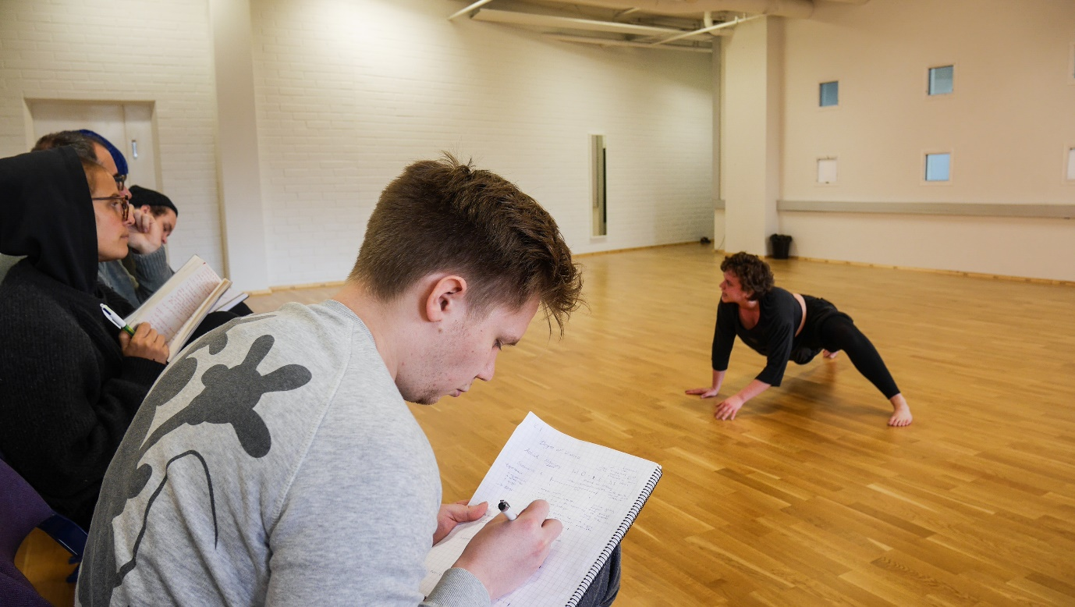
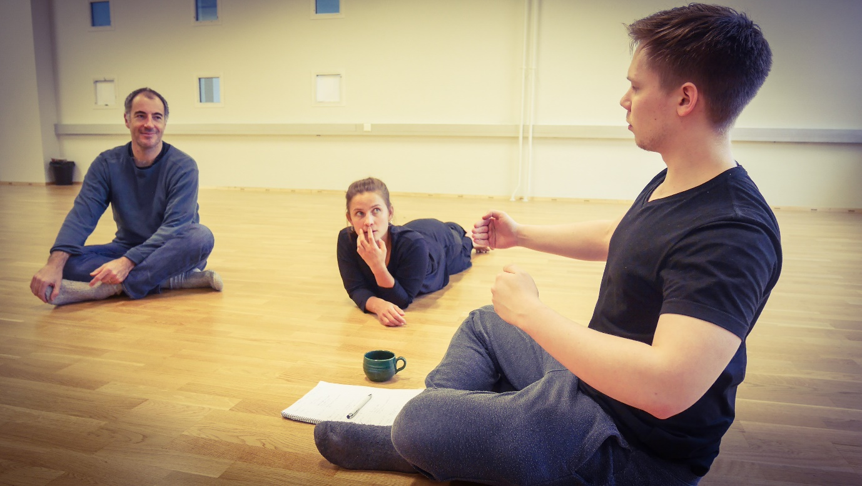
As for the monologue itself, the students continued to incorporate the physicality of an animal into their performance, which was explored in the previous week. Davide also added other elements such as interaction with the audience, physical restrictions, different focus points (audience, space, self), etc. depending on the personal needs of the student to develop their work. 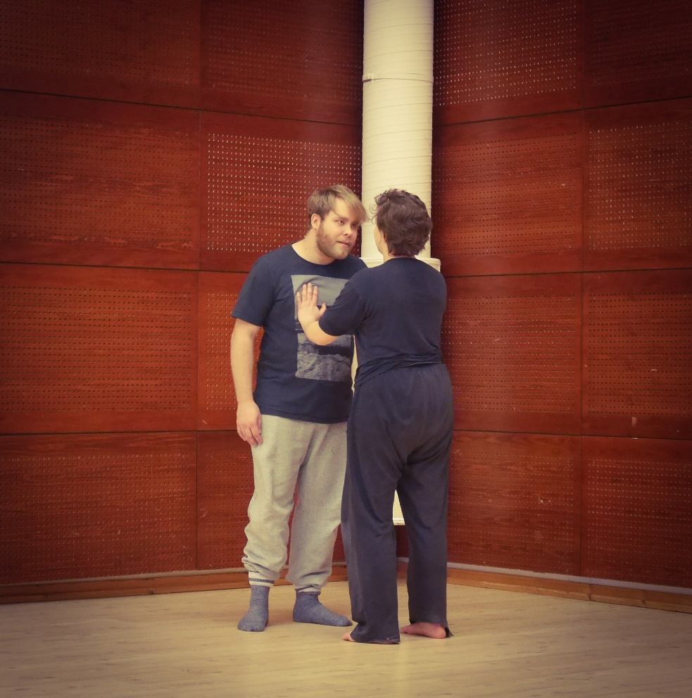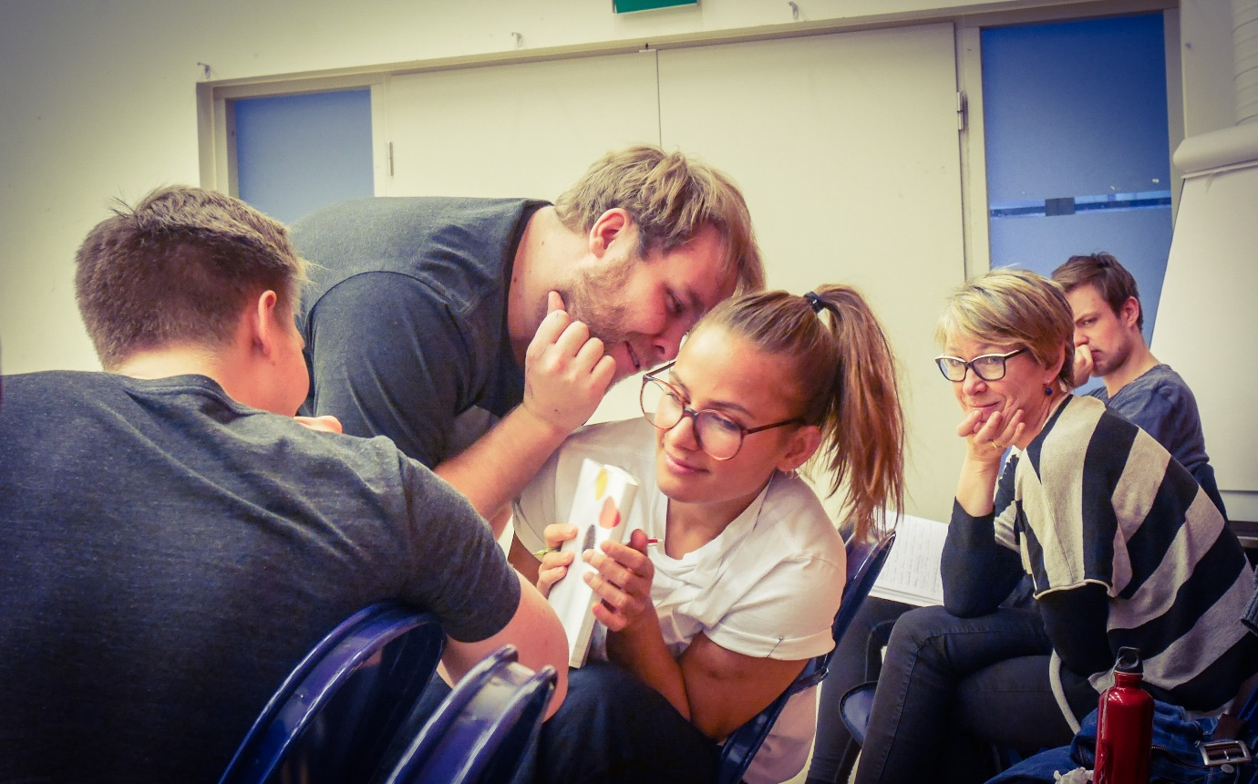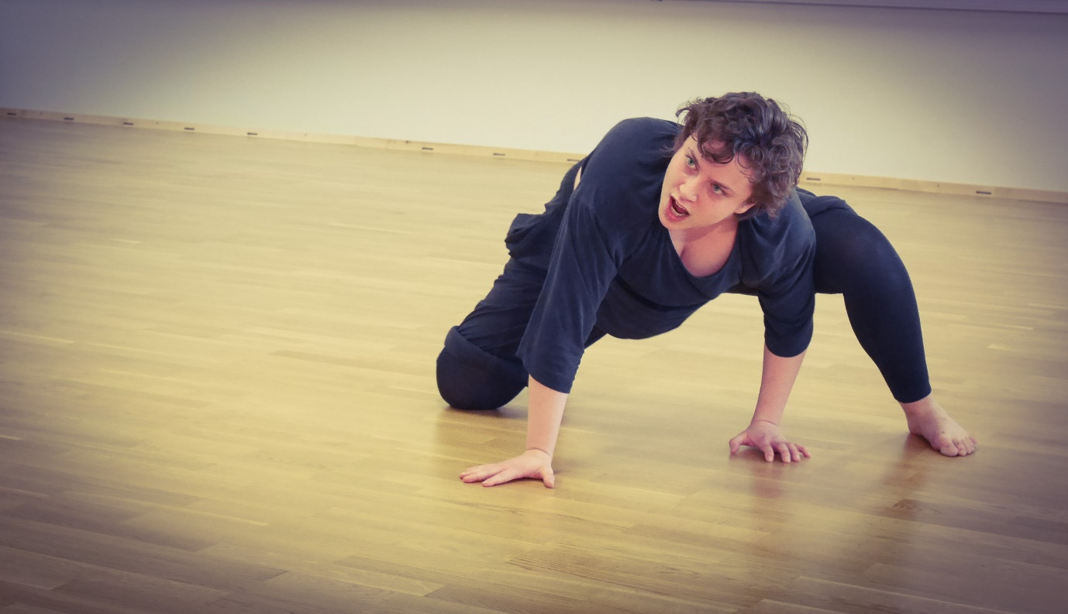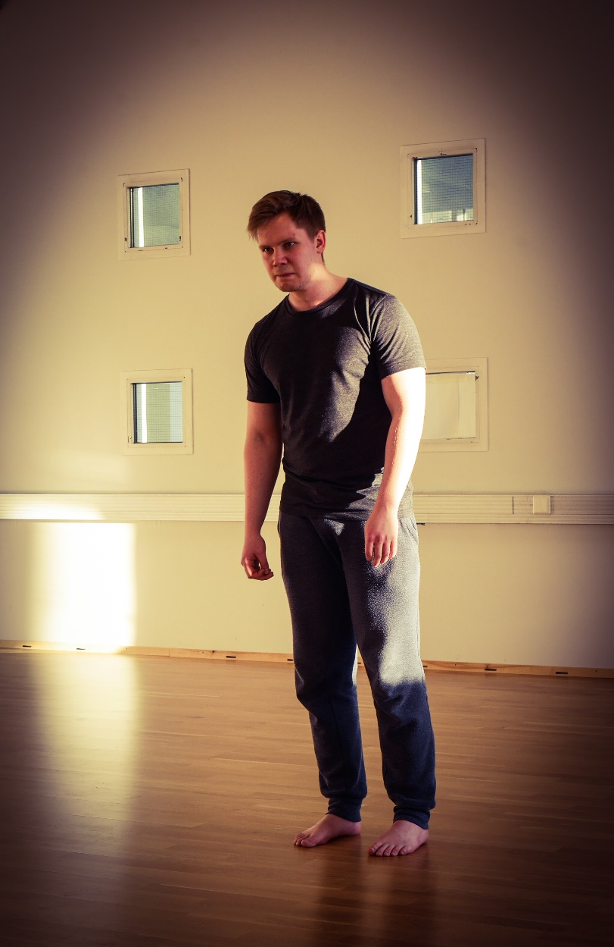

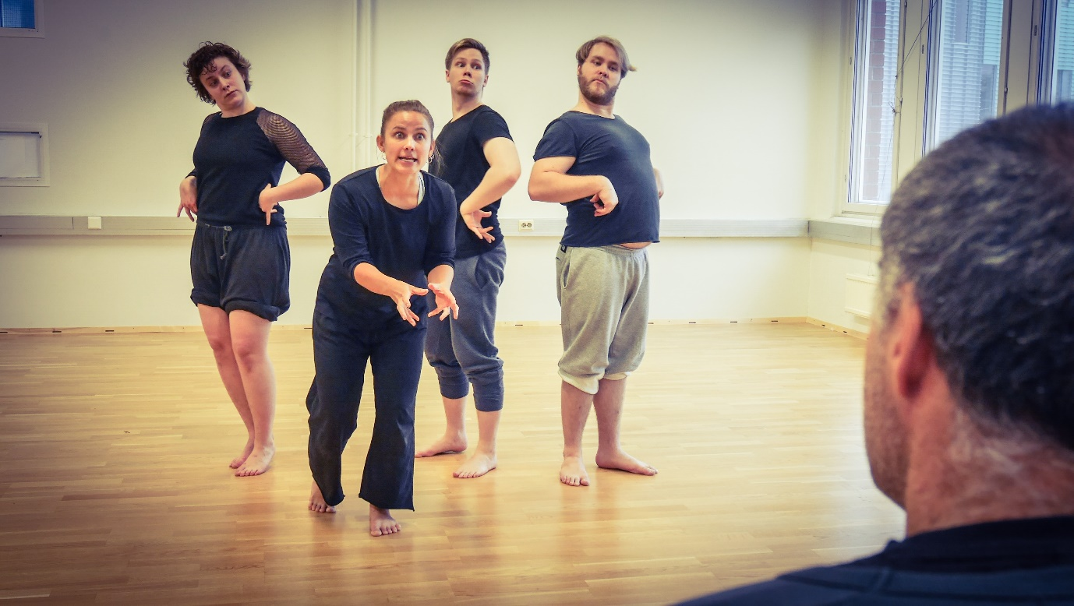
>>>>>>>
An important issue came up while we were discussing the images and situations of the hidden violence that should be intolerable. Because Davide told them to bring up something that they personally think should be intolerable, there were many different opinions as to why a certain image or situation is violent. Some of the heated discussions included the topics of online banking, unwilling sex in a relationship, abortion, etc. Davide, after listening to them, said that it was fine to have opinions on issues. “But,” he continued, “as an artist, you have to understand the dynamics of violence that is behind the phenomenon. How it happens, what kind of mechanism is at work to cause such a thing. You have to go beyond “Oh I think this is wrong!” or “This is evil!”
It is not easy to be completely devoid of personal feelings and opinions about violence, and I do not think that one should avoid them. After all, those feelings and opinions are coming from a certain point of view, which is necessary to make any substantial work as an artist. However, I do agree with Davide in that the artist’s work entails something more than just having an opinion and expressing it. The aim of an artist is never about winning an argument. Ideally his or her work contributes to our understanding of humanity and the world in which we live, and maybe, somehow, transform them, too.
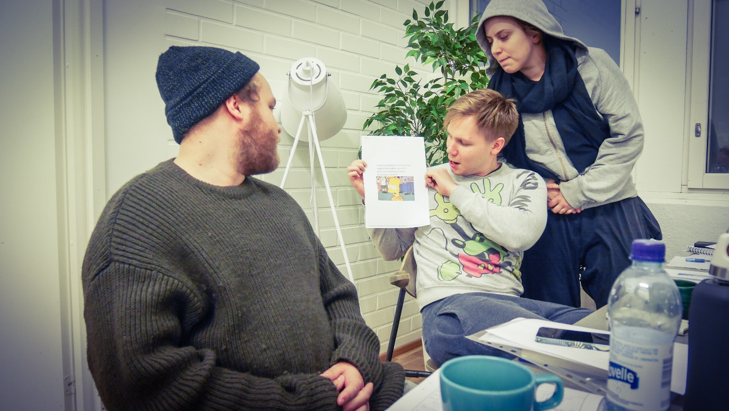
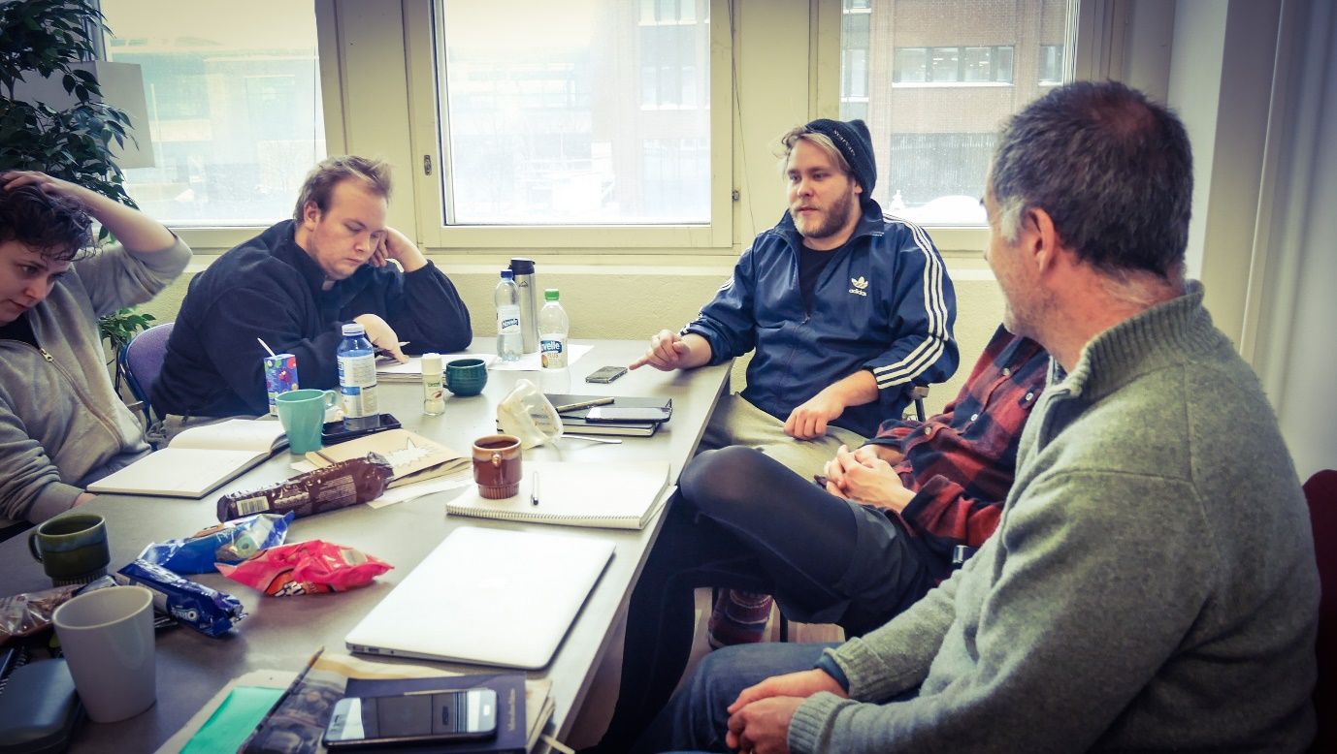
>>>>>>>
Davide gave a lecture on sociological points of view on violence one afternoon. He said that instead of explaining one coherent narrative of one concept, he would like to list several ideas from distinct sociological literatures. There were quite many of them, and they were complex thoughts. For example, in the capitalistic society media sensationalizes violence, which causes it to be devoid of substance and political, ethical value. Or the postmodern society is defined by its waste, the increase of superfluous things. Or power went away from the hands of the state and was handed over to the free market and the Internet, which resulted in the dissolvement of human communities. Or the popularity of Reality TV programs such as the Bachelorette indicates the acceptance of a totalitarian structure for entertainment’s sake. And the list went on.
But in the nutshell, sociology considers violence as a phenomenon driven by societal structure or mechanism. This view contrasts with that of anthropology that analyzes violence on the inter-and intrapersonal level.
It seemed that the lecture overwhelmed many of us who were listening. Davide’s hope was that someday those ideas would help the students to contextualize their artistic research on violence.
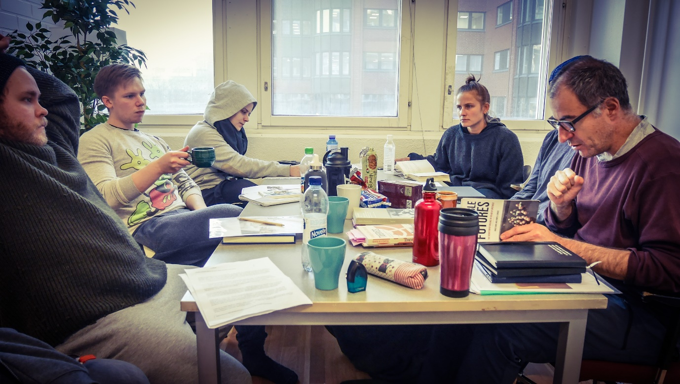
>>>>>>>
We also watched a movie “Crash” (2004) together. Many of us were deeply affected by its morally conflicted characters and constant disruption of the viewer’s expectation of the story. There is no clear “good guy” or “bad guy” in the movie. It skillfully shows how complex and tragic the hidden structural, societal violence, namely racism in this case, can be. I had watched it a long time ago, but watching it again now felt more relevant than ever before.

In addition to the movie, the students shared violent pieces of music for inspirations for their future work. It was interesting to not only listen to them but also watch different reactions to the same music.
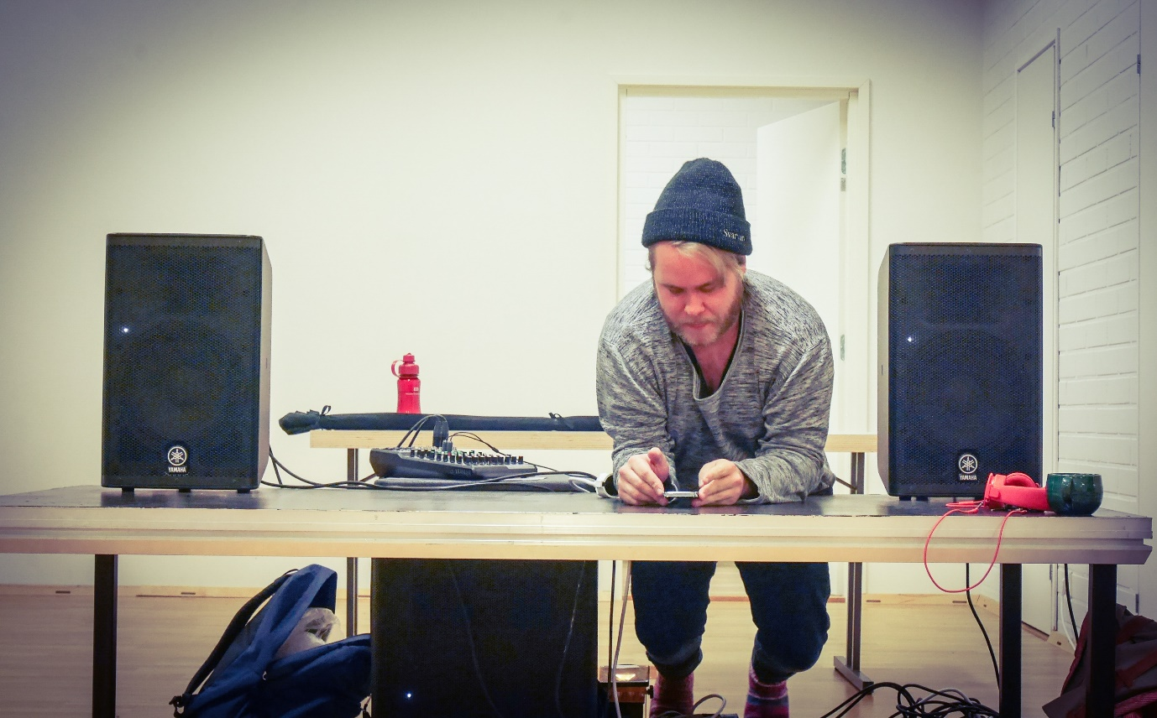
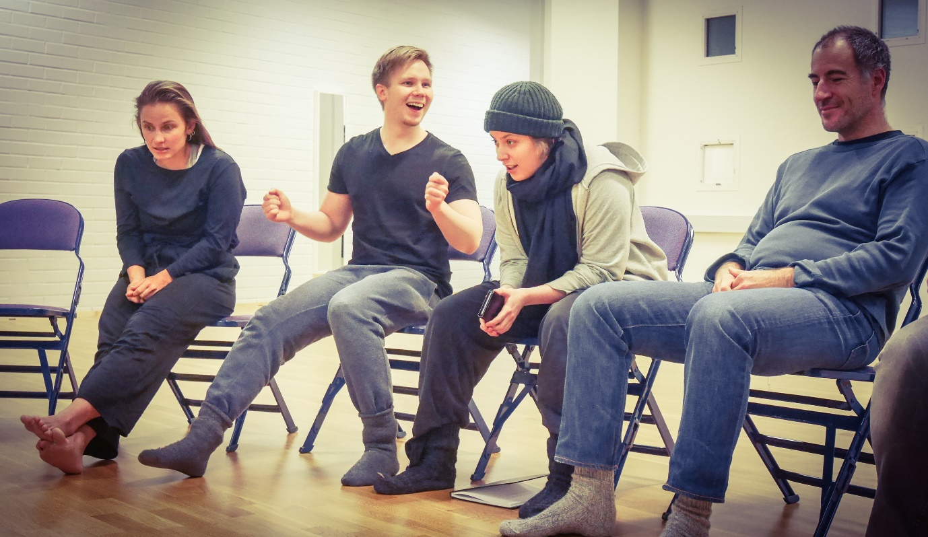

>>>>>
On the last day of the week, we had a feedback session and spent some time on planning for the next week. As the feedback, the students shared what was helpful and what was confusing for them during the week. My impression was that they were starting to get engaged in the framework of artistic research and that their curiosity and interests were growing.
As for the plan for the next week, in addition to the physical training and the monologue work, the students will go out of the class room to do a field research on the invisible violence in daily life. The possible places to go to are a school, a gym, and a hospital. With all the work they have done both physically and intellectually so far, it is going to be a substantial step forward into yet another new branch of their artistic endeavor.
Good work!

To be continued…

