A blog entry by Yuko Takeda (TEO) on 26.11.2017, Sunday

- How to do artistic research as an actor?
As a theatre pedagogue and actor, I’ve been observing the course titled “Violence and Photography” for the 2nd year Swedish acting students this fall. Theatre director and researcher Davide Giovanzana is the initiator and leader of the course, and he is doing it as a part of his post-doctoral research. The course is, therefore, a part of a long-term artistic research, involving the Performing Arts Research Centre (TUTKE), the Swedish acting department, and theatre pedagogy department. Davide had asked me to collaborate with him in his endeavor to incorporate artistic research into the actor’s education to develop his or her own method.
It is an interesting and ambitious proposition in its framework, and the content of the course couldn’t have been more topical. I’m very excited and lucky to be a part of this.
As of today, I’ve observed four class sessions, about halfway through the course. Davide has given the students various tasks and ideas as provocation.
They started out by looking at some of the iconic photographs of violence from human history.
Then the students picked the photos that spoke to them strongly and then were asked to “recreate” them as close to the originals as possible. The original photos were very powerful, loaded with historical, moral, and ethical turmoil such as this one.
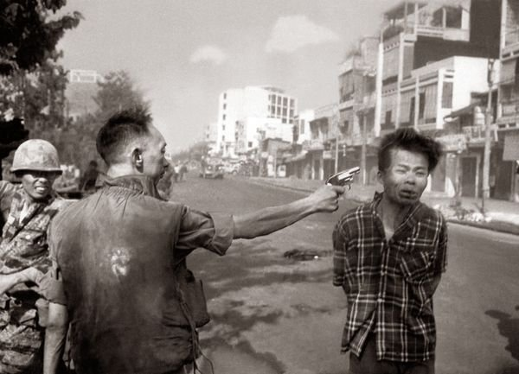
Source: CNN
How to recapture the violence that had happened a long time ago and in far away places… In uncertainty, the students searched and tried many ways.
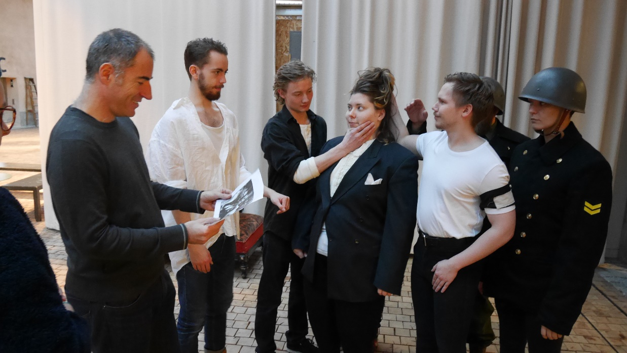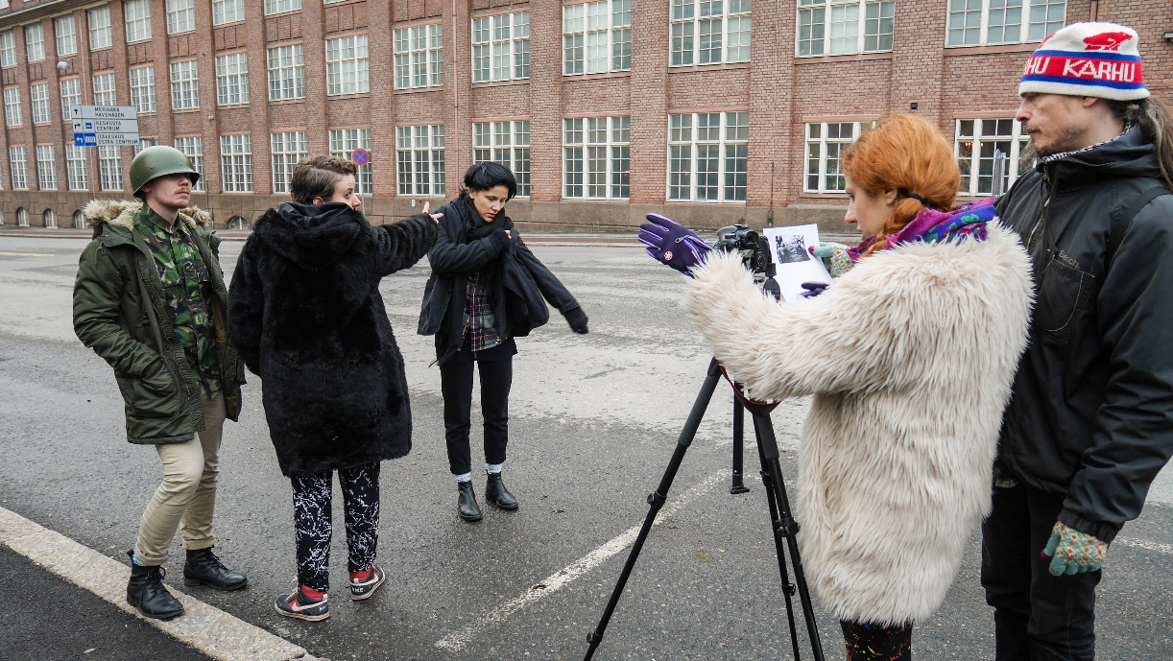
The photographer Kemê Pellicer took photos and edited them. The results were hauntingly powerful and provoking. Afterwards, Davide asked the students to do the second photo session with Kemê. This time “it’s with a twist,” he said. It’s not about reproducing the moment in the photograph but to place the original photographic composition in a different context (e.g. changing genders, races, or the time-period, etc.).
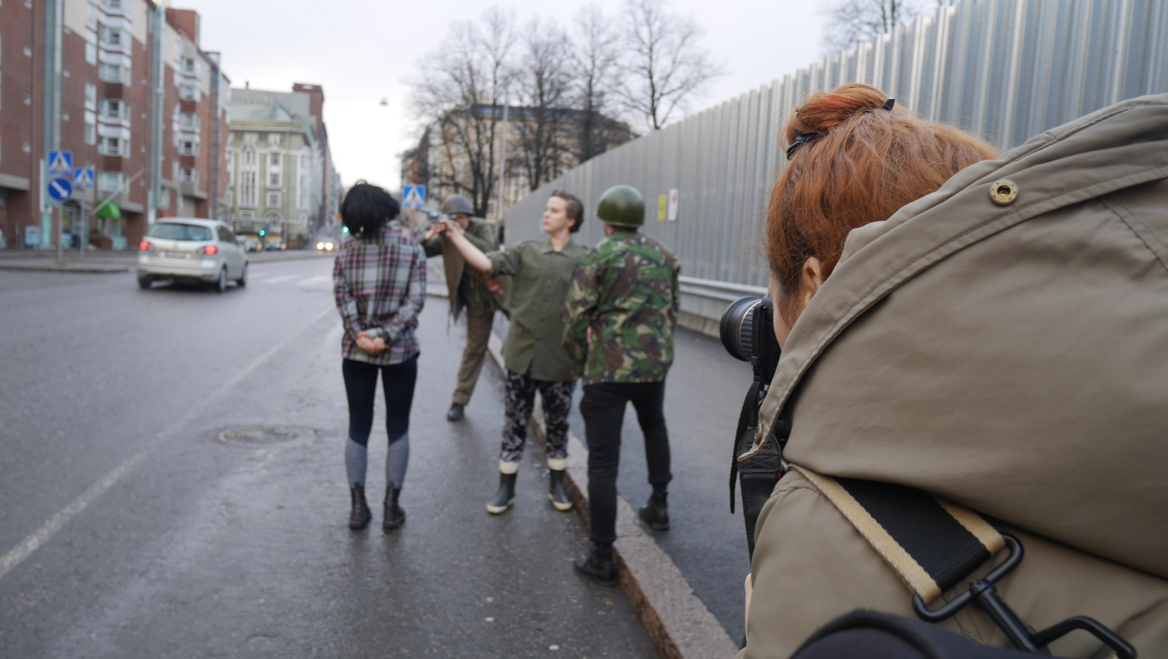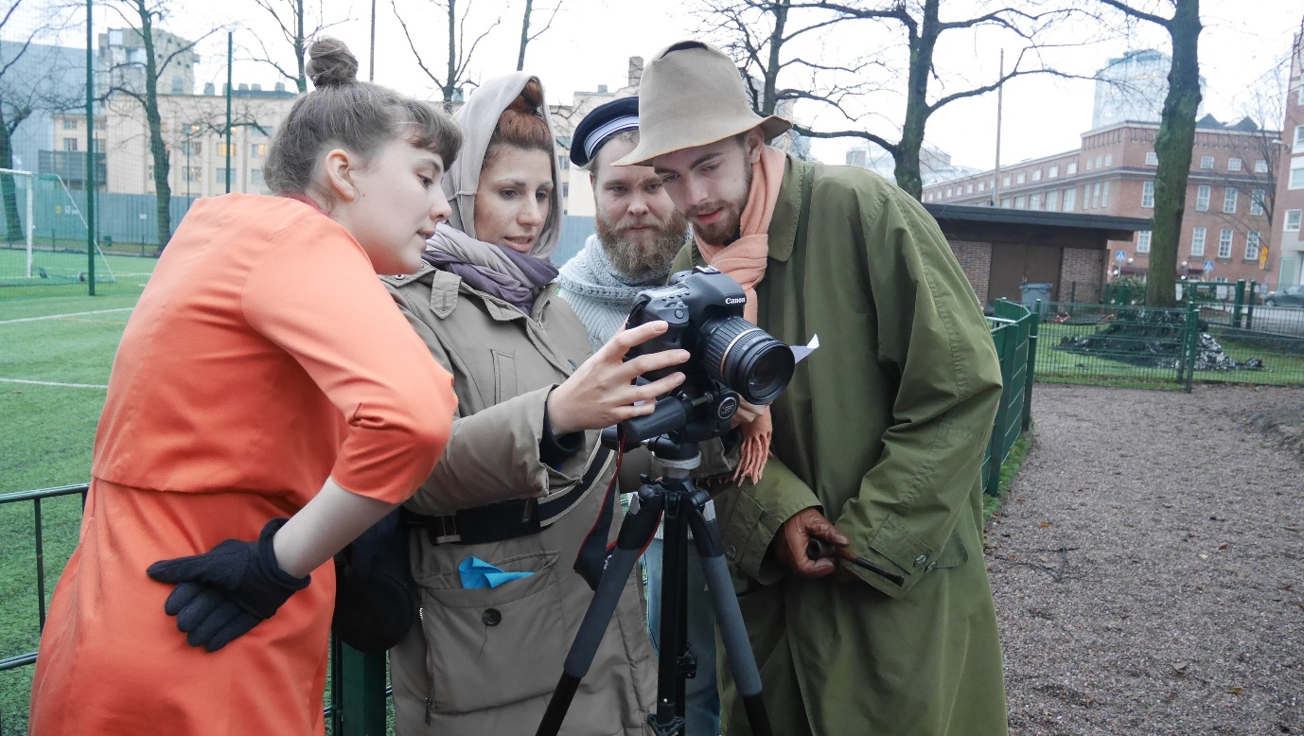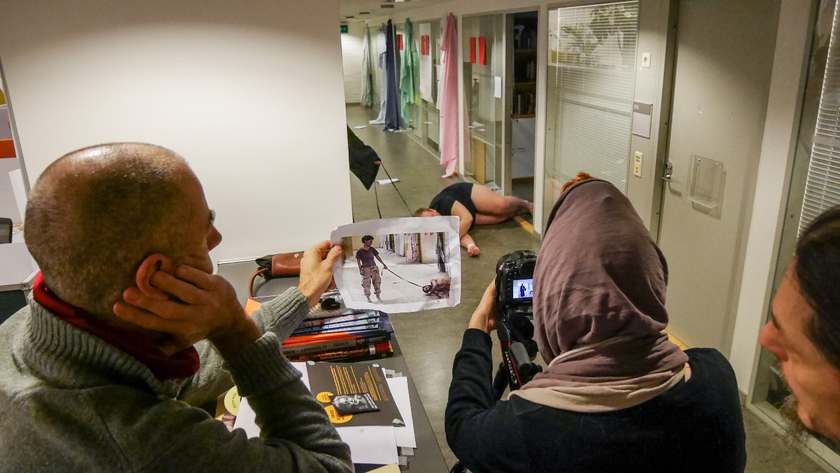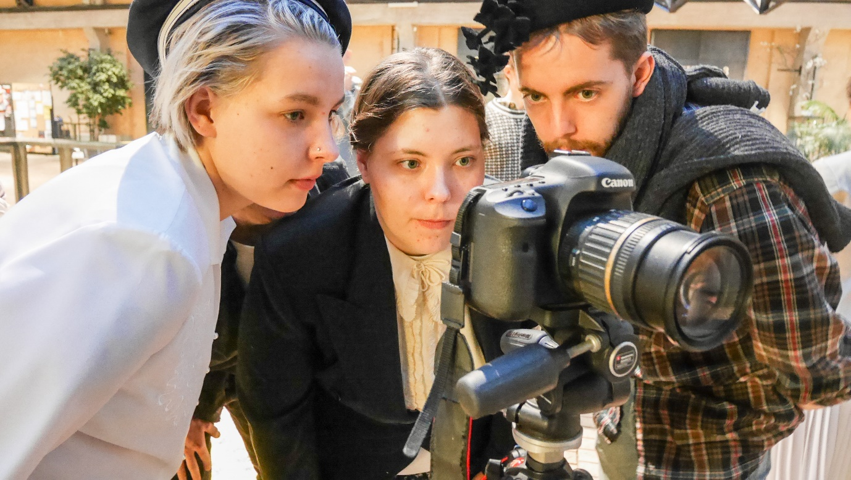
They are still waiting the results of the second round at the moment.

In between the photo sessions, they also had a workshop led by Anastasia Trizna, coordinator of Eve’s Ribs (an educational and artistic project to tackle the problem of silencing down the topic of gender discrimination, especially the violence against women. More info: http://rebraevy.ru/en/main-2/). After presenting the background and activities of Eve’s Ribs, Anastasia asked the students to create mind-maps regarding the topic of violence. They huddled around big pieces of paper and jotted down whatever came to mind in thinking about violence-related theme words. No discussion, just letting the flow of thoughts manifest on the paper.

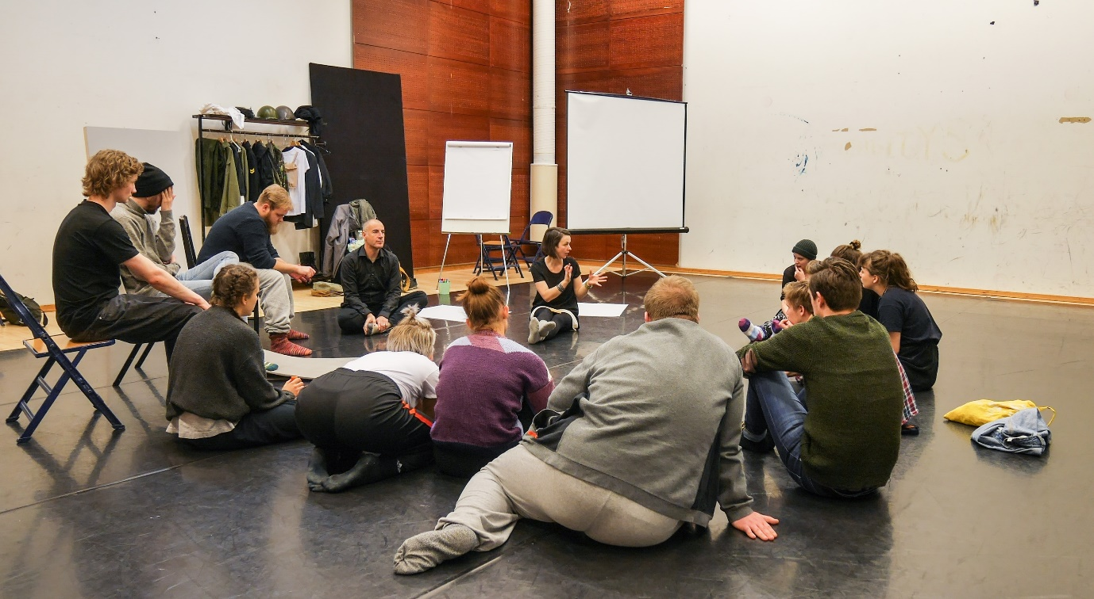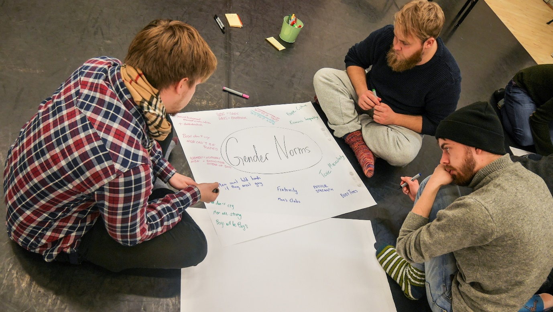
Afterwards, they got up on their feet and did a few physical exercises that involved sharing and personal memories of violence and generating physical gestures inspired by the words written on the mind-maps.
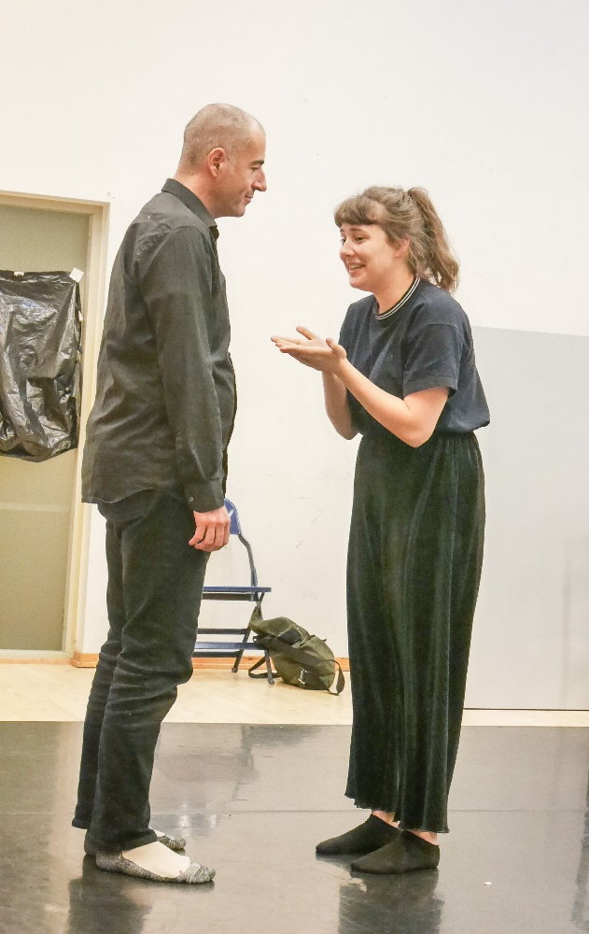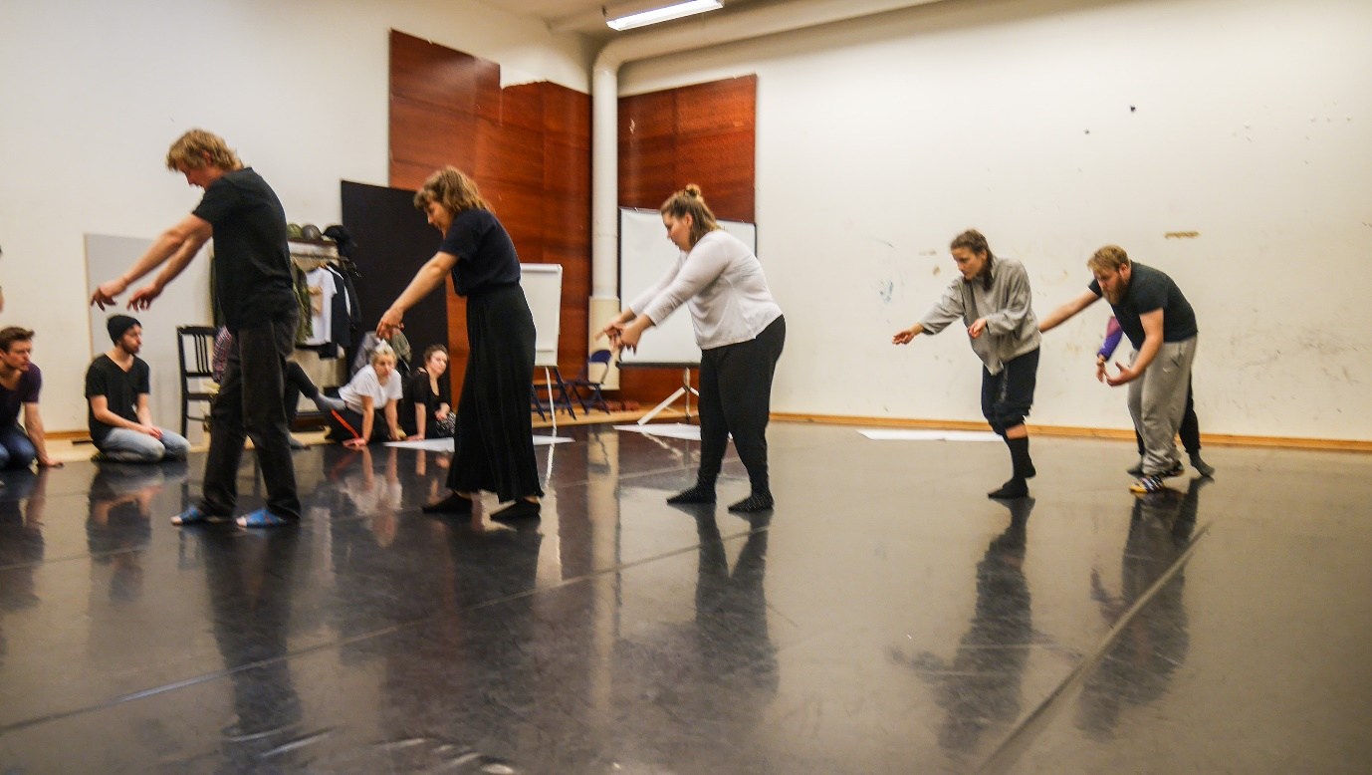
In addition to all the above, Davide gave a few other provocations to the students. He had them discuss a theatre production “Play Rape” by Anna Paavilainen. Not all of them had seen the show, but the subject of discussion was eventually evolved into more universal themes such as the representation of violence in theatre.
It was fascinating to hear the diverse angles and perspectives to think about violence. A few arguments in the discussion got stuck to my mind. One was about the origin of the Western theatre. The oldest theatrical events were believed to have started in Greece as rituals of sacrifice, the killing of the innocent for the greater good. The essence of Greek tragedies is in the heat of violent action. If the moral and ethical layers could be set aside for a moment, theatre plays have been fueled by violence, the disruption of equilibrium. If “violence” is too strong of a word to use, it could be momentarily replaced by “conflict.” In any case, the theatre culture in the West has never been without the shadow of violence giving depth and ambivalence to humanity it represents.
The other one was about the actor’s role in portraying violence. A lot of questions started to pop in my mind while listening to the discussion. Does the actor need to feel violent in order to perform violent action on the stage? What is the responsibility of the actor “being in the moment of” violence? How can an actor imagine violence as an embodied image? The embodiment of imagination excites me because that is what I’ve been learning to practice and what I think is one of the crucial parts of the actor’s craft.
Davide also introduced the students to two plays: “Seven Seconds / In God We Trust” by Falk Richter and “The Author” by Tim Crouch. Both plays deal with the theme of violence in unique ways. The first one is written in a way that there is no line division between “characters.” It could be read in many ways, and the perspective of the speaker(s) changes. Davide had several students read the play out loud in turns.
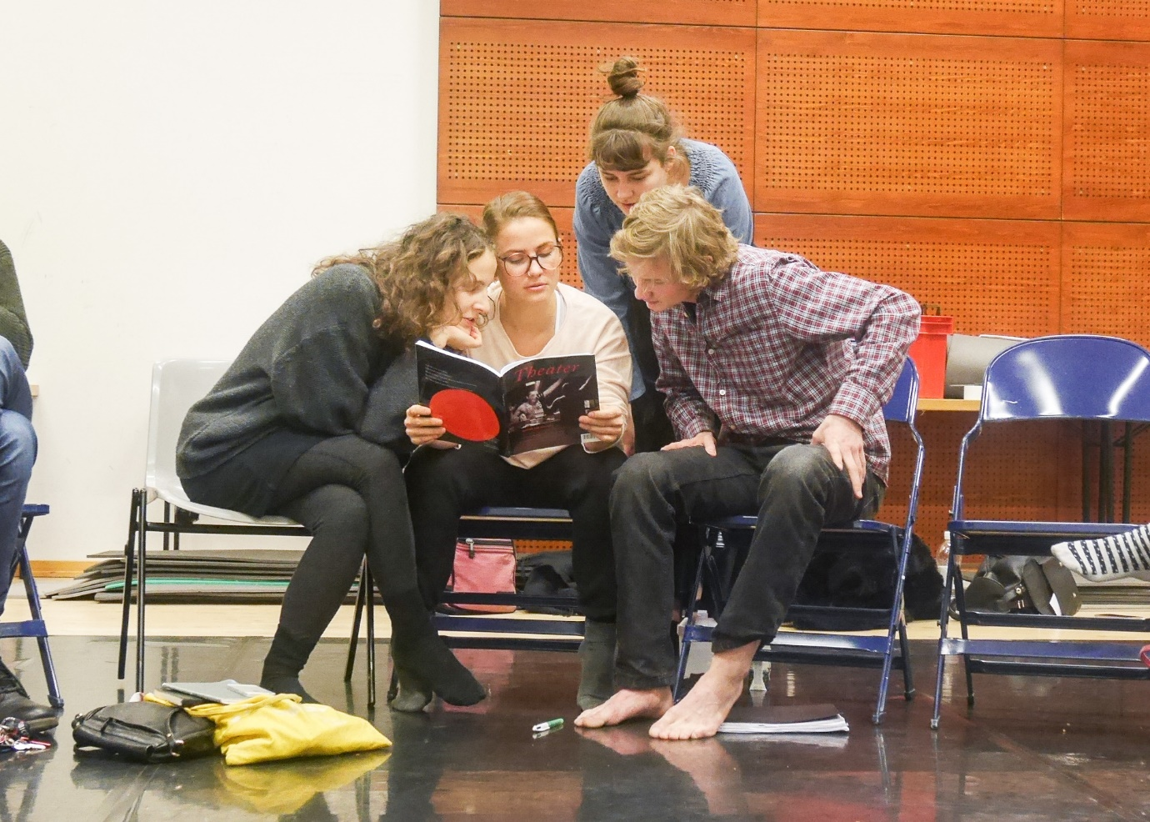
The second one is a play within a play. To describe his experience of watching the play himself, Davide had the students sit in two rows facing each other. In the show, one row was the actors and the other, the audience. The actors were talking about the play that they said that they had seen. But the play had never actually happened. But just by listening to the actors’ talking about it, the audience got to experience something profound.
The surreal thing was that as Davide was describing what he saw and heard in the show, the students were very absorbed in his story. The effect of violence is most strongly felt not just by witnessing the act of it but in one’s imagination as well.
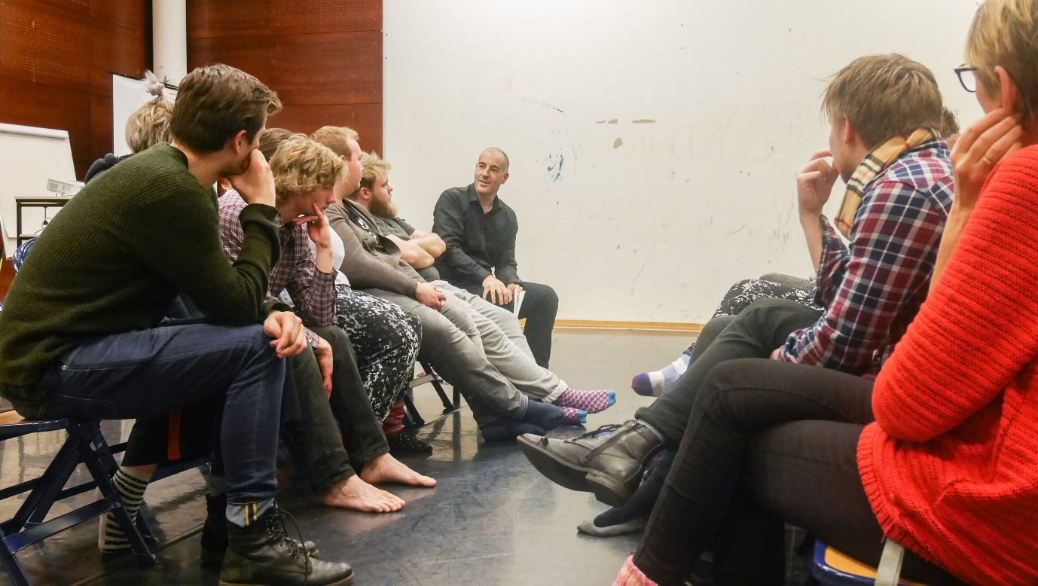
So, a lot of things have happened. A lot of information to process for the students. At the end of the week, I led a brief reflection session and got to give them a few questions to ponder over the stuff they’ve done in the course so far.
1. What got stuck to your mind and/or body from the course this week? (image, words and ideas, sound, other sensorial experience, etc.)
2. If you were to “explain” what violence is to a person who has never experienced it, what would you say as of now?
3. As an actor, what would you like to inquire/explore/search more in regard to violence? What are you curious, confused, or unsettled about it?
Reflection is a very important part of artistic research, especially when the researcher is an artist and he or she is trying to develop a method or practice for his or her craft.
And Davide has nicely said one other important thing in embarking on artistic research when he was responding to a few students who expressed uncertainty in dealing with such a sensitive, complex, deep topic as violence. He told them that the course was process-oriented and that “failure” was a part of developing consciousness.
I feel that those Swedish acting students are off to a good start on their artistic research. Although groping in the dark, they are willing to try their best. What an inspiration in itself.
This leads me to borrow the words of Samuel Beckett, which sum up the attitude of an artistic researcher for me.
“Ever tried. Ever failed. No matter. Try Again. Fail again. Fail better.”
As the task for the second half of the course, the students will be writing monologues of the individuals captured in the photographs of violence.
I'm excited for them.

To be continued.

