”Too far or too close: the challenge of distance”
written by Yuko Takeda on 3.12.2017, Sunday
Throughout the course, the students have been given many provocations to start their artistic research as actors. As the start of the second week, they had a guest lecturer Max Ryynänen to share his thoughts on the experience of violence from aesthetic and ethical perspectives. I missed the lecture part and only managed to catch the discussion afterwards. From what I heard, there were many more layers of situations and stories regarding violence in photography. I cannot summarize the content of the lecture I missed, but the important seemed to be the complexity of the subject itself. Davide said that any scientific or artistic inquiry starts with amazement. Being amazed by the things one doesn’t know. Then one begins a journey.
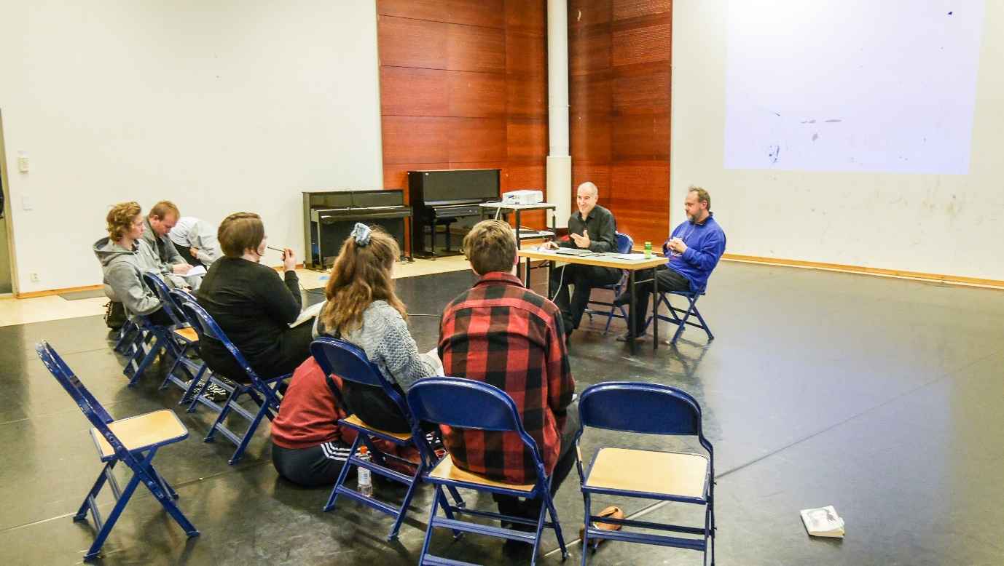

:::::
The main work of the second half of the course was building monologues for the human beings captured in the photographs of violence. Each student picked the character he or she portrayed in the photo recreation and re-imagining process. To start with, Davide asked the students to be in costume and had them do improvisational exercises. The purpose seemed to be to build a character firstly from concrete, tangible things such as the positions of the bodies, the landscape, and the weather, all of which could be gleaned from the photos. They tried to live in such given circumstances by repeating simple physical actions. The embodiment of the specific surroundings the characters inhabit came first before adding any “psychological makeup” (emotions and voice) to them.
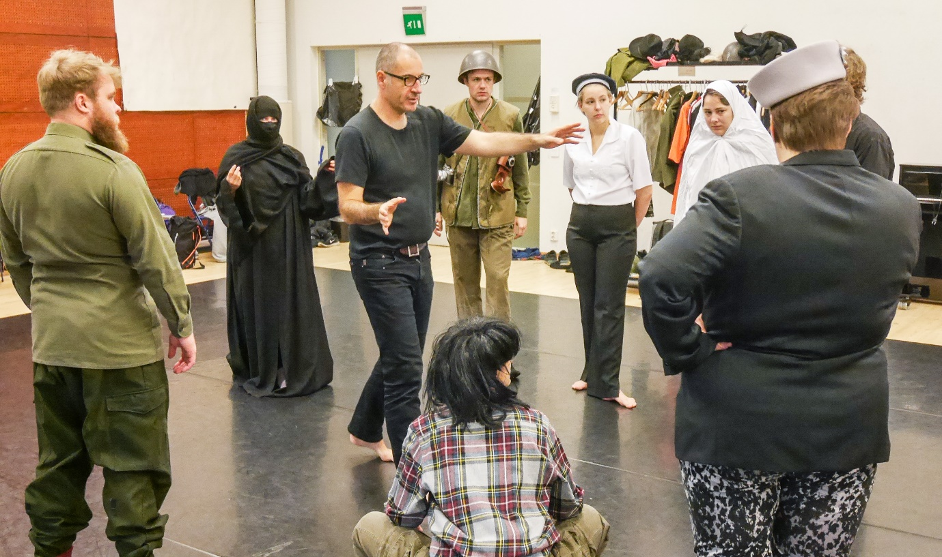

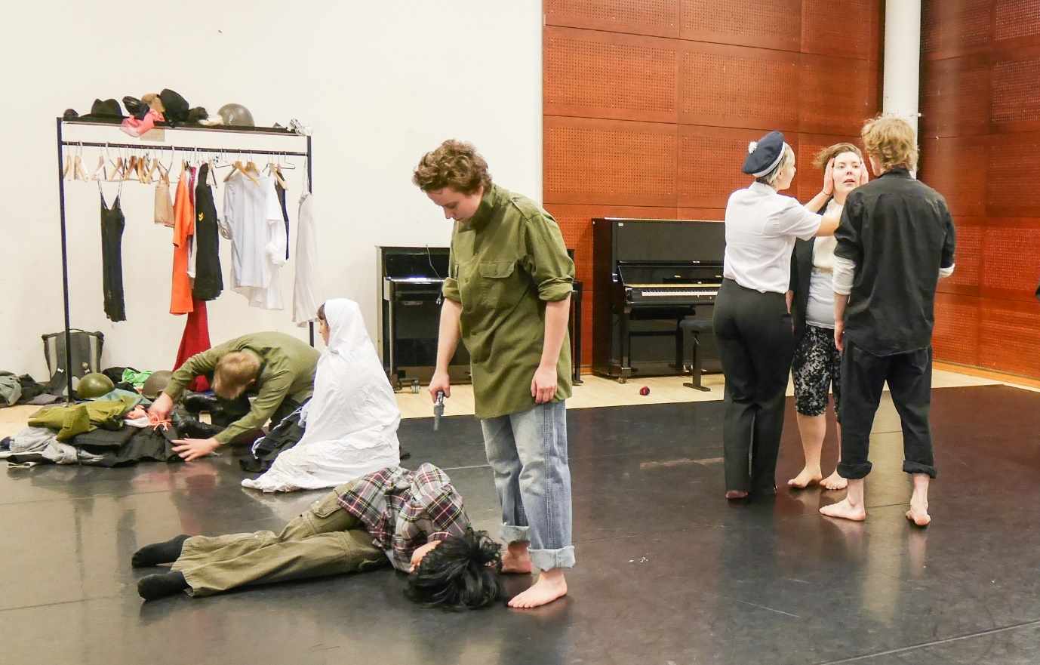
Slowly but surely the students accumulated intensity in their physical actions and started to let emotions and voices come out of their characters. Something alive was popping in the improvisation.

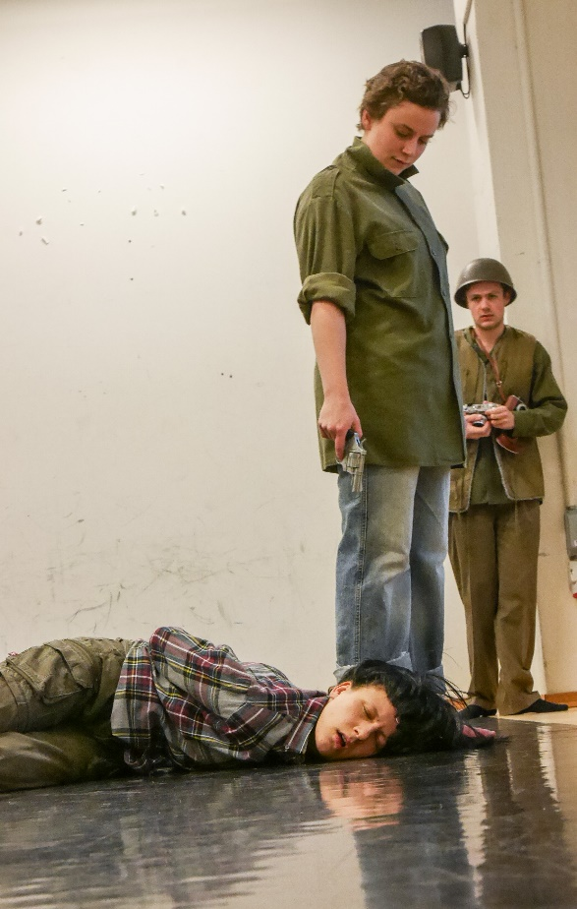
Afterwards, it was time to work on one character at a time. The students had to go in front of the class one at a time and perform a work-in-progress monologue. Davide reminded them that the purpose was not to present a final product but to build a character through the monologue work. There would be a lot of improvising on the spot, he said.
So, for two days, that’s what they did. Usually the work started out with the exact body position of the character in the photo and with other characters present as well to get closer to the original composition. Davide would instruct him or her to begin by taking in the concrete situation and repeating just one line over and over. As the work deepened and heated up, usually with more text and emotion, the photograph would be projected onto the back wall to give further stimulation to the actor and to the ones who were watching.
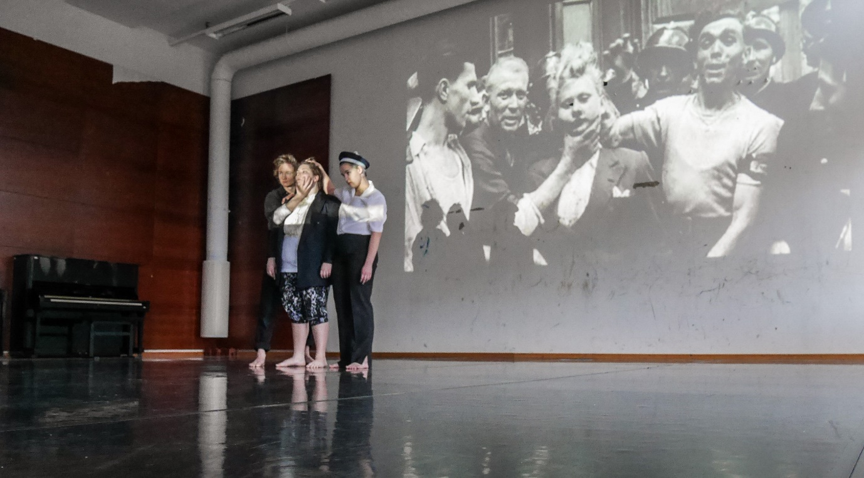
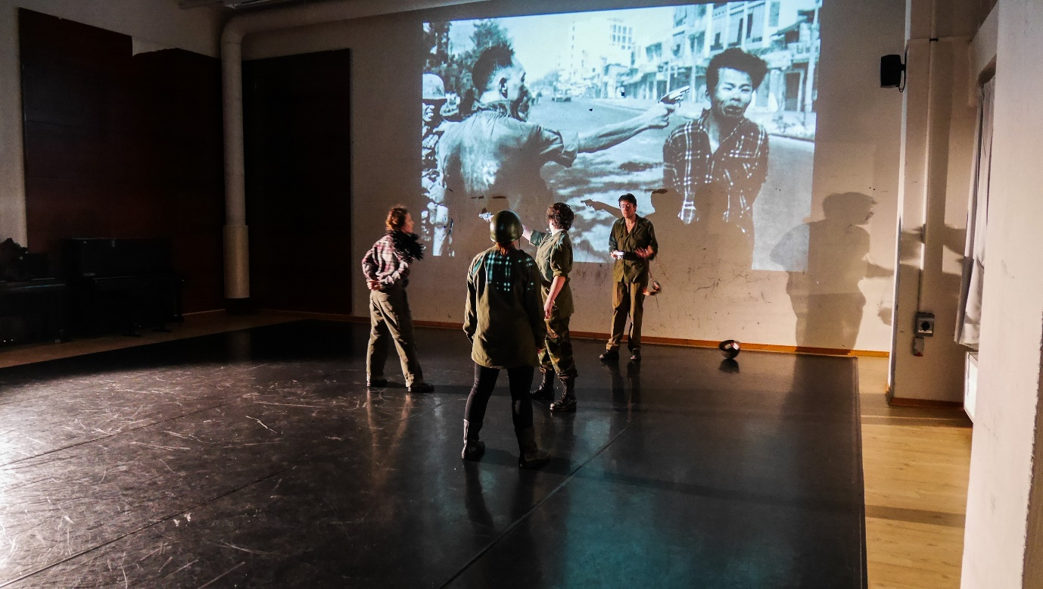

::::::
Reflecting on those two days of hard work by the students, I couldn’t help but feel empathy towards them with their struggle.
The actor’s process is, from my own experience as well as what I’ve witnessed in others, extremely personal. By “personal” I mean that everything the actor does and say as his or her character becomes a visceral memory stored in the actor’s body. It is a lived experience that could be easily mixed up with the one of real life. In other words, sometimes the strong feelings on the stage follow you off-stage. Therefore, one of the important skills for an actor to learn is to be able to choose to be in or out of the boiling lava of emotion, to really step back once the story is told to the audience.
In fact, one of the challenges that came up in the monologue work was “How can I embody something as strong as extreme violence and not be affected as a private person?” One student shared an interesting story. She used to enjoy performing violent scenes in the play and had no problem before or after the performance. But when she was assisting her classmate’s monologue as a passive acting partner to whom the violent lines were spoken, she felt violated and overwhelmed. Suddenly she realized that she was experiencing violence as a private person, not as a character.
Her story sparked a discussion about the actor’s body and the private body. It’s the same body of the same person, but something about the consciousness of the actor makes it possible to differentiate the two. The students are beginning to feel the difference and wanting to learn the skill to do so.
For Davide, his focus on the monologue work was how to bring violence “closer” to the audience, how to bring life, humanity to the people in the photographs that seem so remote from us. He quoted a Hungarian war photographer Robert Capa, “If your pictures aren’t good enough, you’re not close enough.” As he worked with the students on their monologues, some of them expressed the feeling of helplessness and emptiness. They’ve got the desire to do good work and be true to the people they portray. But they felt that their bodies were not fully ready to embody the experience of the real people in the photos. “I feel like I don’t have the tools to explore anything about my character,” one of them said. There seemed a big distance between the person in the photo and the actor’s body and mind.
Distance in the actor’s process… You don’t want to be too close to a degree that you cannot differentiate fiction from reality. You don’t want to be too far to feel anything at all. So, how can an actor know the right distance to bring life to a character?
Imagination, empathy, and humanity. Those are the words Davide often used for the last few days to encourage students to search for ways of exploration. During the monologue work, when a student was able to tap into the vulnerability and complexity of his or her character, he would point it out and say, “I didn’t see ‘a victim’ of violence, I saw a human being.” That, I feel, epitomizes the meaning and purpose of “re-imagining violence” for the actors.

:::::
At the end of one session, the photographer Kemê Pellicer stopped by to share her thoughts on the photos she took and edited. As much as it’s been such work for the actors to be the characters in the photos, Kemê also has done a great amount of work to make the photos as powerful as they could be. It was such a rare and special thing to listen to her side of the story.
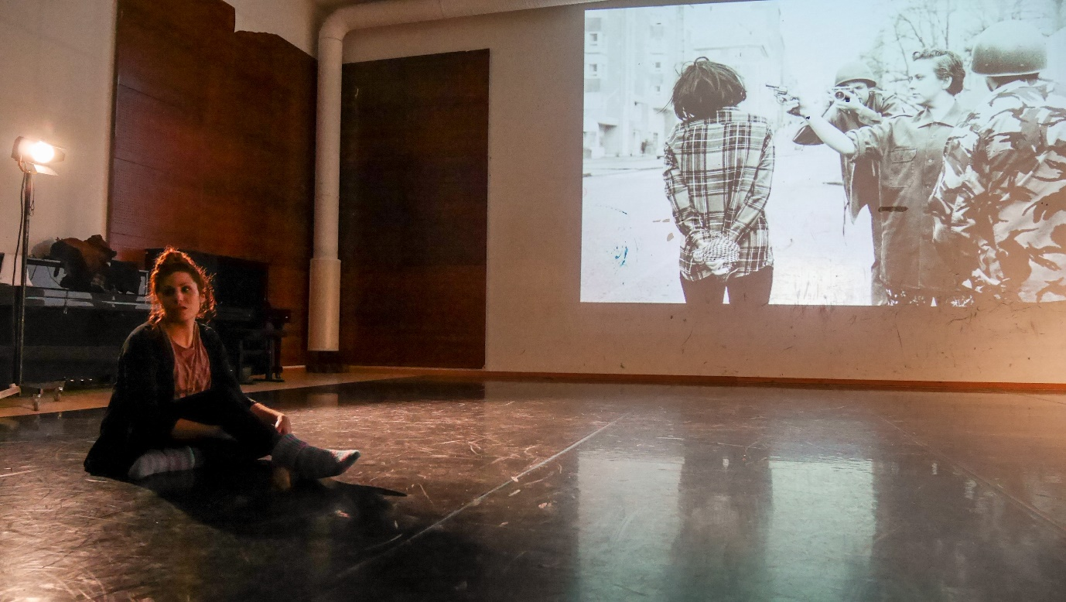

::::::
The last day of the course was mostly run by me. The students had already done a great deal of reflection both in and outside the course. So, instead of another reflection session, I decided to hold a short Suzuki Method session to share one of “the tools” they could use to develop and explore their characters. Specifically, I tried to connect a few elements of the method to what they had been working on in the course, such as embodying extreme conflict or violence. To my relief and amazement, they dove into the exercises with joy and rigor after all the days of daunting, intensive work. It is one of the things I admire about this group of actors.
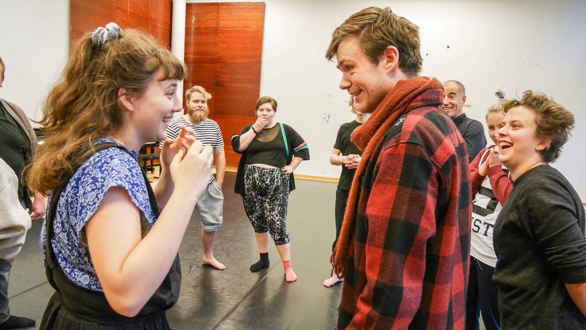
:::::::
Davide gave a brief wrap-up speech in the end. There were more questions than answers. The questions that haunt us and drive us to search. He asked them to keep the questions burning.
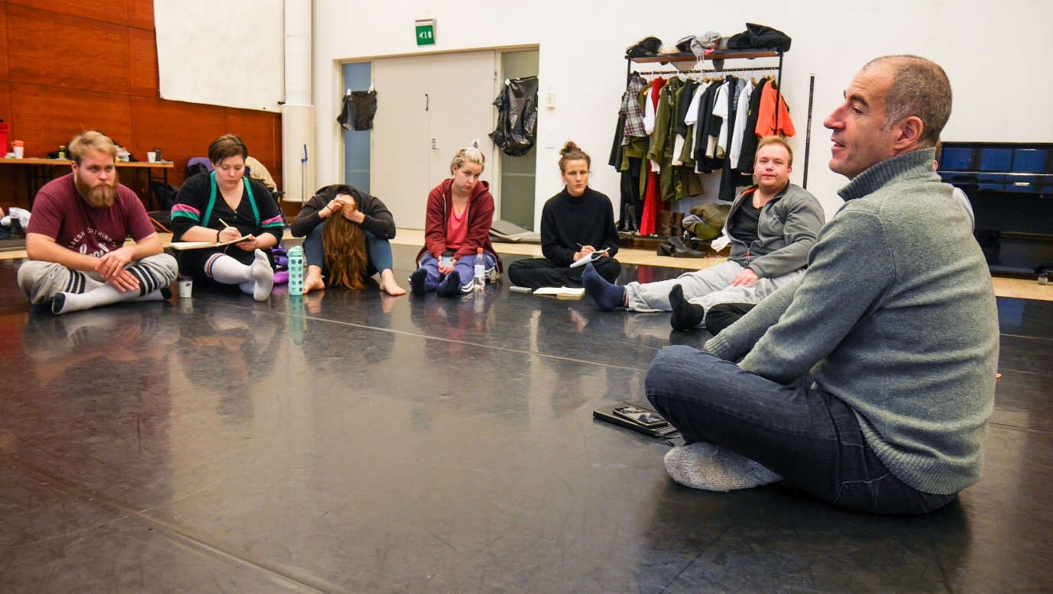

The work will continue next year with the half of the group. It will be a full-time, 6-week long process. I will also continue to be a part of it as a pedagogue.

So. To be continued.

