Navigating through chaos and disorientation
27.1.2018 (Sat) written by Yuko Takeda
For the third week of “Imagination of Violence- atelier 1,” we moved the main place of work from ETLAB (the Peforming Arts Lab/ Työpajankatu 10 A) to Studio 1 at Teatterikorkeakoulu, TeaK (Theatre Academy/ Haapaniemenkatu 6).
This change of space had been scheduled a long time ago, so we all knew about it. But I hadn’t really anticipated the influence the change has had on me this week.
ETLAB is a space for educators, researchers, and doctoral students at Uniarts Helsinki’s Theatre Academy to investigate under fascinating themes and pursue their interests in art and art pedagogy. The space is in walking distance from the main building of TeaK, but it is isolated from it enough to be free from all the hustle and bustle of the school. It has a clean wooden floor and big windows. We had the luxury of spending two weeks there. It was like being in a secure incubator.
Studio 1 at TeaK, on the other hand, is a black box theatre space with a concrete floor and no window. It is located right by the cafeteria and aligns with other studio spaces in Tori, the lobby. In other words, it exists in the place where all kinds of actions happen all the time. Coming back to the lively, hectic atmosphere of a theatre school after the tranquil isolation of a laboratory space was slightly disorienting to me.
And the third week’s schedule was somewhat echoing the disorientation I felt. There were many different things to do in class: physical training, physical improvisation with music, the monologue work, the field research for invisible violence, the discussion on a scholarly paper about fashion and violence, listening to a lecture on violence by a psychologist, watching a documentary film “The Act of Killing (2012).” Each one had a strong impact in its own right. It felt as though we were being stretched to many directions.
Davide also invited the students to attend a series of presentations by postdoctoral researchers, including his, one morning. Before jotting down the highlights of the week, I want to mention a few things about the presentations. They are related to the theme of this blog post and raises an important issue in the field of artistic research.

The first presenter was Davide. He told the audience the summary of his current research, a part of which is this course. One of his initial questions to start his research was “How can theatre respond to violence?” From there, he planned several ateliers where he and the students could investigate the theme from different angles such as distance (November 2017), intolerability (Jan. & Feb. 2018), and sacrifice (autumn 2018). He also intended to incorporate artistic research into the actor’s process in the courses to develop his or her own methods. In the beginning, he did not know what those ateliers would produce or generate. Once the atelier series started, it has been like a Pandora’s box. The complexity of violence and the imagining of it have kept getting deeper, more perplexing, and more sensitive.
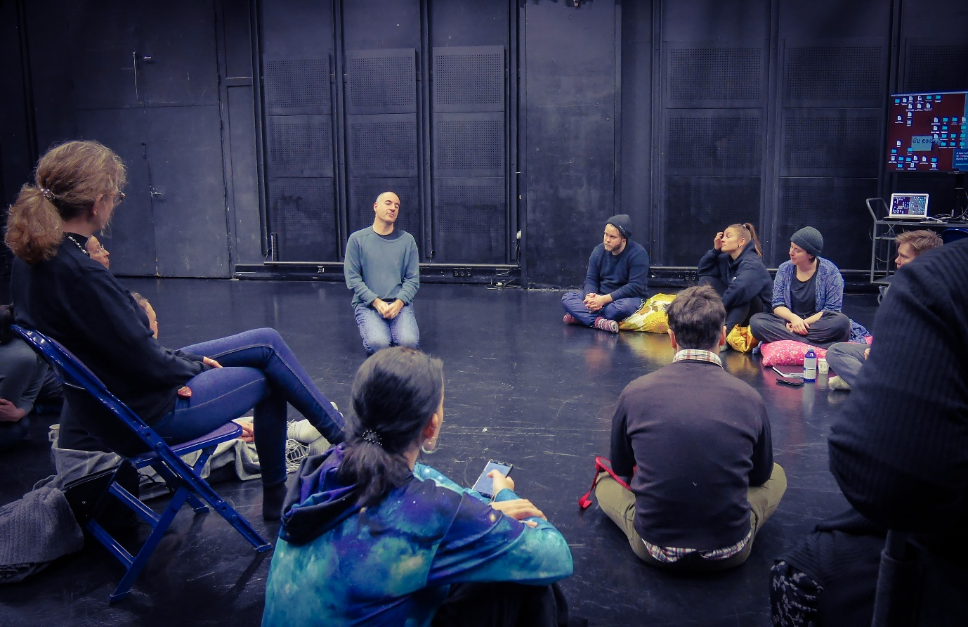
After Davide finished his speech, the students were asked by the audience what their experience was like in the course so far. What is the difference between this course and any other acting courses?
One of them said that the framework of research put no expectation on the actor’s work, which is liberating. “Usually in an acting class, even if a teacher tells me to do whatever I want, there’s an expectation to be ‘good.’ But in this course, I can be ‘bad,’ and that’s part of my research.”
Another student expressed her struggle and discovery in embodying violence. “When we were dealing with the theme of distance last semester, I was thinking, ‘Whose pain can I embody?’ Some of the images of extreme violence felt so remote from me that I didn’t know how to reenact it. But Davide told that we had to find humanity in those who commit acts of violence and to love them to play those characters. I worked on my monologue of violence in this course, and now I think I’ve found it. I love my character.”
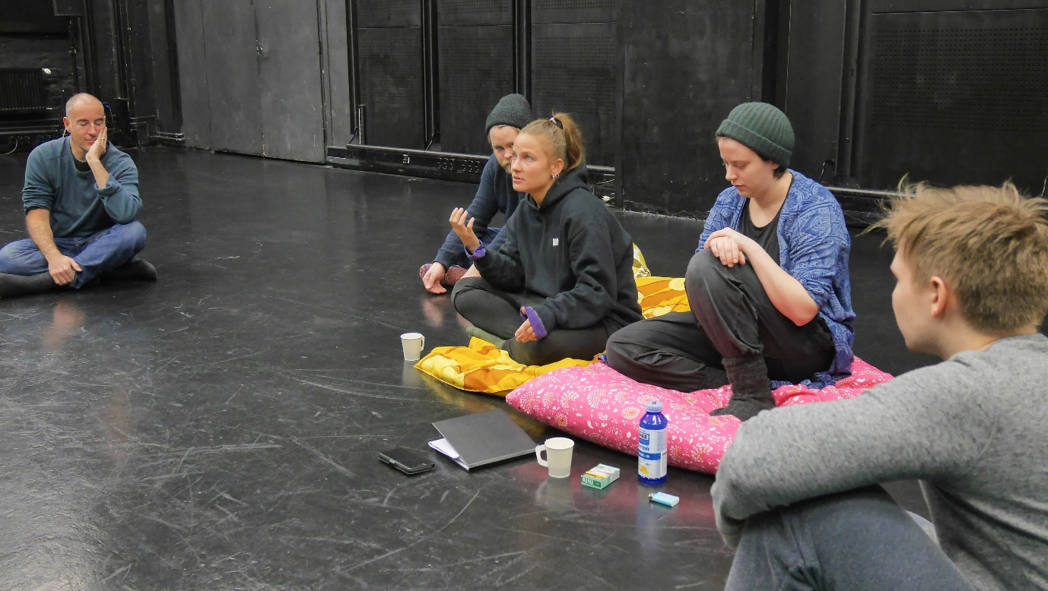
>>>>
After Davide was Anu Koskinen, an actor and researcher. She sat on a cushion, facing the audience, and said that she wanted her presentation to be more like a conversation. She briefly and quickly told her past works and research, most of which were about connecting the body to Foucauldian thinking, developing an embodied corporal methodology for artistic research, and practices of self. She defined “self” as the corporal manifestation of ethical conceptions, values, and constructions.
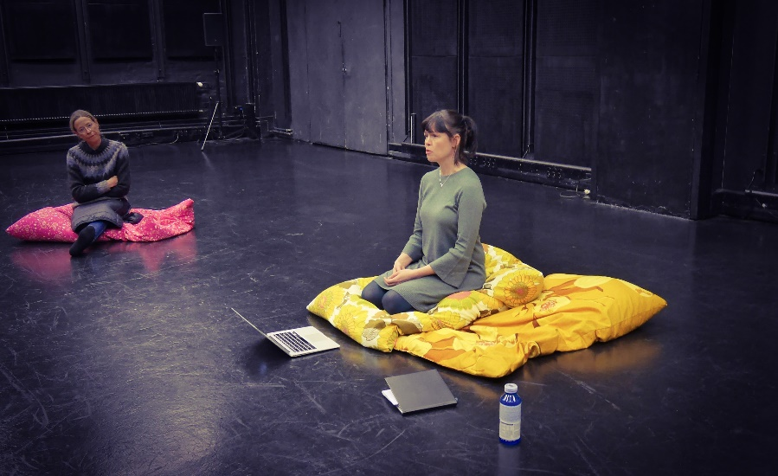
What struck me most about her presentation was when she talked about the burnout she experienced after conducting an artistic research and performance regarding climate change. “I must accept my being an ant. Unless you’re the president of the United States or something, you have no power to change anything in the world. I was completely burned out after the last performance I made. So, yes, I am an ant, and that’s, that’s.. I must accept it.” She expressed her hesitation in placing activism and artistic research side by side. What difference can an artistic researcher make in the society after all?
Her frank delivery sparked a few emotional reactions from the audience. If one doesn’t want to contribute to the society or a community in some way or the other with one’s research, then what’s the point of doing it? etc.
It seemed to me that the questions boiled down to “Artistic research for what? For whom?” … Some people might say that it’s the process that matters. Maybe so. But I also think that honesty to those simple questions can help in navigating through this rapidly changing world with a massive amount of information spewing all over, confusing and overwhelming the minds of ours.
>>>>>>
Now, let’s go back to the students’ work for the third week.
The physical training consisted of the Suzuki Method, the Hino Method, and Viewpoints as usual. We used movement classrooms at TeaK for the training instead of Studio 1 because the studio has a concrete floor that is not suitable for some of the exercises I teach, for example, stomping in the Suzuki Method.
This week I tried to be more conscious of specific, individual needs of each student in training and to formulate instructions and feedback according to them. The aims are the same as before (strong concentration and focus, greater sensitivity and specificity of the body, powering the voice with the whole body, etc.), but each one has a different pathway to get there.
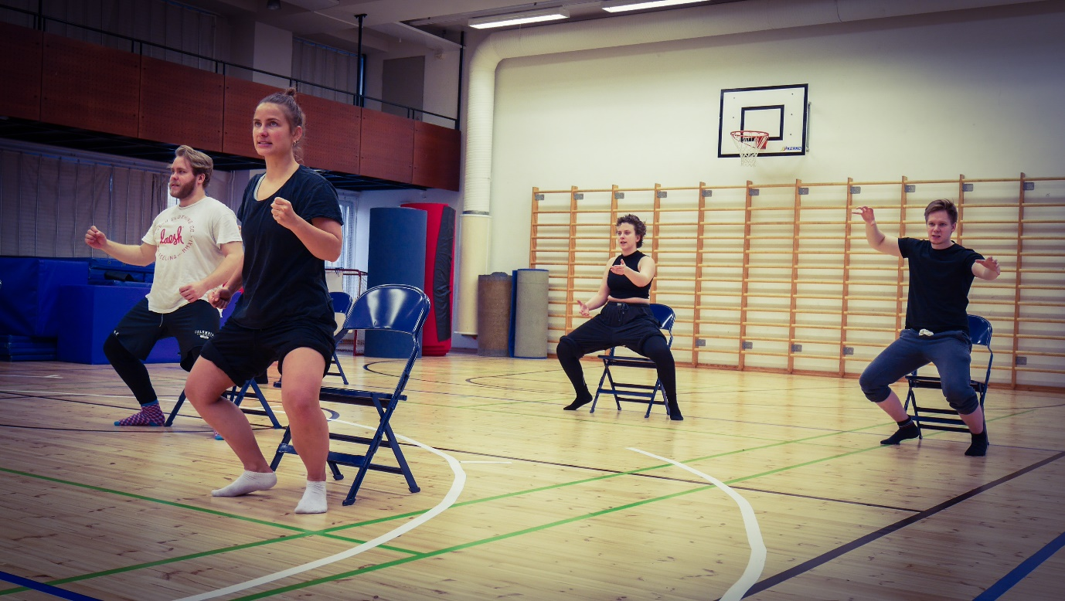
At the same time, I also started to emphasize the awareness of space and others. The Hino Method has many exercises where one practices to sense other’s intention through the body and move accordingly. To be moved by the other requires complete listening and surrender to the body’s natural ability to respond. It’s harder than we think.
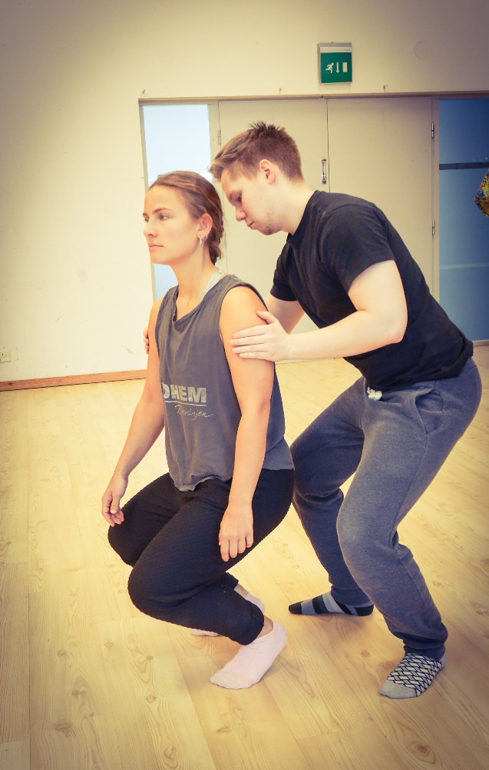
In Viewpoints whole-body listening is important as well. In addition, a performer needs to become aware of him or herself in relation to the space and other people on the stage and to make choices for a collective story. It builds a sense of an ensemble quickly. Everyone seemed to enjoy practicing it.
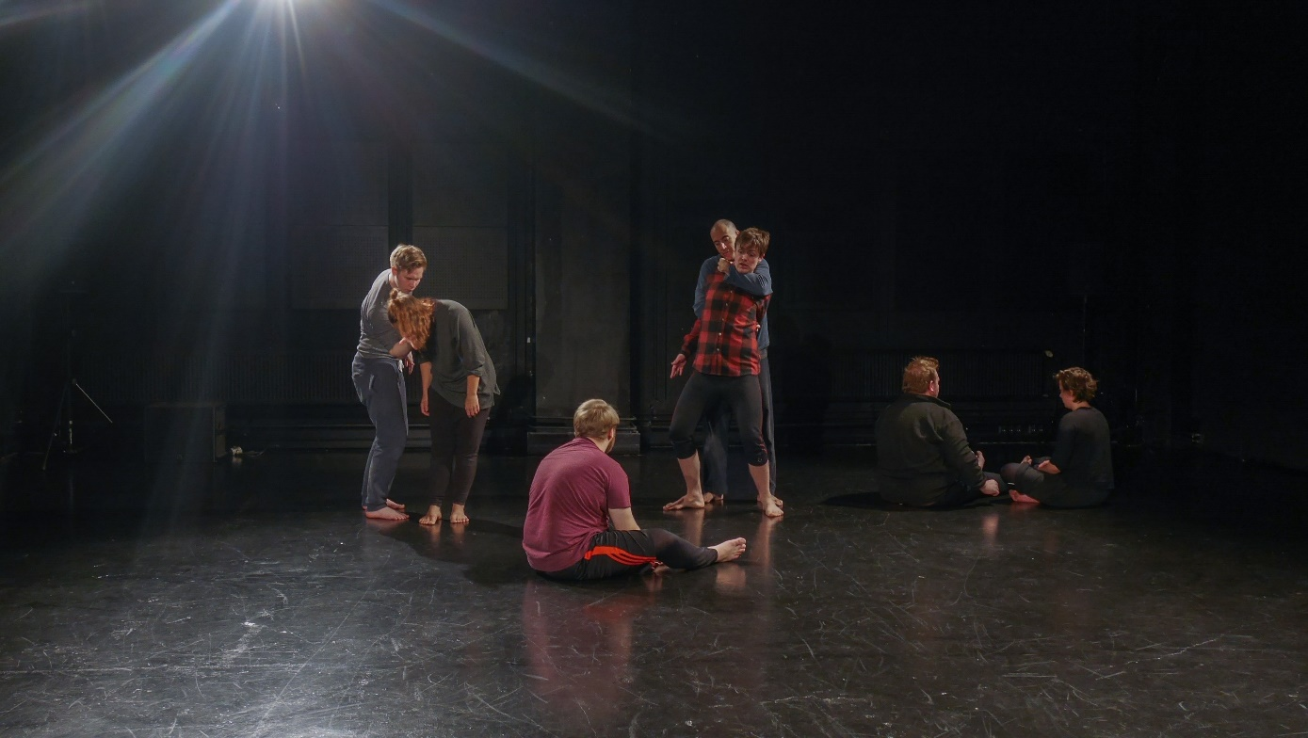
>>>>>
Davide’s physical improvisation with music was about how to embody music. They began with moving invisible brushes to “paint the music” for a few minutes. Then he asked them to use parts of their bodies to do so. “How can your fingers embody the music? Your right shoulder? Your tongue?” etc. A very dynamic piece of classical music was meant to constantly surprise the student’s body and mental state so that he or she wouldn’t fall into just dancing to it. Day by day the improvisation evolved to the stage where the students got to use their whole bodies for a longer duration of time. The main purpose of the improvisation this week was to open one’s body up to the impulses from the music without judgement.
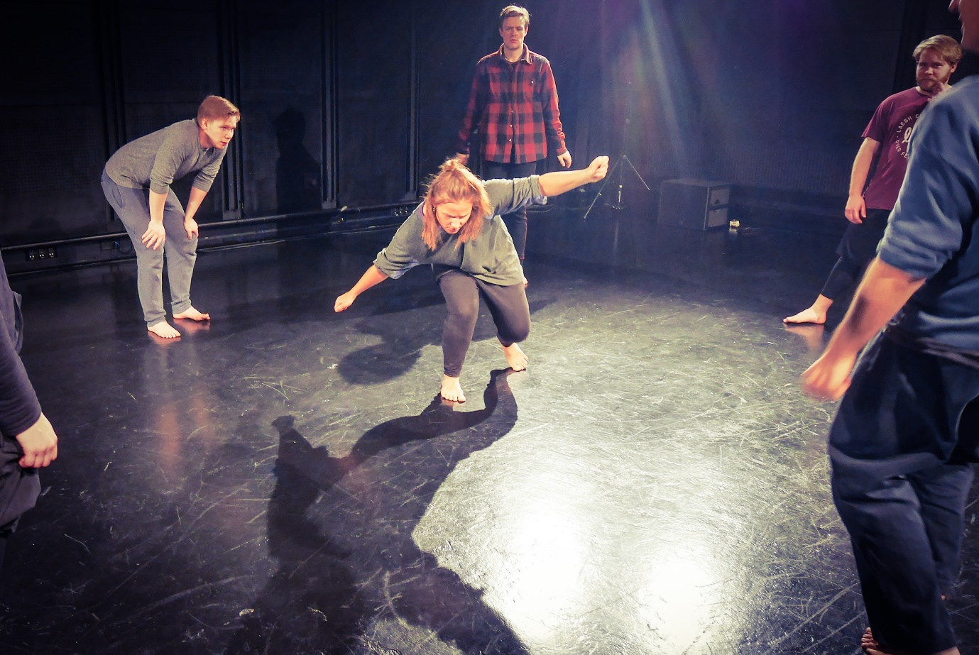
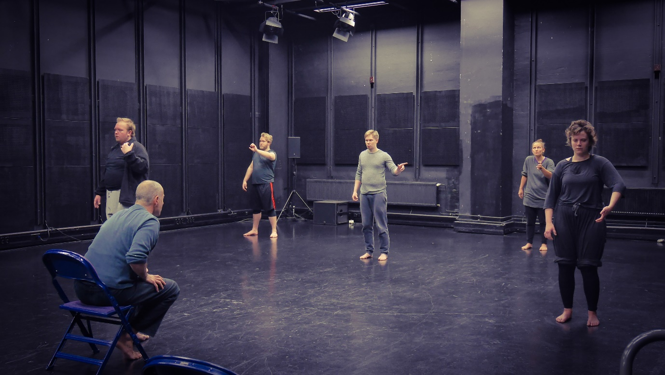
“The next step,” Davide said at the end, “would be to embody imagination with music. I’m talking about the image that surprises you, not an imposition.”

>>>>>
Another main work of the week was the field research to unveil invisible, hidden violence in daily life. The students formed three pairs to go to three different locations: the gym, the school, and the hospital. They spent one afternoon to come up three research questions or hypotheses for observation. When they were trying to articulate their research questions and hypotheses, Davide gave them a piece of advice.
“Think about what happened instead of why it (invisible violence) happened.” We tend to have opinions and ideas about certain places, which limits our perception to see things as they are. Demanding a reason for a phenomenon might aggravate the tendency. It’s a good idea, at least for the beginning, to try to observe with as much of an open mind as possible.
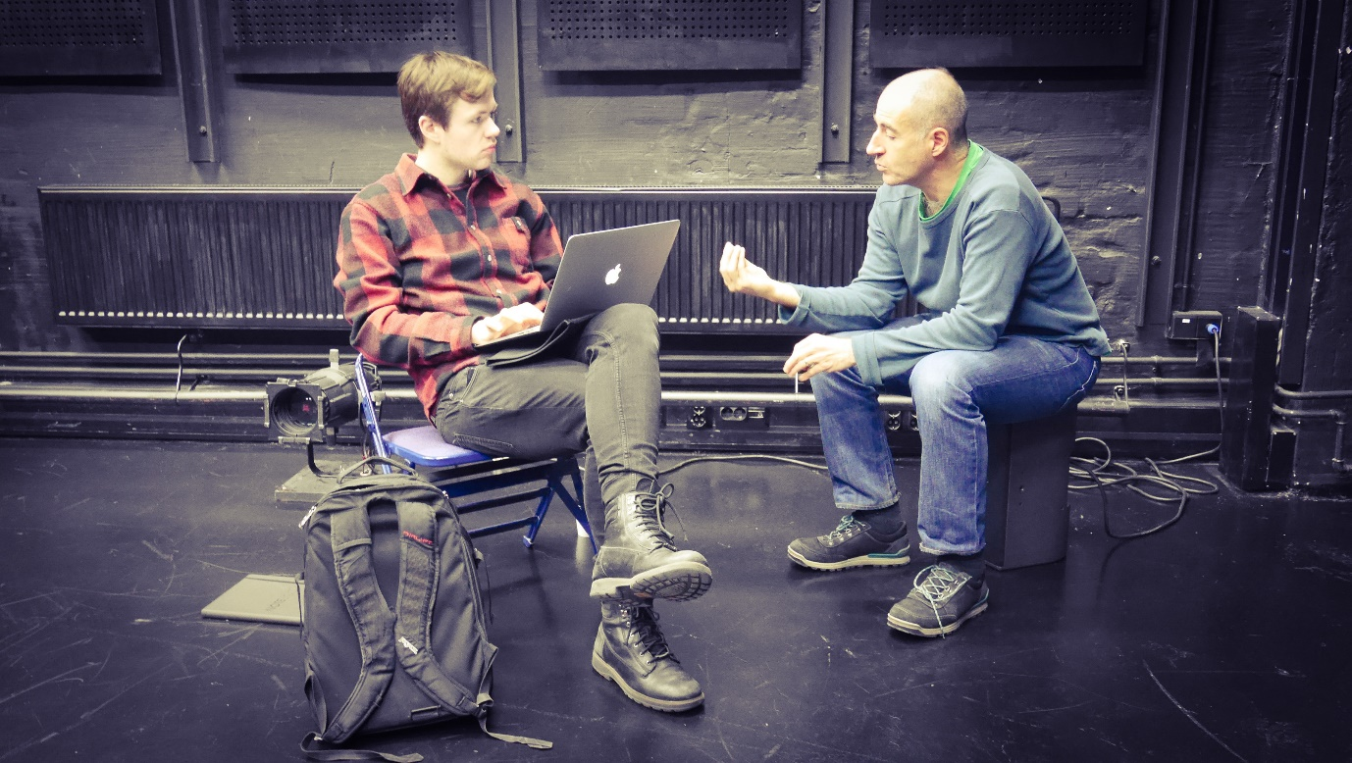
And then in the next-day afternoon, they conducted the field research. I followed each pair to check in with them. One pair sat at the student cafeteria at TeaK to observe the people there and their relationship to the architecture to see if there’s any behavioral difference or hierarchy among students from various departments. The second pair observed at the waiting areas of a public hospital and a private health center. Their primary focus was the status of the patients in relation to the architecture of the space. The third pair went to three different gyms with different prices in Helsinki. Their interests were mostly about gender, ethnic, class divisions in the gym.
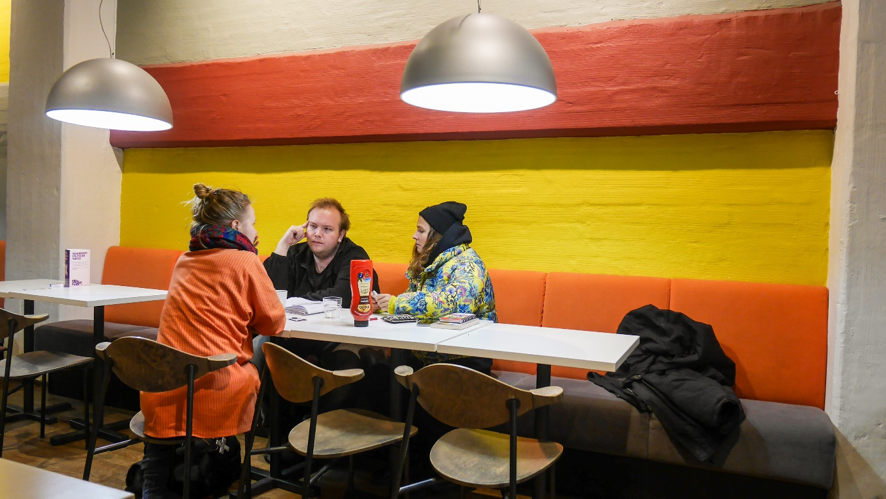
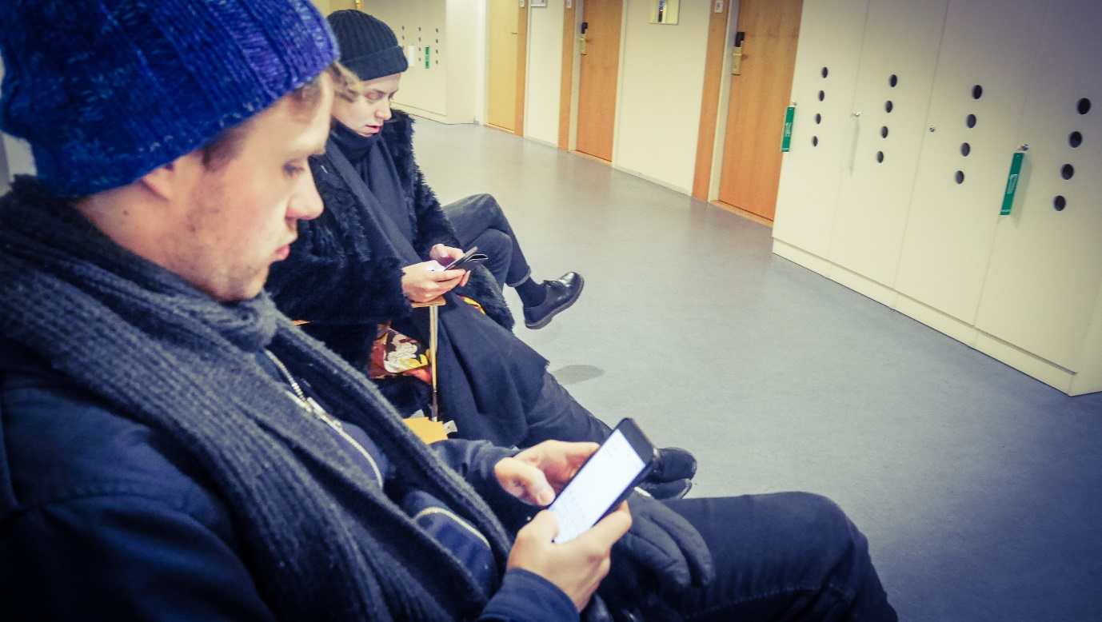
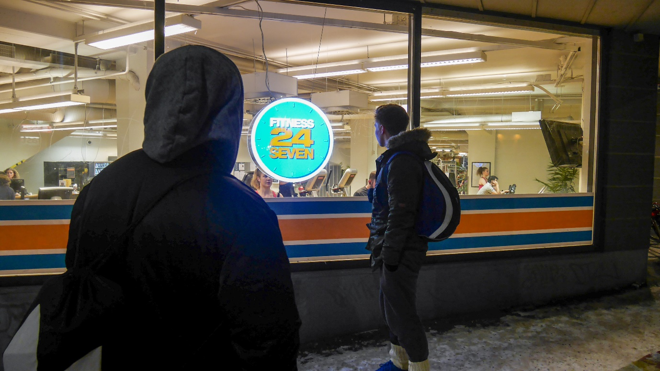
Afterwards, they shared their observations and conclusions with the rest of the class. In addition to observing, some of them did interviews and data analysis to gather more information. It was very fascinating to hear what they shared. It sounded to me that they saw a lot of things, but they were not so sure about how to draw conclusions out of them. At this stage, Davide reminded them that well thought out research questions and hypotheses would make them look at the data with a clear point of view and form further questions to investigate more if needed.
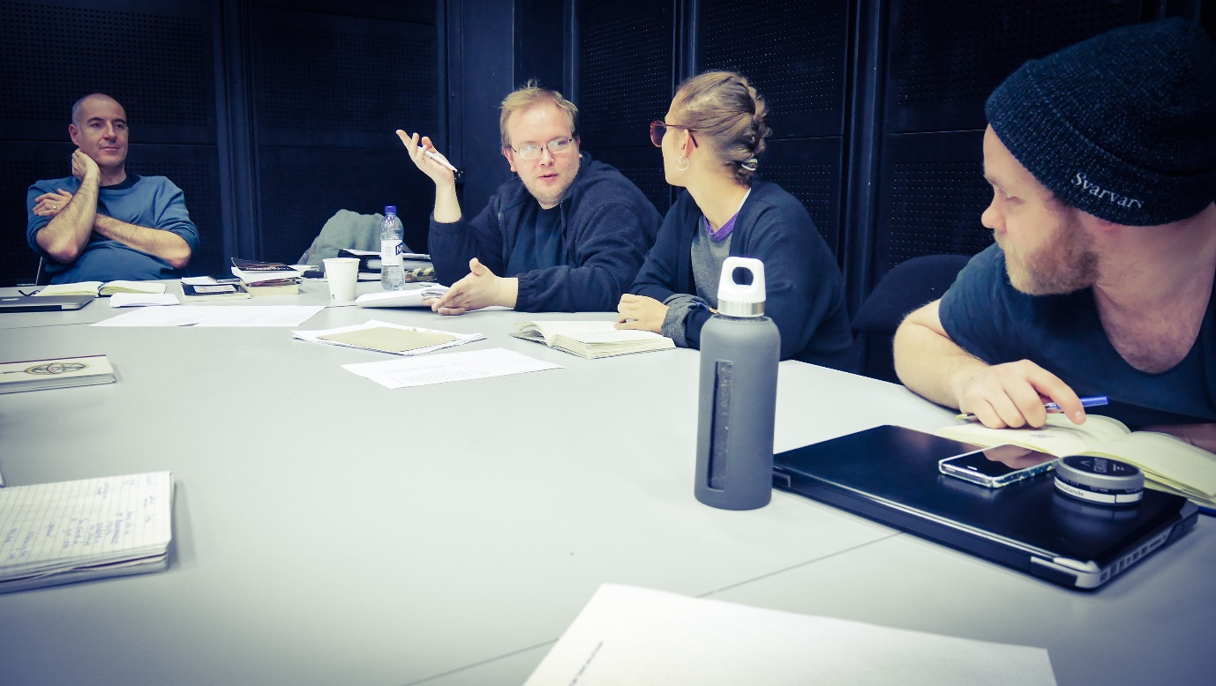
It takes practice to come up with good questions. The students seemed to have taken a step forward to widen their capacity for artistic research through the field work.

>>>>>>
As for the theoretical part of the course, the students read one scholarly paper about fashion and violence for discussion (“Vital Violence: Aesthetic Antagonism and Real Fashion” written by Otto von Busch, 2016). The article illuminates the power structure behind fashion and states that fashion could be the means of exclusion in the society. In other words, fashion is not simply about personal choice or aesthetic but is something that has deeper and more far-reaching influence on social status and culture. It is one of the prime example of hidden violence.
There was also a lecture on violence by a psychologist Pablo Escartin one afternoon. Pablo gave the students the overview of different theories and schools of thought regarding human beings and their violent behavior, such as the biological basis, developmental psychology, motivational theory, rational theories, etc. A stream of fascinating scientific facts and discoveries seemed to captivate the students. Pablo concluded his presentation by saying that in psychology, violent behavior is viewed as the result from the disability to regulate feelings.
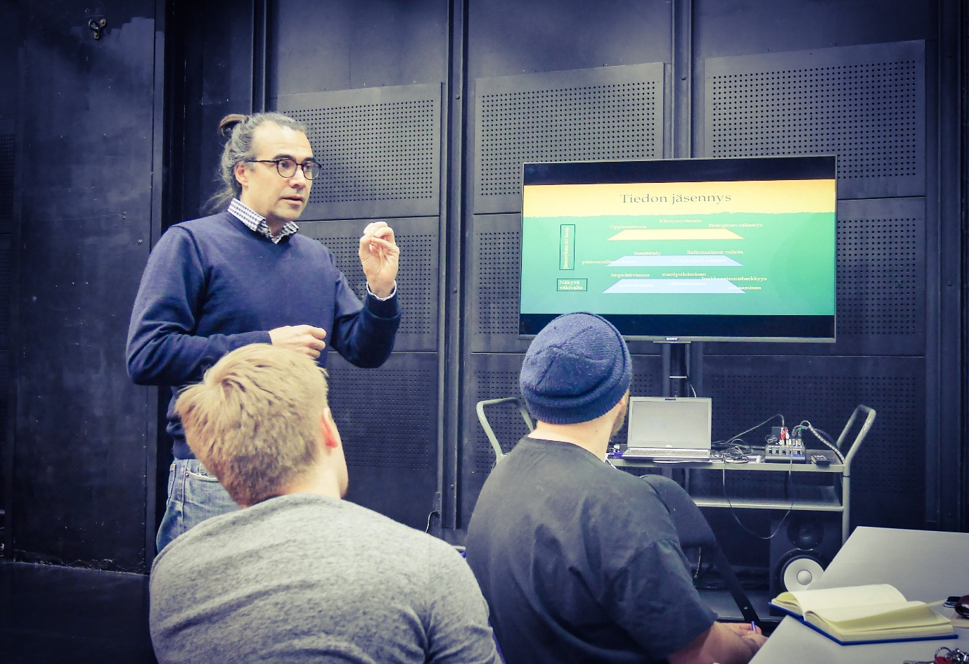

>>>>>
As a provocation of the psychological trauma of violence, we watched a documentary film about the individuals who were involved in the mass killings in Indonesia from 1965-66. The name of the movie is “The Act of Killing” directed by Joshua Oppenheimer. The film’s ingenious storytelling reveals not only the cruelty of the massacre but also the suppressed pain and agony of the executioners. After the movie was finished, we could not really talk about it because it was too disturbing and too visceral to put into words. I felt rather disoriented. And it seemed that I was not the only one to feel so. What do we or can we do once we know that this kind of violence exists? Where do we go from here?
The important thing is to transform those questions into fuel for deeper understanding of violence, not to give into gloom and doom.
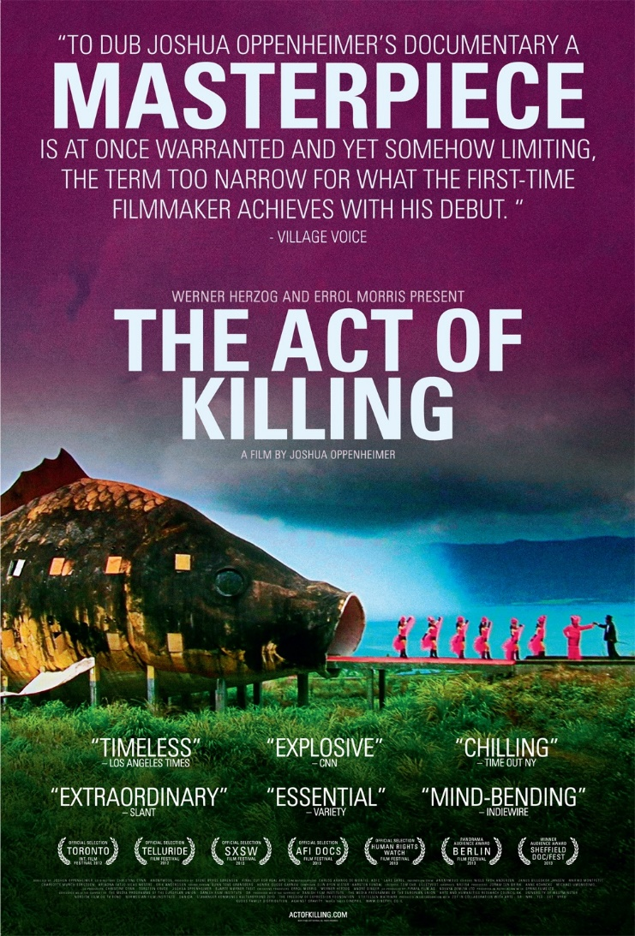
(Image source: http://drafthousefilms.com/film/the-act-of-killing)
>>>>>
To conclude all the monologue work they have done for the last few weeks and to move onto the next thing, three students performed their monologues in full on Thursday. The progress they’ve made from the beginning of the course was astounding. It was clear that they were able to tap into the kind of energy needed to portray the violent characters with power and a touch of humanity. I felt that every aspect of the course and even the other work they’ve been doing outside the course somehow came together to support and enrich their performances. And that’s the experience to which navigating through chaos and disorientation leads. Though overwhelmed and confused at times, the students have been processing a tremendous amount of input underneath their consciousness and with a sheer desire of the heart to perform.
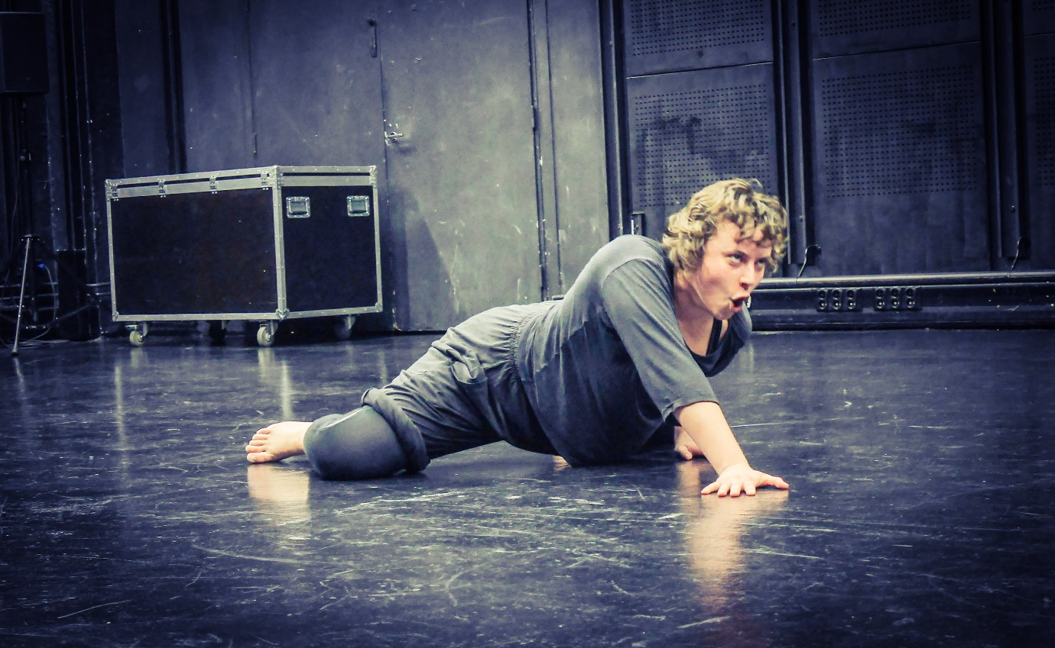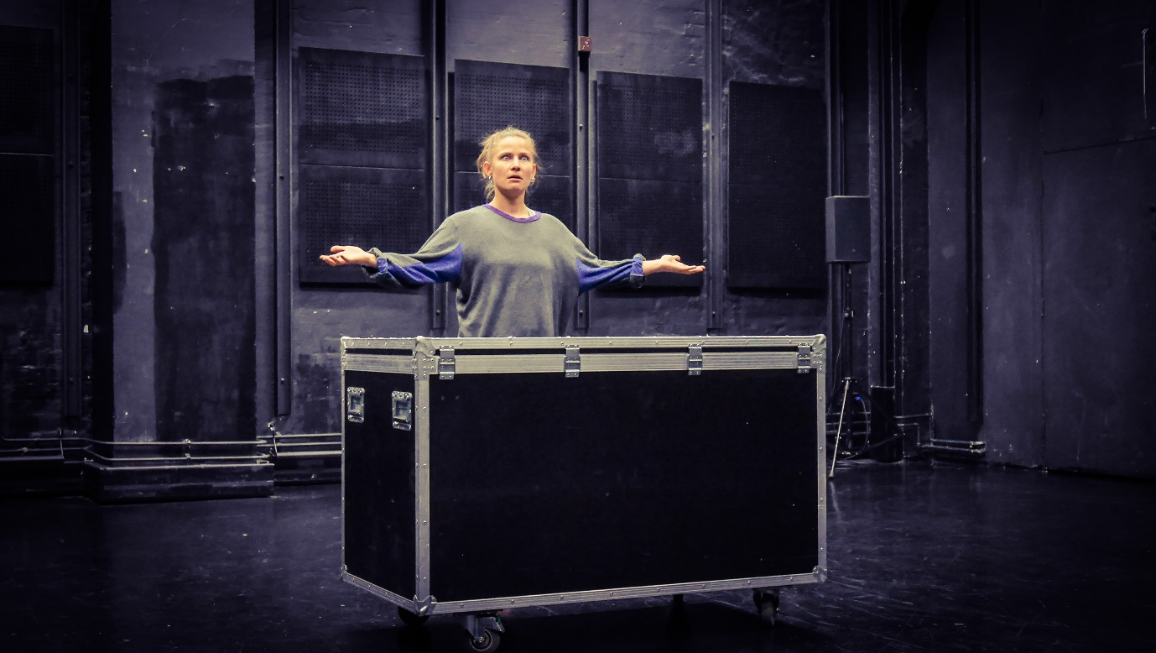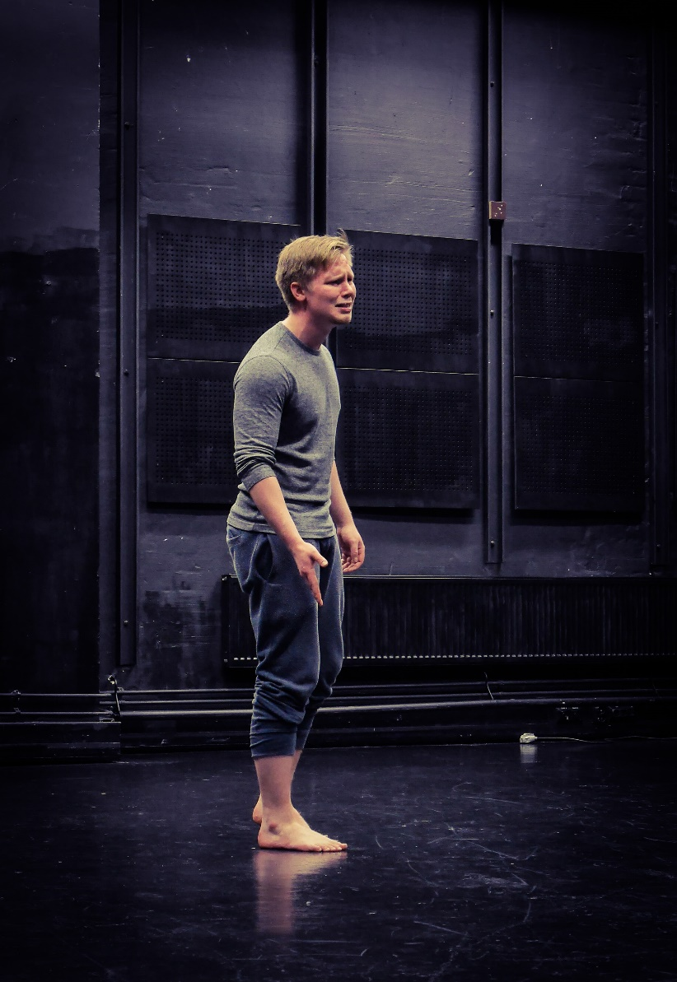
>>>>>
I led an hour of a reflection session on the last day. Instead of discussing or talking about what they have learned so far, I asked them to write down what they remember from the past three weeks of the course. Remembering, as mundane as it may sound, is not the same as recalling the past events. It is active organizing of and selecting from perceived information. It is the first step to make sense out of one’s experience. It also tells a lot about what one considers as important or valuable or interesting. And by physically writing it out and looking at it, one’s memory gains another layer of embodied experience. I think it is an important part of a learning process.. to remember.
I would like them to really feel and own their experience first before reaping insights from it, which will come later.

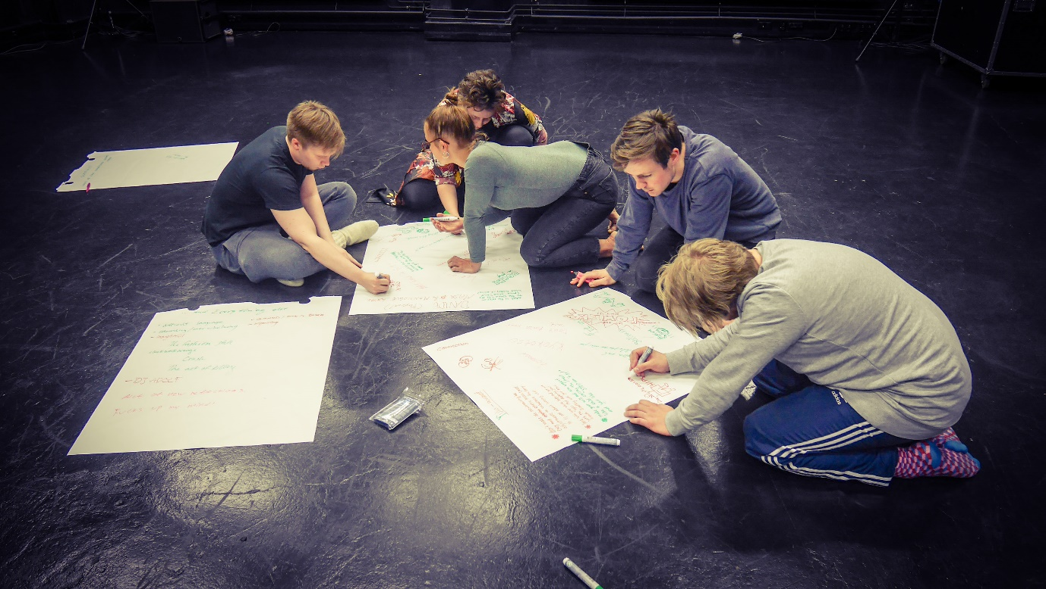

>>>>
During the final hour of the week, Davide told the plans for the next week. The main work will revolve around the grotesque, over-the-top violence in pop culture. In addition, he will teach them mask acting. As for the theoretical part, they will continue learning about psychological views on violence. The students seemed excited for what’s to come.
Good work!

To be continued…

