Violence and fun
Written by Yuko Takeda on February 4th (Sun), 2018
The main work of the fourth week of the Imagination of Violence course revolved around extreme, grotesque violence in pop culture. This included the restaging of the violent images and videos in pop culture entertainment and working on the texts of the infamous school shooters (Eric Harris, Sebastian Bosse, and Pekka-Eric Auvinen) as monologues.
In addition, the masks from Commedia dell'arte were incorporated into the work to discover and harness new dynamics of energy and voice.
As for the theoretical part, Davide gave a lecture on trauma one afternoon. And a psychologist Pablo Escartin was invited back to answer questions regarding the psychological aspects of violence.
The students also watched the recording of a dance performance “ActsAndAffects” (premiered in 2017 at Zodiak), choreographed by Kirsi Monni. The performance deals with the questions and experiences that arise from the relationship between the violent media and reality. It was relevant and important to the course as an artist’s response to violence.
>>>>
It was an unusual week for me. I was absent for most of the week due to the theatre and dance pedagogy department’s field trip to Kautokeino, Norway. (It was for an educational creative workshop with a group of local high school students and the teachers and students from the Sámi University of Applied Sciences and the Oslo National Academy of the Arts.) That is why the summary of the week written above is short without much of my input. I came back on Friday afternoon to watch a work-in-progress performance by the students as a conclusion to their work of this week.
While I was in Norway, I called Davide and two students from the course every night to ask what they did in the course that day and what they thought and felt as questions or challenges. It was mainly for me to stay in touch with the course and to get an overall picture of their educational and creative experiences. The following reflection is based on the phone conversations I had with them.
One of the words I heard the most this week about the course was “fun.” Davide wanted the students to channel the untiring playfulness of childhood to approach extreme, grotesque violence in pop culture. Such violence includes beating each other up in a wrestling match, an eye gorging spectacular in Game of Thrones, obsessive shooting in video games like Grand Theft Auto, and the list goes on. Violence for entertainment numbs a moral or ethical layer of one’s cognitive process and appeals directly to the physiological base of experience such as the rushing of various hormones (testosterone, adrenaline, endorphin, etc.). Instead of judging them as evil or wrong, the students explored what it means and feels to embody such violence on the stage, in a theatrical context.
“It feels weird to have so much fun with extreme violence,” one of the students said. “The exhilaration I felt was a bit creepy, ‘cause I forgot about violence for a second. How does this thing affect me or where does this lead me to?” At the same time, taking a distance from judgement in exploration seemed to liberate them, too. “I like it. Playing in such an absurd, grotesque universe opens my mind on another level,” another student told me.
Davide also continuously told me about the positive, fun atmosphere in the classroom, which allowed many powerful moments of the embodiment of violence to happen. He also said that a methodology for the course was getting clearer in his mind. “There are three different layers of violence for this course. One is ambivalent violence, the one where it is hard to differentiate the good from the bad or the reversal of the two happens. The first two weeks of the monologue work they did was about that. The second one is invisible violence, the one where violence is hidden in a non-event. The field research was to discover such violence. The third is a gory, grotesque, extreme violence in pop culture, which is connected to childlike playfulness and childhood.”
For further exploration of the third one, they will be using fake blood next week. A lot of it.
“I’m curious to see how fake blood will affect their work,” David said excitedly. Most of the students were excited about it, too.
As for the questions and challenges this week, they ranged from practical ones such as physical exhaustion from the exercises to philosophical ones such as “What and why are we doing it?” About the philosophical challenge, one student explained to me, “We talked about extreme violence in pop culture for shock value and how it desensitizes our morality. So, then, aren’t we doing the same thing in class right now? It’s a lot of fun, but.. I don’t know. This might be just a phase in the process, but I sometimes think about that. What is our responsibility in this if this is an artistic research? So, I’m a little confused.”
>>>>>
Hearing all this, I was very curious and anxious to see the students’ work-in-progress performance on Friday. It was a collection of all their major works of the week: the speeches by school shooters and the sequence of enacted violent images and videos from pop culture accompanied by violent music. Here are some of the moments from the performance:
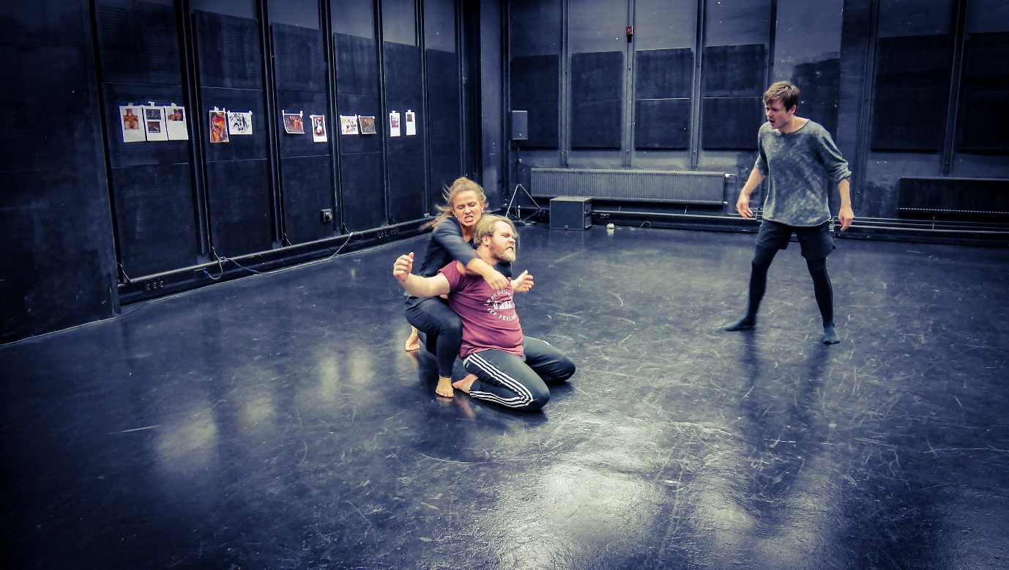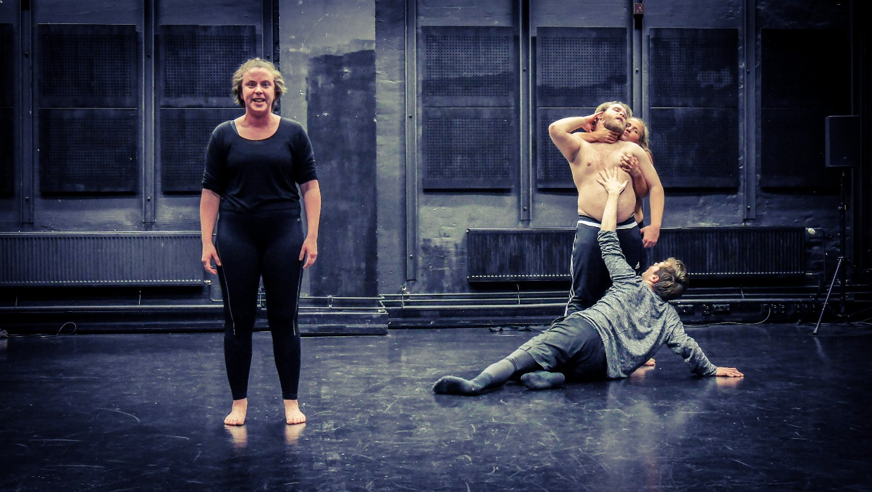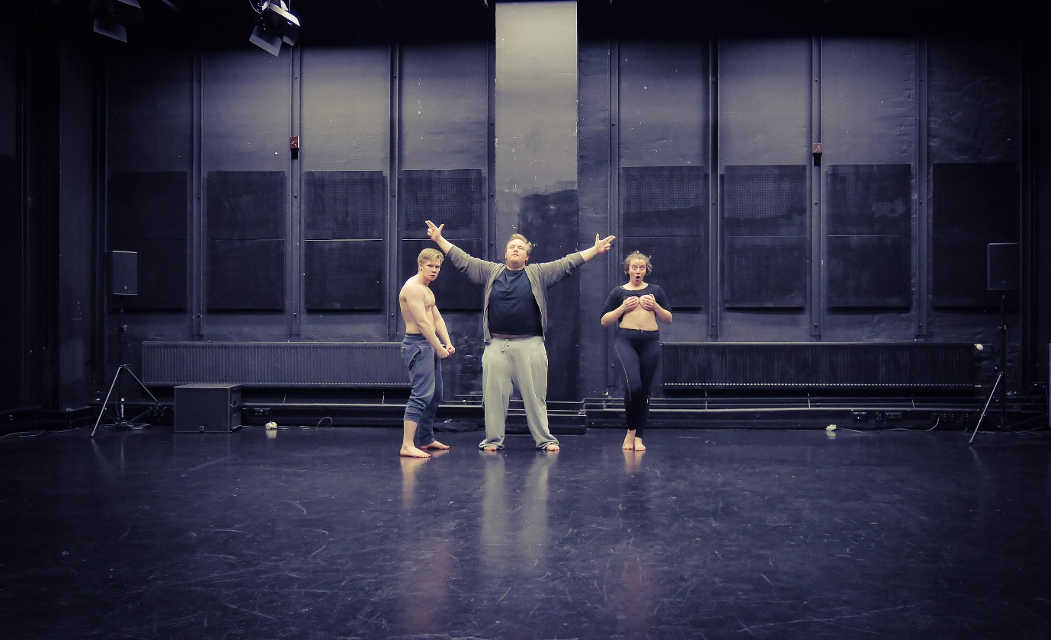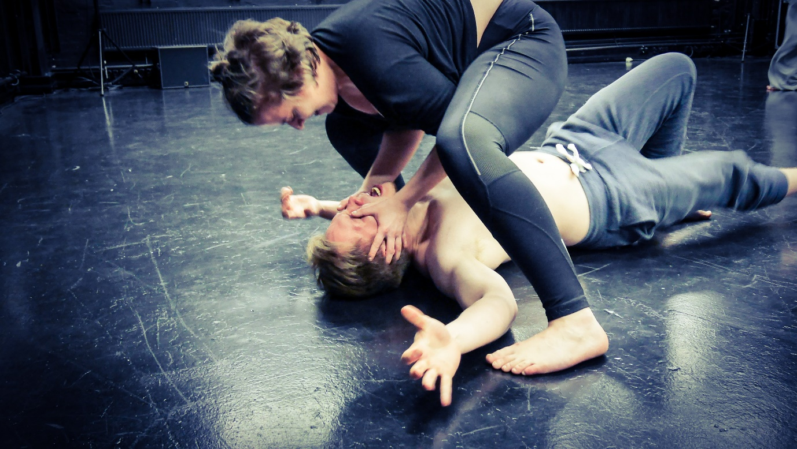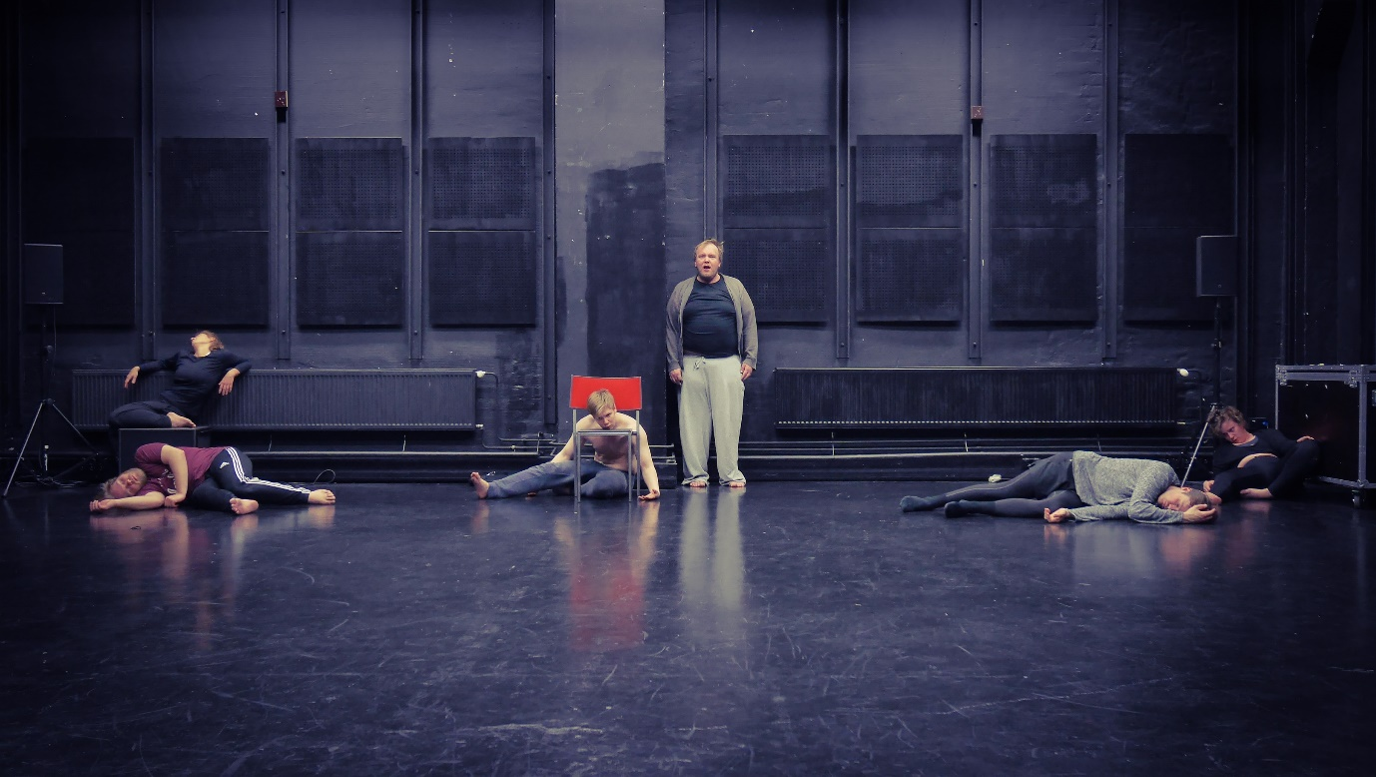
>>>>>
It was a strong experience, stirring a lot of questions and thoughts in me. Afterwards I asked Davide what it was about. He said that it was about the relationship between violence and fun and that they used contrasting styles of pop culture violence to explore it. All the speeches from different school shooters were declamatory so that it would be like a competition, “Who gets to be the loudest?” What he said was visible and audible in the performance.
I also wanted to know what the students thought about the process and performance this week. What were their points of view? One student said, “For me, it’s really simple. There’s too much violence in the world, but we are so desensitized by it. So, this is to show that violence as fun is disturbing. That’s the meaning for me to do this.” On the other hand, a few students expressed a degree of uncertainty and discomfort in the process, which makes them stop and think “Why are we doing this? What are we telling the audience?” But they keep on trying and exploring because they feel the need to get out of their comfort zone and grow as artists.
Davide shared his starting point for the course, “I’ve personally experienced violence, which deeply affected me, and I’m still affected by it. So, I wonder why there is violence and what we can do about it.” This echoes with what he said earlier: How can theatre respond to violence?
“How can theatre respond to violence?”—The word “theatre” is often taken for granted in the question and interchanged with arts or artists sometimes. But what I experienced in the students’ performance on Friday made the word crucial for me. Why do we choose theatre, instead of TV or film or any other medium of expression and influence? When we enact still images or videos or written text on the stage, they become something else, something alive. Theatre can be a visceral dialogue between a specific time and space, the performer(s), and the audience. All the entities involved in the dialogue contribute to the story being told and change because of it. I feel and believe that theatre is an extremely powerful, exciting, generous art form for humanity and that actors are the heart of it.
>>>>>>
Having said all this, I would encourage the students to release the pressure of an artistic research and nourish their playful spirit and a sense of fun for their endeavors. Their curiosity and humanity give depth and meaning to the process no matter how unsure they might feel at times.
Plus, there will be fake blood to play with. It will be fun.

Good work!

To be continued…

