“Deepening the enquiry”
14.4.2019
by Yuko Takeda

The Week 5 of Imagination of Violence – atelier 2: sacrifice and playing the victim went by intensively.
In terms of the content, most of it was the continuation or further development of what they’d started during the previous week: academic research on violence, sacrifice and playing the victim and personal monologues. In addition, they also conducted the follow-up experiments based on the observations and hypotheses from the original experiments on their personal questions and challenges regarding acting. I, as always, led the physical training session at the beginning of the day every day for 90 minutes or so.
Overall, there was an underlying attitude of deepening the enquiry. This attitude was suggested and encouraged by Davide at the beginning of the week, when he shared his thoughts and feelings about the course. So far, his observation is that all the acting work and experiments in the attempt to research violence in the course doesn’t look very different from so-called “a normal theatre class.” They still have to talk about the characters, given circumstances, objectives, actions, or the familiar vocabulary in acting. And they still have to create some sort of internal and/or external conflict to enliven what’s happening on the stage.
So, does that mean that theatre is indeed based on violence or that violence is one of the infallible pillars of theatre? Or are we just “failing” the research? Davide pondered.
He then said that in any case he would like to go a little bit further than those possible conclusions. “I’d like us to explore the hidden violence behind the obvious violence,” he told the students. What it is and how we could approach it are still unknown. But we will at least try.
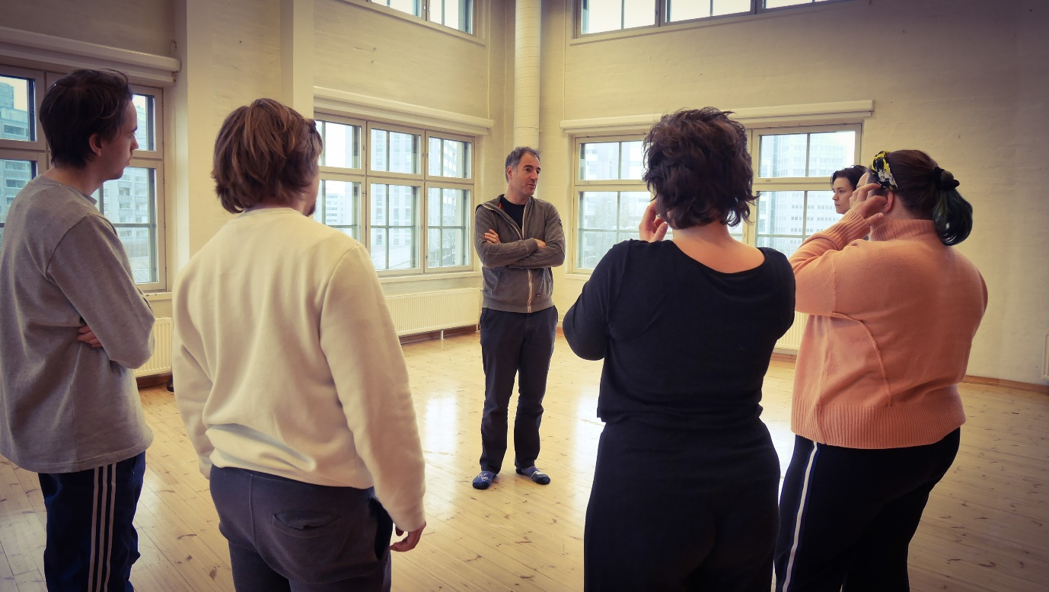
Here are some highlights of the week.
- Academic research regarding violence and sacrifice
At the beginning of the week, the students in pairs shared their findings from the previous week with Davide.. Afterwards, Davide asked each pair how they would like to proceed or enquire further.
The first pair’s research is about consensual violence. They were originally inquiring about BDSM as a possible type of violence that is beneficial to those who experience it. They list the contract and after-care as the elements for consensual violence. Now their questions are about where or at what point violence would happen if such violence was to put on the stage in front of the audience and how simulated or non-simulated violence on the stage affect the audience.
They told Davide that they would like to continue developing the exercises and experiments and to have the audience to test them in the future.
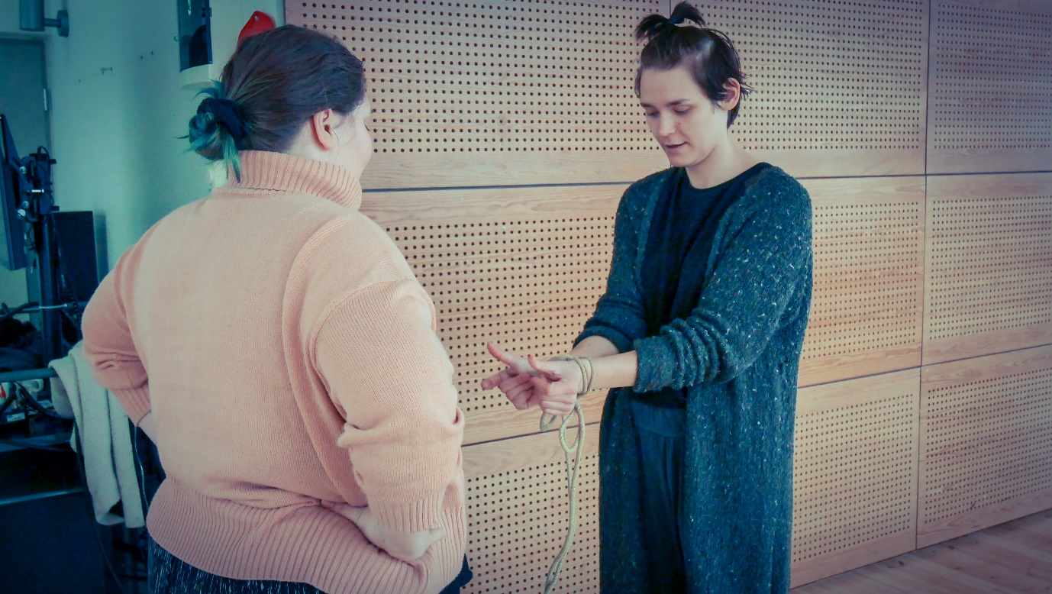
The second pair was researching animality of female and male genders in Hollywood films. They’d watched Ocean’s 11 (2001) and Ocean’s 8 (2018) last week. Their observations and insights were interesting to hear. They said that they would like to watch more films to collect more data on the subject.
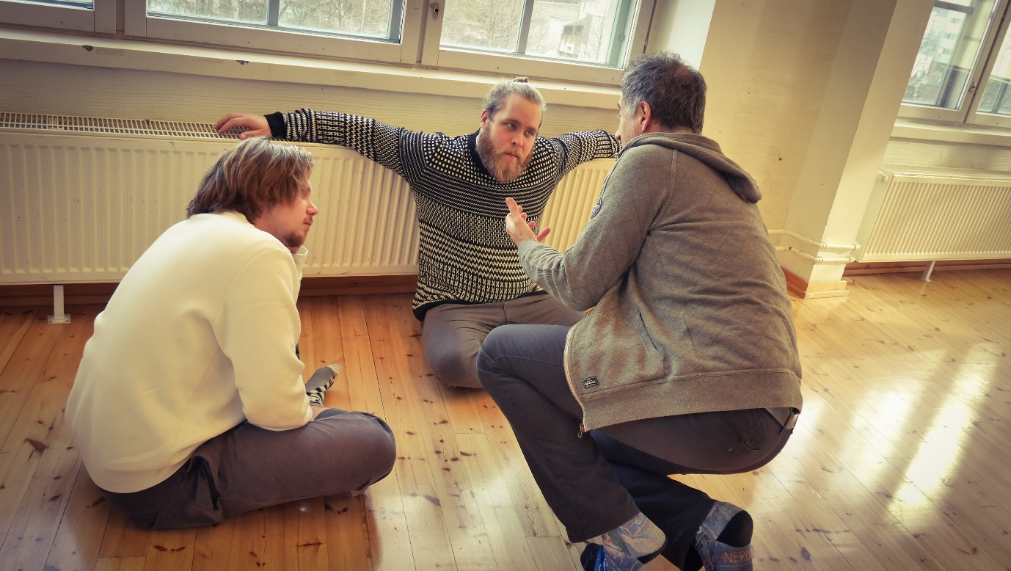
The third pair had sent a questionnaire about the actor’s sacrifice to a group of actors in various working styles: freelance, independent theatre, fixed contract, etc. They shared the summary of the responses they’d gotten and drew a few conclusions based on it. As to how they would like to proceed in their research, they brainstormed with Davide for a while and decided to conduct one-on-one, face-to-face interview with the first-year Swedish speaking acting students at TeaK to ask about their first solo work course and the sacrifice they make for it.
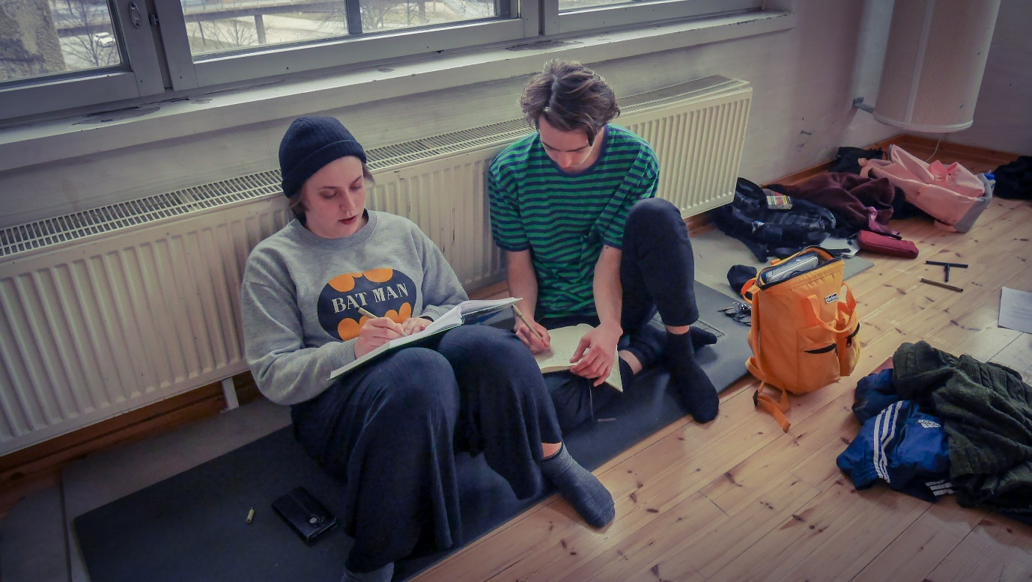

Davide then gave the students one to two hours each day to continue their research.

- Experimentation on acting
For the first few weeks of the course, the students faced their personal challenges/questions regarding acting in the so-called “scientific experiments.” Its primary purpose was to foster an objective, non-judgmental attitude towards learning and evaluating acting. A typical setting for the experimentation is that there is one student as the subject and the other students serve as a group of “scientists” who observe. Each “scientist” student has a specific area of observation such as the actor’s body in relationship to the space or the text, etc. Davide gives 5 to 6 rounds of experiment for each subject under a certain theme or question. After each round the “scientists” make notes of their observations and finally draw some kind of conclusion or hypotheses.
This week Davide did follow-up experiments based on some of the students’ hypotheses. The themes were the exploration of the space, pauses, and the inner friction of the actor’s body. The experiments brought up both fascination and confusion in the minds of the students.
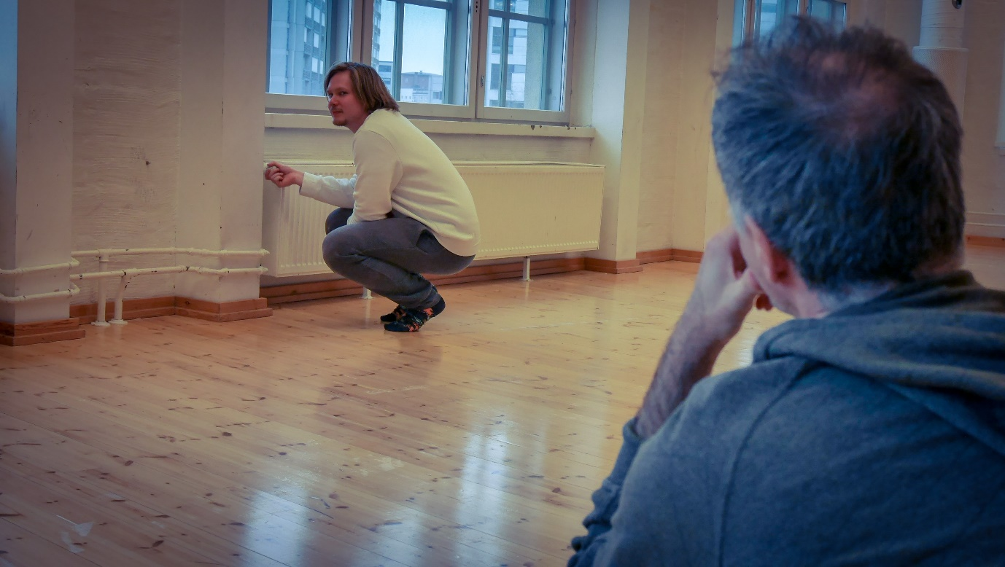
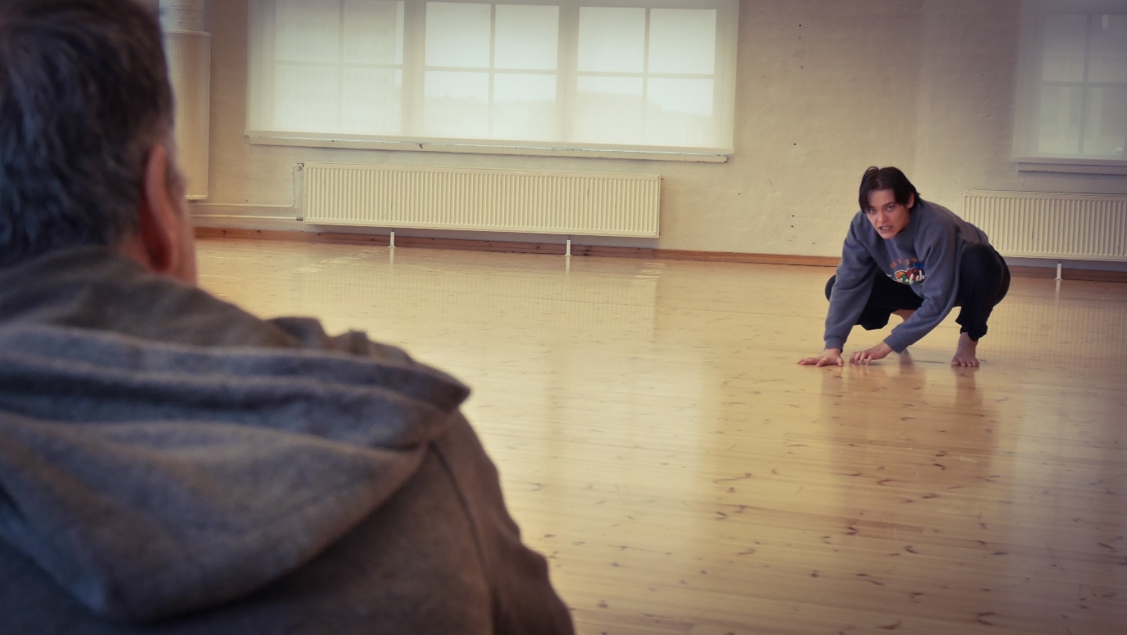
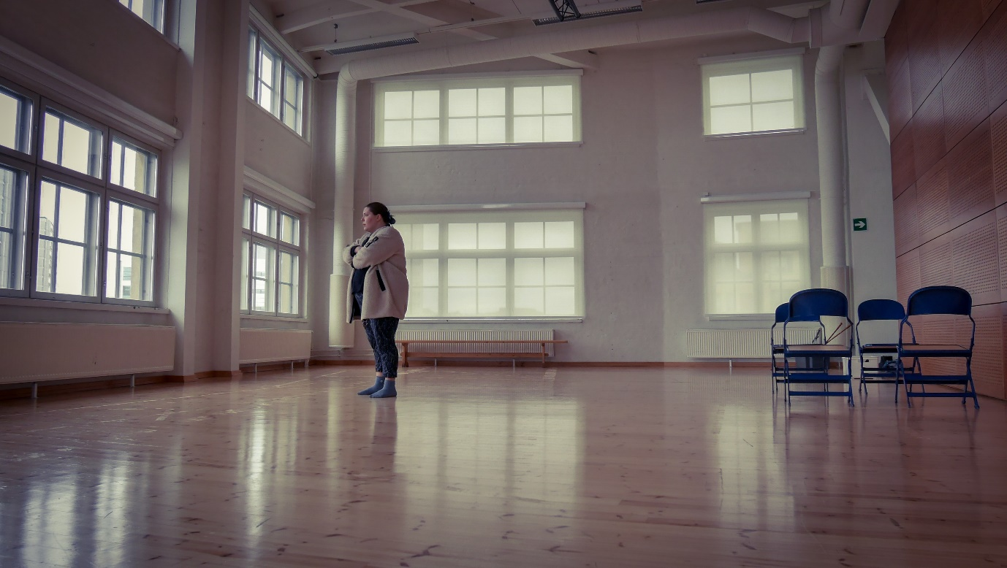
At one point during the experiment, one student asked what exactly artistic research was and how he could do it. In his mind, those “scientific” experiments revealed that it was impossible to be completely objective in evaluating or observing acting. Each person sees what happens on the stage differently. Also, there are so many other factors involved in determining the quality of acting than just a few mentioned in the experiments…
Davide listened to the student’s confusion and told that the definition of artistic research was still in the midst of development. But to Davide, it is about the expansion of consciousness regarding one’s artistic practice. Instead of pursuing the universal truth or objectivity, artistic research strives for deeper and keener awareness of what happened and happens as an artist navigate through his or her enquiry and practice. In order to do so, one needs to first step aside from the desire to judge because once judgement is made, there’s no more room for questioning and learning.
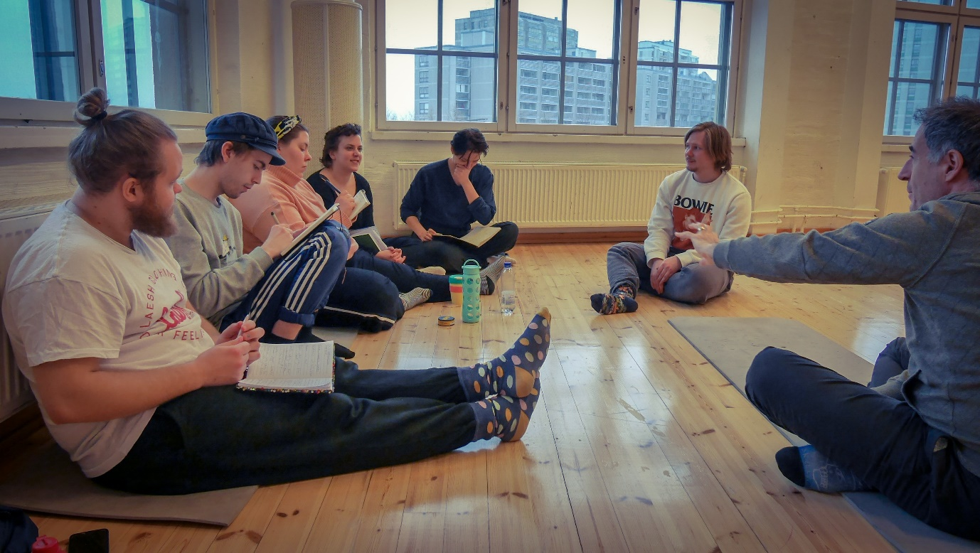

- Personal monologues and scenes
This week Davide focused on finalizing the texts for the monologues. He spent a good amount of time on each student to give advice and guidance for further development. Sometimes he would help them by working the text on the stage, meaning that he would have the student read the text out loud, while trying out some physical actions and circumstances.
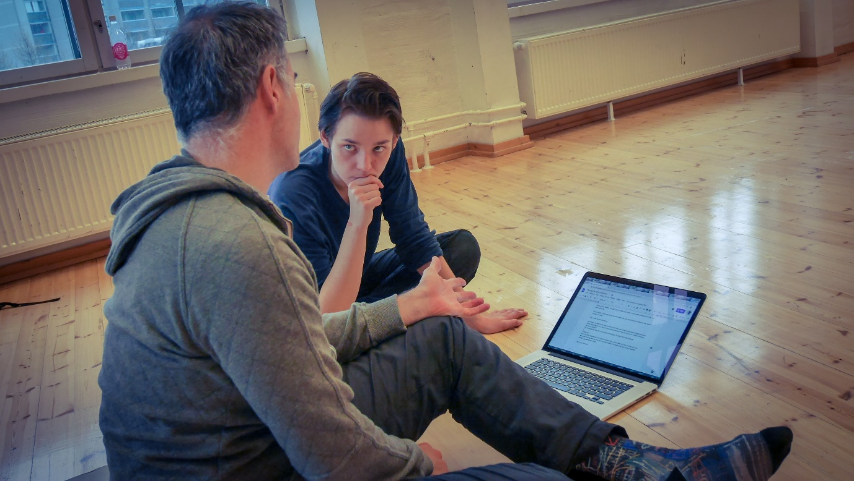
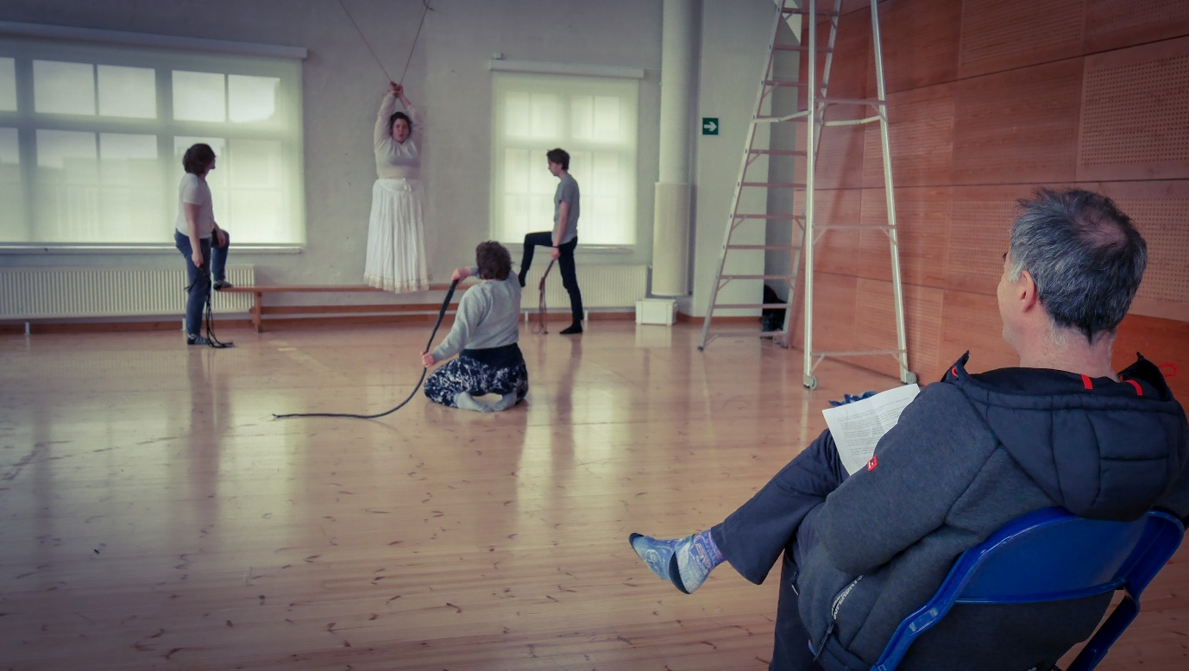

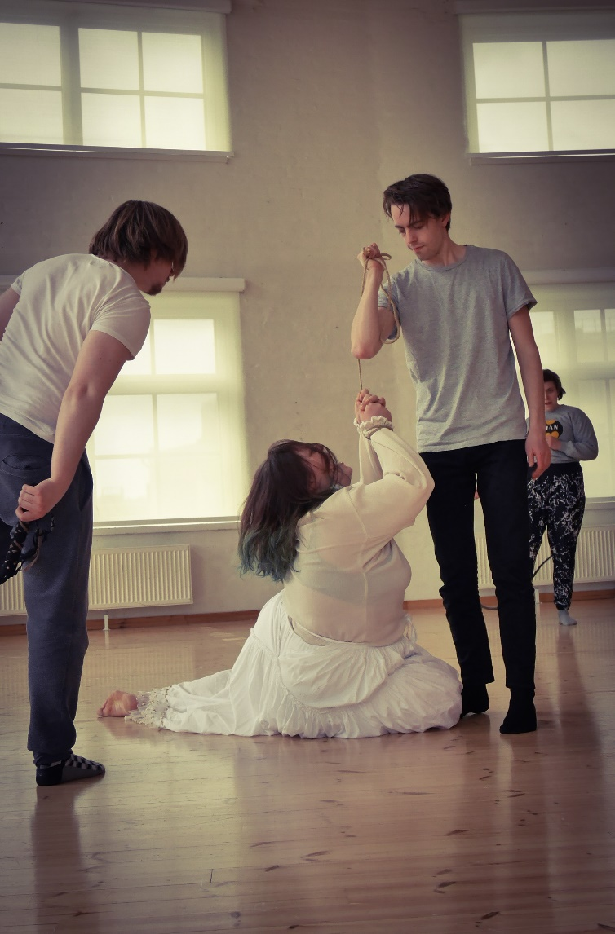
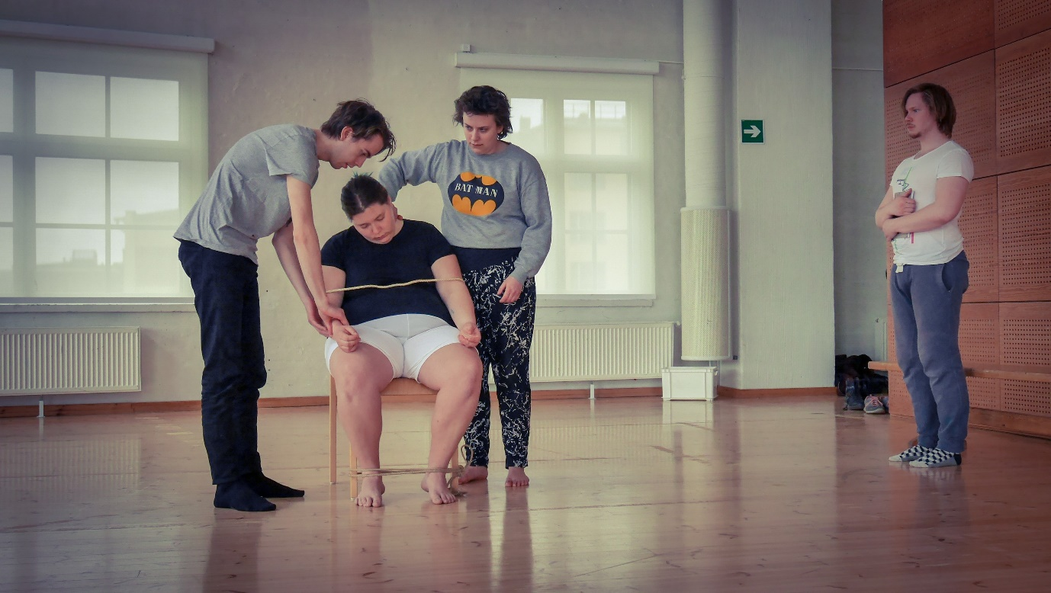
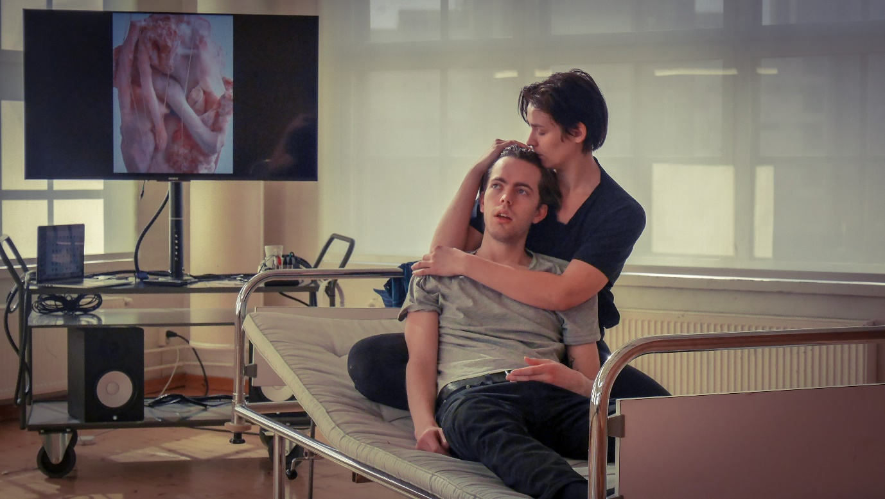
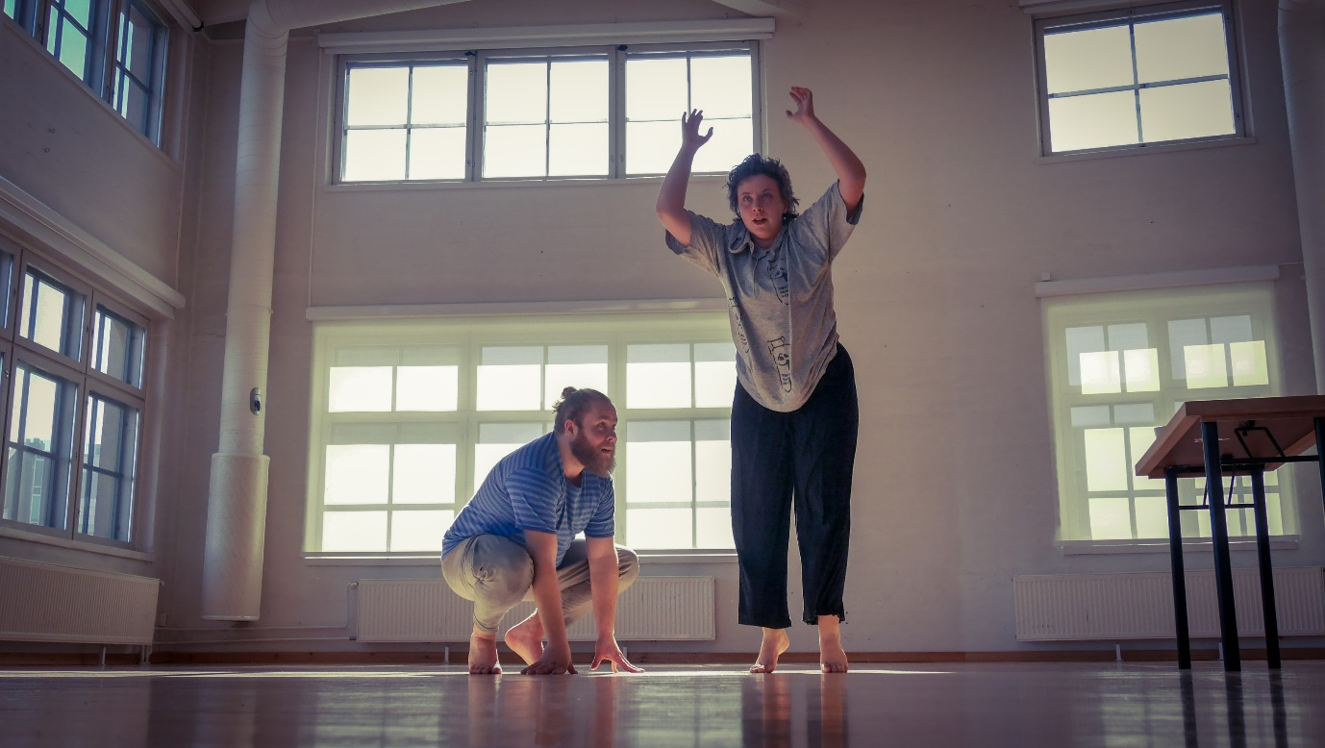
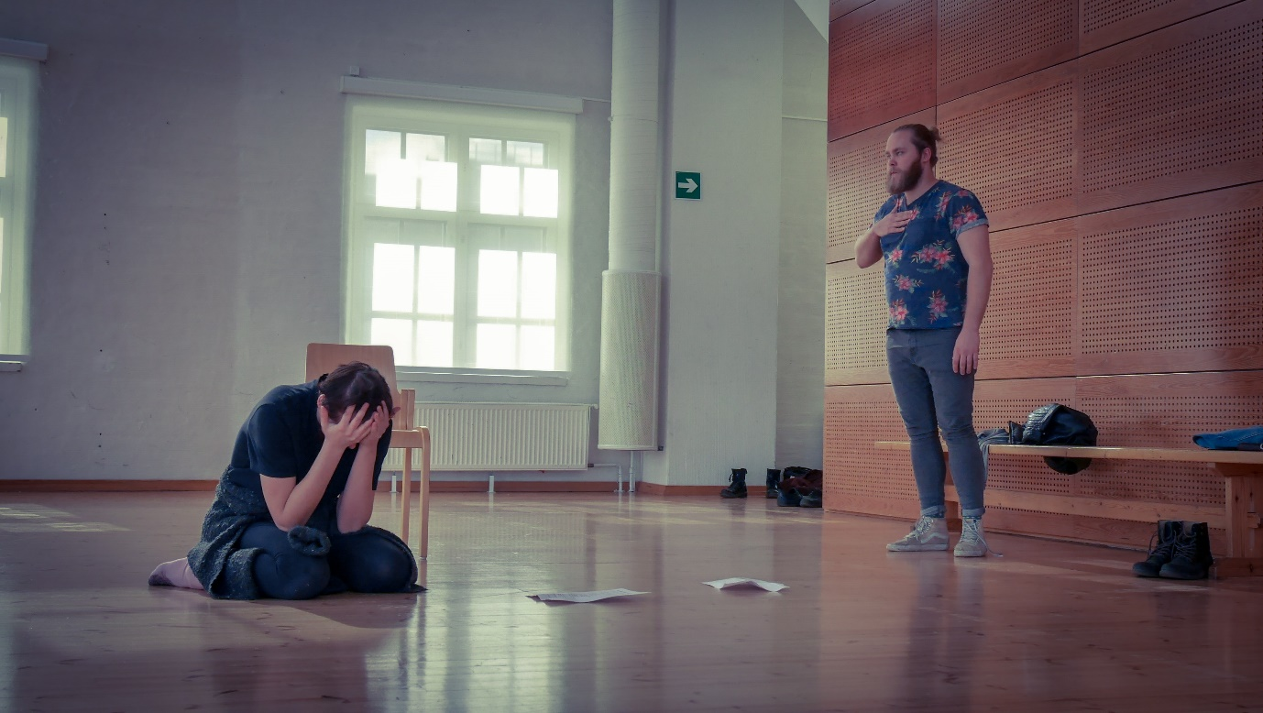
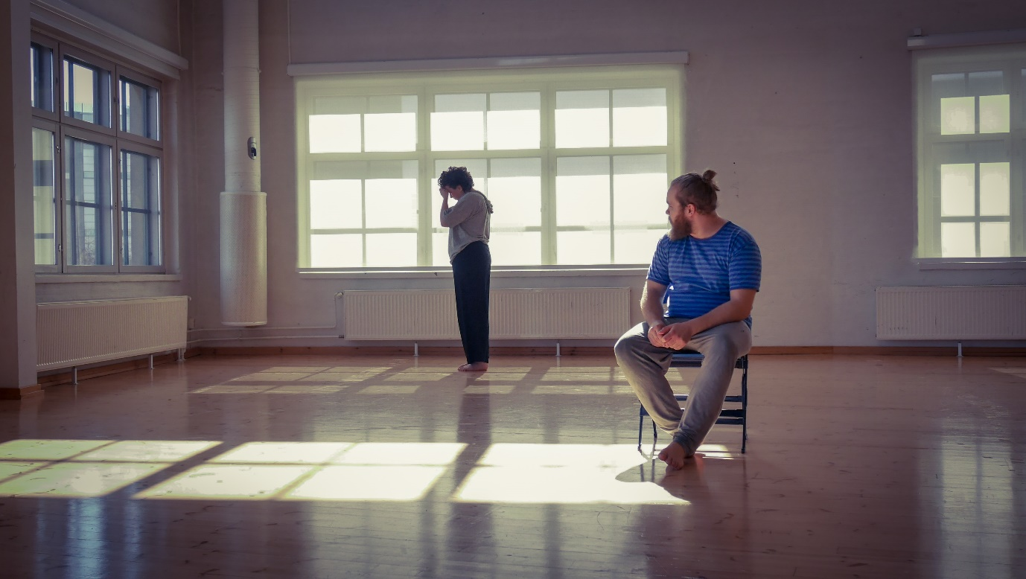
Davide also worked on a few scenes inspired by the Teuvo Hakkarainen’s sexual assault scandal story.
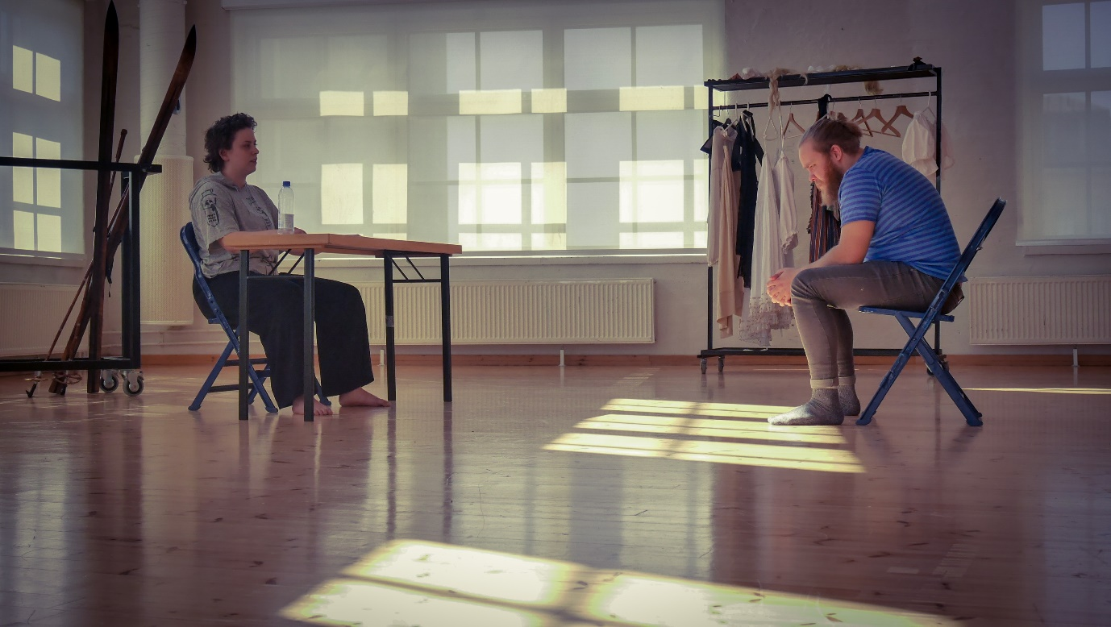
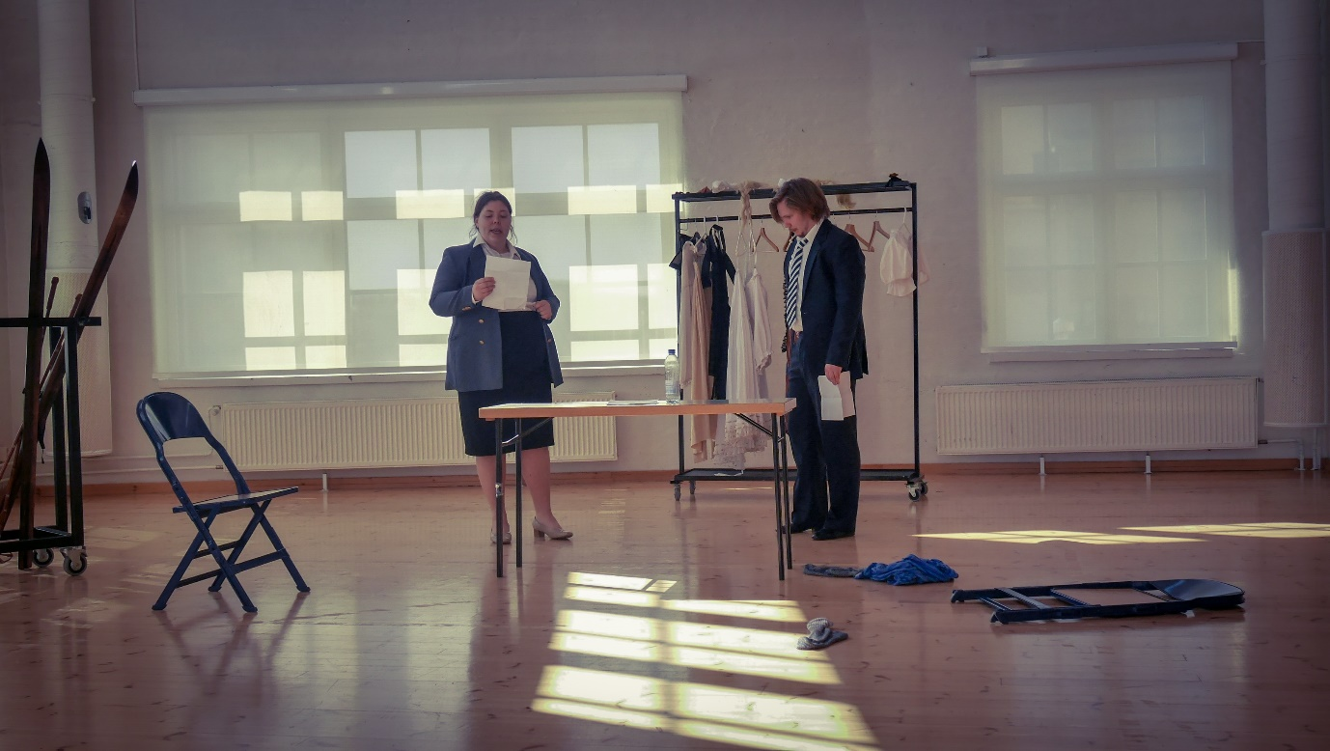
All the monologues and scenes are slowly but surely transforming into something really fascinating.

- Physical training
In response to this week’s underlying attitude “deepening the enquiry,” I focused mostly on how we could deepen our practice. Whether it’s Suzuki or Viewpoints or Hino Method, after a certain period of time, you know all the essential forms and vocabulary of the method. Especially when it comes to a physical technique, the majority of practice consists of repetition. It is so easy for the mind to be in the auto-pilot mode, where you just go through motion without much awareness or thought. Sometimes adding a new element to the exercise or inventing a new one could snap you out of the dullness and give fresh insights. To me, however, the fundamental issue is about the quality of one’s attention and awareness towards one’s own body and surroundings.
So, I had students do very simple exercises with very specific direction and focus. I encouraged them to examine carefully how their bodies were reacting and dealing with the task at hand and how their consciousness was affecting that. In addition to instructing the students, I sometimes participated in practicing with them as well.

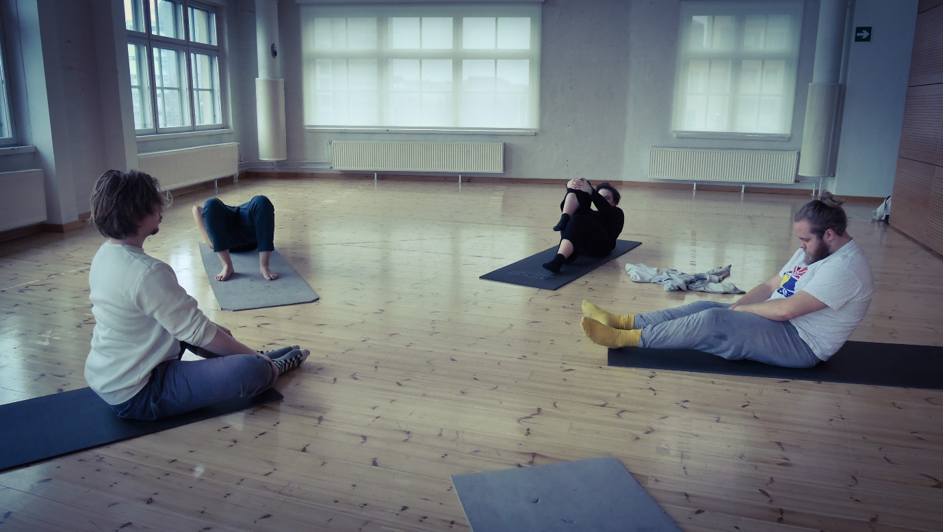
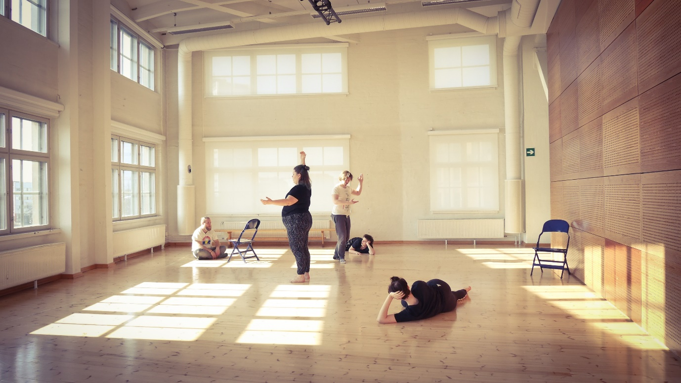
The one day I realized that when trying to do something simple such as connecting and moving the elbow and kyokotsu (a point in the chest bone, about 2cm above solar plexus) together with utmost precision, I felt it almost impossible to do so. But in facing such impossibility, my curiosity towards the body exploded; millions of questions started to live in my consciousness. And suddenly repetition of practice was no longer just repeating the same thing. Each time I wanted to find out more about my body in the space and in relationship to other people. It felt like digging deeper and deeper into the body to excavate hidden gems.

… This small yet significant realization was very much in tune with the underlying attitude of the week.
Having said all this, after such an intensive week, I felt the need to have fun with the students towards the end of the week. So, on Friday morning, we did an improvisational game where one student conducted a vocal orchestra. It was hilarious and somehow affirming of the fact that the students have come a long way in listening to and connecting each other better.
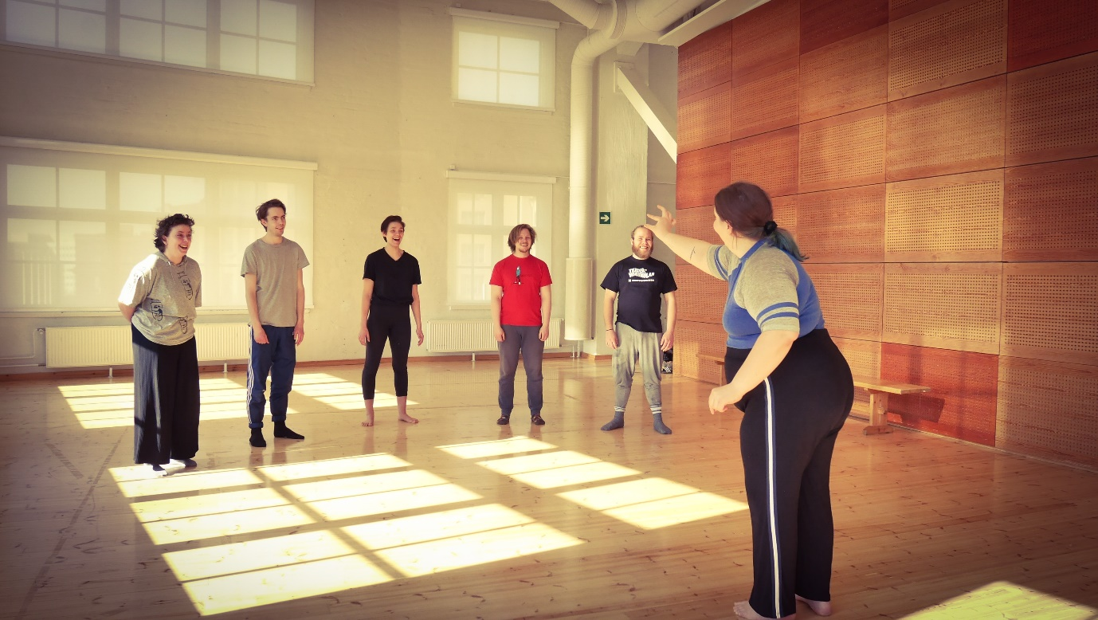

Good work!

